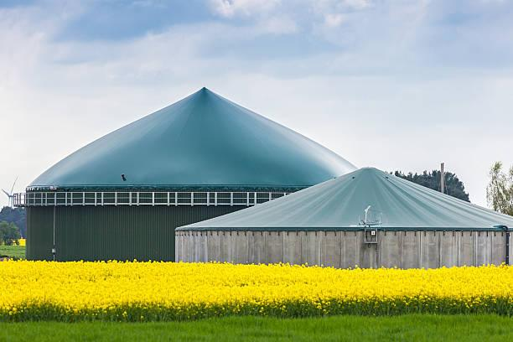
Renewable Natural Gas
Insights and Recommendations for California

Maritza Correa ‘18, Benjamin Demonbreun ‘18, Sean Hackett ’21,
Nefeli Ioannou ‘19, Camila Tussie ‘21, David Yosuico ‘20

August 2018

Table of Contents

Acknowledgements 4
Executive Summary 5
Report Outline 7
Introduction 8
What is Biogas? 8
Anaerobic Digesters 8
Composting 9
How Much Biogas is There? 11
How is Biogas Treated? 12
Cleaning and Upgrading 12
Cleaning and Upgrading Processes 13
Framing this Study 14
Uses of RNG 15
Transportation Fuel 15
Biogas Vehicles 15
Feasibility 17
Passenger Vehicles 17
Trucking Fleets 17
Vehicles for Site Operations 18
Municipal Transportation 18
On-Site Energy Generation 19
Electricity Generation Options 20
Combined Heat and Power 21
Industrial Feedstock/Other 21
Plastics 21
Food for Fungi 22
Summary of Obstacles to Broader Biogas Utilization 23
Pipeline Injection 23
Gas Pipeline Network in California 23
Gas Quality Standard Requirements 25
Interconnection Process 25
Siloxanes 27
Minimum Heating Values 27
The Regulatory Landscape Surrounding RNG 28
The Renewable Fuel Standard (RFS) 28
RINs and RVOs 29
The “eRIN” Pathway 32
Low Carbon Fuel Standard (LCFS) 34
California Senate Bill 1122 36
Rural Energy for America Project 37
Problem Area 1: Organics Diversion from Landfills 38
California Senate Bill 1383 38
What Happens to Waste Now? 39
Sorting Waste With Bins 39
Waste Collection 39
Recyclables and Waste Designated for Landfill 39
Organic Waste 40
Landfills: the Final Destination for Waste 41
LFG Collection 41
Opportunities for Higher Landfill Gas Recovery 42
The Problem with Flaring 43
How Much Organics Diversion Is Already Taking Place? 43
How Things Need to Change 44
Alternative Daily Cover as Green Waste Recycling 45
The Co-Digestion Opportunity 46
Edible Food Recovery 47
The Problem with Sorting 49
Implications for Current Landfills 50
Organics Diversion: Conclusion 51
Problem Area 2: Dairies 52
Problem with Manure 52
Anaerobic Digesters in Dairies 53
Trucking Biomethane 56
Manure Storage 57
Dry Storage 57
Liquid Storage 57
Slurry Storage 58
Countering Emissions from Enteric Fermentation 58
Red Seaweed 59
Algae-Based Water Treatment 59
Case Study: Fair Oaks Farm 60
Dairies: Conclusion 61
Economics 62
Biogas vs. Fossil Natural Gas 62
A Note on Energy Companies 65
RNG vs. Other Renewables 66
A Study of the Growth of the Solar Energy Industry 69
Conclusions & Recommendations 73
General - RNG 73
Organics Diversion 75
Dairies 76

Acknowledgements

We would like to thank all the individuals listed below for so generously sharing their time and expertise in discussions, meetings, and site visits. Our special thanks are due to Johannes Escudero of the RNG Coalition, Dave Lewis, Gracie Brown and Steve Moorleghen of PG&E, Sarah Rizk of Loci Controls, and Greg von Wald of Stanford for helping define the two focus areas.

Arvind Akela, SV Clean Water
Bob Anderson, Chevron
Tony Boccaleoni, Republic Services
Kyle Borgert, EPA
Hank Brady, CalRecycle
Gracie Brown, PG&E
Brenda Cabral, BAAQMD
Osvaldo Cordero, Zanker Recycling
Johannes Escudero, RNG Coalition
Manon Fisher, SF Water
Raleigh Gerber, Clean Energy Renewable Fuels, Inc
Angela Goebel, Monterey RWMD
Mike Gross, Zanker Recycling
Tyler Henn, Clean Energy Renewable Fuels, Inc
Jeff Lindenthal, Monterey RWMD
Anthony Luong, Republic Services
Mike McCloskey, Fair Oaks Dairy
Shannon Miller, EtaGen
Jenny Milne, Stanford
Steve Moorleghen, PG&E
Julie Muir, PSSI/Stanford Recycling
Brad Neff, Chevron
Ira Pearl, Montauk Energy
Rolando Perez, Stanford
Sarah Rizk, Loci Controls
Joan Salwen, Stanford
Anne Schauer-Gimenez, Mango Materials
Yaniv Scherson, Anaergia
Karri Ving, SF Water
Greg Von Wald, Stanford

Finally, a big thank you to Brian Bartholomeusz, the Executive Director of Innovation Transfer of Stanford’s TomKat Center. We are deeply grateful for his mentorship throughout this project, no part of which would have been possible without his knowledge, advice, and encouragement.

Executive Summary

Over the past decade, California has undertaken aggressive steps to capture and utilize fugitive methane emissions from a variety of sources where they are an unavoidable byproduct. These include biogas emanating from landfills, wastewater treatment plants, farms, and dairies. To combat these climate pollutants, the California Senate Bill 1383 was signed into law in 2016 which established targets to achieve a 50% reduction in the level of statewide disposal of organic waste from the 2014 level by 2020 and a 75% reduction by 2025. In addition, SB 1383 requires that dairies in California control their methane emissions as early as 2024. The bill mandates the establishment of infrastructure and policies for dairy farms to reduce methane emissions by up to 40% from 2013 levels by 2030. The challenges and opportunities presented by these two initiatives are the primary focus of this study.

Various incentive schemes at the state and federal level have proven to be powerful driving forces behind biogas capture, conversion, and commercialization efforts. Chief among these is the Renewable Fuel Standard which requires, among other things, a traceable pathway from suppliers to users, compressed natural gas (CNG) vehicles. However, to date, California has trailed other states in the advancement and harnessing of biomethane and renewable natural gas (RNG) opportunities for a variety of reasons including:
- Sub-optimally aligned and coordinated regulatory/permitting processes and agencies
- Excessive project time and cost and
- Economic and regulatory barriers to biogas utilization including significant regulatory hurdles for pipeline injection.
Resolution of these obstacles will be key to realizing the objectives of SB 1383.

It has been estimated that the Organics Diversion effort will require the establishment of 150-200 new “landfill equivalents” at a cost of $1.5-2.5B.
- Given that only 2 new landfills have been approved in the past 2 years, it is clear that a dramatic re-design and streamlining of the approvals process will be required.
- Upgrades to existing recycling facilities and some of the 900 wastewater treatment plants in California could absorb a large portion of these diverted organics and possibly reduce the regulatory burden and investment required.
- A major challenge is the currently variable and sometimes excessively high (40%) contamination levels in organic waste. A much more aggressive statewide effort of outreach, education, and enforcement will be required to bring these down to an ideal 5-10%.
- It is imperative that obstacles to pipeline injection and on-site electricity generation be conclusively addressed and resolved. It is unacceptable that it is currently easier to flare biogas than it is to make use of it.

The challenges faced by dairies in California are primarily a function of their size and distributed nature. Their inability to individually realize economies of scale and their distance from potential offtake sites significantly erodes the economic viability of their biogas exploitation potential.
- Concepts based on dairy cluster models with a variety of processing, transportation, local utilization, and pipeline injection options do appear to offer a pathway to project viability. These have been successfully piloted in other regions and the results of the PG&E cluster study should go a long way toward defining the operational and economic frameworks of this model.
- It is imperative that variances to restrictive local zoning and land use ordinances be expedited on a case-by-case basis to facilitate these undertakings. The interests of surrounding communities has to be taken into account but should not create unbearable burdens on the already stressed dairy industry.

A great example of a large dairy that has been able to capture methane and use it both as a vehicle fuel and for electricity generation is the Fair Oaks farm in Indiana. Complete with on-site CNG fueling stations, Fair Oaks exemplifies how a large-scale RNG project on a dairy is not only feasible but also profitable.

There are a number of other challenges and opportunities related to these two focus areas that could contribute to the attainment of some of the higher level goals of SB 1383 and similar legislation. These include:
- A comprehensive upgrading of existing landfills and wastewater treatment facilities to maximize biogas production/extraction efficiencies. An incentive or cost sharing scheme would probably be necessary due to the associated costs.
- Incentive programs for fleet conversion to CNG. While creating market pull for RNG, this would also help displace diesel and bring all the associated environmental benefits.
- An eRIN pathway for RNG use by electric vehicles. This would significantly expand the opportunities for biogas utilization, even at a relatively small scale due to the far greater ease of electrical interconnection compared to pipeline injection.
- Incentive programs to reduce or suppress enteric methane emissions from livestock; these are comparable or higher than fugitive emissions from manure.

Last but not least, the only way RNG projects can truly burgeon is if they become inviting to investment. It is therefore crucial to encourage financing of RNG projects by minimizing the financial insecurity currently faced by the industry. Stabilizing RIN prices and encouraging long term power purchasing agreements will allow banks and financial institutions to procure the level of security necessary in order to allow investment.

The 15,000 potential RNG production sites in the United States have the capacity to generate 8-12 million tons of methane equivalents annually, enough to power 3 million homes or displace 2.5 billion gasoline gallon equivalents (2% of US annual transportation energy demand). The exploitation of this resource is not only essential but also economically viable.

A comprehensive list of recommendations can be found at the end of this study.

Report Outline

This report outlines the current state of the renewable natural gas (RNG) industry and all of its accessory industries. We introduce biogas, where it comes from, how it is treated, and how it can be used. Uses for biogas usually require cleaning and upgrading. It can then be used in many different ways in the automotive industry, the shipping industry, the electricity grid, as an industrial feedstock, and much more.

We illustrate the current systems for delivering natural gas in California specifically, especially the pipeline system. Barriers to RNG injection are noted, particularly standards and regulations. A thorough examination of federal programs that incentivize RNG production, like the Renewable Fuel Standard (RFS) and the Low Carbon Fuel Standard (LCFS), is undertaken. California-specific bills that deal with the waste industry, such as California SB 1122 and SB 1383, are also examined to shed light on how California is approaching organics diversion and biogas collection from a regulatory standpoint.

This report then focuses on two problem areas: California organics diversion from landfills and dairies. These two areas are of particular importance because there is a large opportunity to change practices in these areas that may result in a large impact in the waste and RNG industries.

In regard to landfills, we cover how waste is currently being treated, the California government push towards the separation of organic materials from landfills, how this government push can be fulfilled, and how landfills will be affected.

In the dairy section, we highlight how manure and enteric emissions pose an environmental threat, how manure is currently handled, how it can be collected more economically to make biogas, and a few other solutions to countering methane emissions (changing animal feed, local trucking, etc.).

We also delve into the economics of natural gas. We first discuss the differences between biogas and fossil natural gas and the cost of natural gas from different sources, renewable or nonrenewable. A short discussion of the role of large energy companies and their choice of large, centralized projects over small, dispersed projects hindering massive investment in RNG. RNG and natural gas are also compared to other renewable energy sources, like wind and solar power, to predict future trends in natural gas economics. We end this section on a discussion of the takeaways from the solar industry, and how they can be applied to the RNG industry.

Lastly, we provide recommendations to public policy, utilities, and private industry on actions and changes that can be made to promote sustainable growth in the production of biogas, as well as recommendations to fulfill waste diversion goals set out by the California government.

Introduction

What is Biogas?

Biogas comes from the anaerobic digestion of organic waste by bacteria. Three principal sources of biogas are wastewater treatment plants (WWTP), dairy farms, and landfills. Biogas typically consists of approximately 35% carbon dioxide (CO₂) and approximately 60% methane (CH₄) with small amounts of other gases. In terms of global warming potential, CH₄ is much more potent than CO₂. The Intergovernmental Panel on Climate Change estimates that, on a 100-year time scale, CH₄ warms the atmosphere 34 times as much as CO₂ does. Because biogas has such a large methane content, biogas emissions pose a serious threat to the global environment. Shown below is a diagram of where US methane emissions come from. Manure management, landfills, and enteric fermentation come from biogas production, therefore accounting for more than half of US CH₄ emissions. Creating renewable natural gas (RNG), biogas that has been refined to traditional pipeline natural gas quality, serves as a solution to these methane emissions.

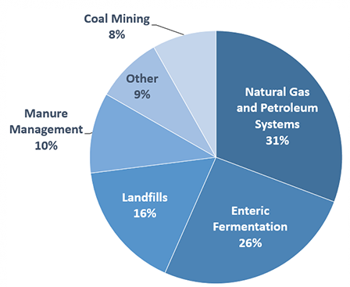
Figure 1: 2016 US Methane Emissions, By Source

Anaerobic Digesters

Anaerobic digestion is the process in which microorganisms produce biogas in the absence of oxygen. To clean up organic waste streams like sewage and food waste, it is a common method to use large, highly controlled anaerobic digesters (AD). The process produces a gas that is rich in methane and creates a byproduct called digestate, a source of nutrients that can be used to make fertilizer from the remnants of the organic waste. Each cycle is heated up to 101 degrees Fahrenheit and takes approximately 15 to 30 days. The anaerobic digestion process follows the following steps:

- Hydrolysis - Hydrolytic enzymes break down complex polymers into simple sugars, amino acids, and fatty acids
- Acidogenesis - Simple monomers are broken down into volatile fatty acids
- Acetogenesis - Fatty acids are broken down into acetic acid
- Methanogenesis - Methane and Carbon Dioxide are produced

Depending on the feedstock in the AD, digesters can be either wet or dry. The feedstock in wet digesters are composed of 10-20% or less of dry matter, while dry digesters have a feedstock consistency of at least 20-40% dry matter. Dry ADs are often simpler to operate, because they require less water to heat, little to no pre-processing and are more tolerant of contaminants, and contain less critical equipment, therefore needing less maintenance. However, the installation costs for these dry systems are higher than their wet counterparts.

On the other hand, wet ADs can accept a wider variety of organic feedstocks and are ideal for optimizing biogas production, since mixers ensure the feedstock is thoroughly digested by the bacteria. The equipment requires organic waste to be pre-processed, especially for mixed organics and green waste like yard trimmings, and it takes a lot of energy to operate, including 20-30% of the heat produced during digestion. The system is also highly sensitive to contaminants, especially sand.

In the US, there are over 1,400 wet ADs at wastewater treatment plants and dairy farms, representing most of the ADs in the country. Dry AD technology is spreading rapidly at landfills, though, and dry ADs account for the majority of new installations in the US.

The choice of AD will widely depend on a site’s specific situation, with factors like available space, capital, type of feedstock, and desired output greatly contributing to the decision. ADs are extremely flexible and can be adapted to best suit the plant. Landfills with on-site digesters favor dry digesters while wastewater treatment plants and dairies favor wet ones.

Composting

Composting is a process that uses microorganisms to aerobically break down food scraps and yard waste into the organic components of soil. Compositing tends to take longer than AD.

The Table below provides a comparison of the net greenhouse gas (GHG) emissions from each method of materials management. It showcases that composting organic waste through aerobic digestion provides a significant environmental benefit over anaerobic digestion because aerobic digestion produces mostly CO₂ and little CH₄. The finished product of composting can be used as fertilizer, offsetting nitrogen-based commercial synthetic fertilizers that may be environmentally harmful. Additionally, composting can increase the amount of carbon dioxide that plants capture and store in the soil.

Table 1: Net Emissions for Food Waste and Mixed Organics under Different Management Options in MT of CO2 / short ton
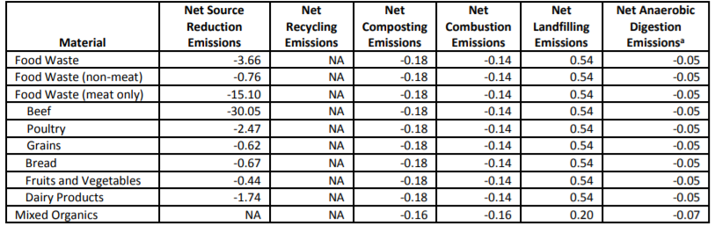

Applying cow manure to rangelands increases plants’ carbon capture and net primary productivity (NPP), but the manure increases the nitrogen in the soil, producing nitrous oxide (N₂O) that can offset about 75% of the climate change mitigation. Composting the manure before applying it is important since carbon capture and NPP are increased, while GHG emissions are decreased.

However, long-term land application of manure stabilizes carbon capture over a few decades, meaning N₂O emissions will eventually overtake the climate benefits of using manure as compost. This balancing is also shown in research indicating that spreading manure more often in smaller quantities sequesters less carbon but emits less N₂O. This indicates that, to minimize GHG emissions of manure composting, careful consideration needs to be given to the composting methods, the quality and the quantity of the compost, and the timing of its application.

Lastly, it is important to note that anaerobic digestion and composting of organic waste are not mutually exclusive. After anaerobic digestion, WWTPs typically dewater the digestate or biosolids, as they are referred to in the wastewater industry. Biosolids are the carbon and nutrient rich soil-like product of wastewater treatment. The dewatered biosolids can be used as a replacement for synthetic fertilizer in commercial agriculture operations and, depending on the quality, as a soil product in non-agricultural settings. Many WWTPs currently pay haulers to bring biosolids to farms and ranches or pay commercial composters to further process the biosolids into compost. There are also a few WWTPs that further process their biosolids into soil blends on site without working through third-party vendors. Dry ADs, like the ones at Zero Waste Energy Development Center, also pay haulers or composters to take the organic waste post-AD.

How Much Biogas is There?

Consultants at ICF published a study estimating biogas potential in California. The following table depicts the RNG potential in terms of BCF/yr. With these values, it is estimated that 2.8 to 5.7 million average homes can be powered per year.

Table 2: RNG Production Potential in CA from Various Feedstocks
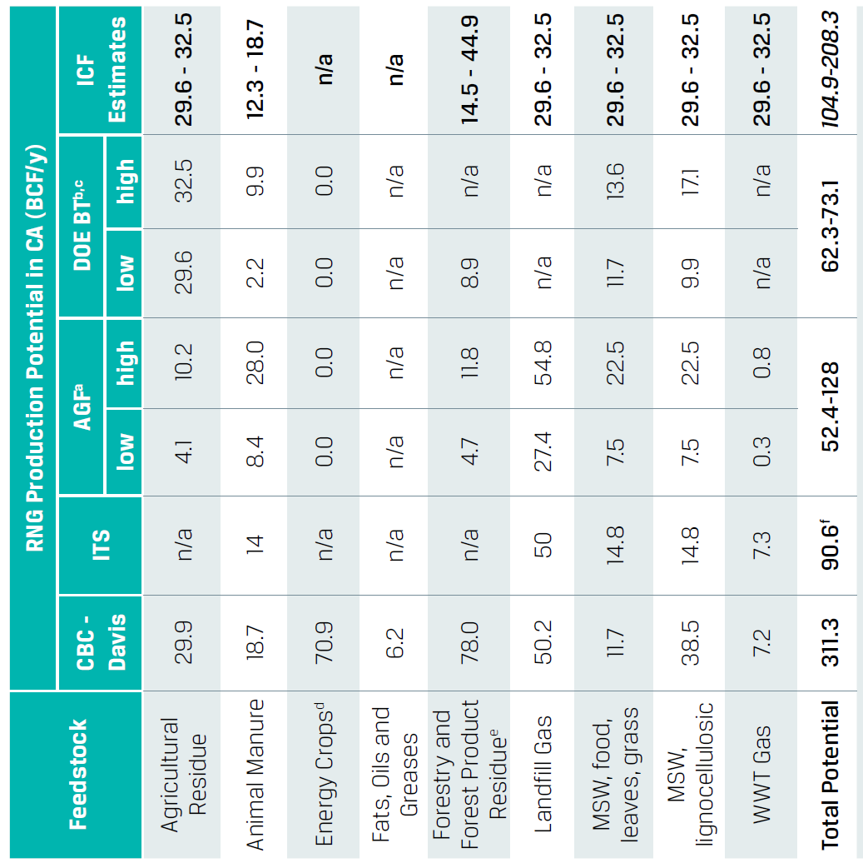

How is Biogas Treated?

If biogas is to be used as an energy source, impurities must be removed to bring the combustible methane to a state in which it can be burned cleanly without damaging equipment or the environment. The typical makeup of raw biogas varies depending on the source, as shown in the table below.

Table 3: Biogas Composition (by % makeup) ,,
Component | Agricultural Waste | Landfill | Industrial Waste | PG&E Pipeline Biomethane Regulation
Methane CH₄ | 50–80% | 50–80% | 50–70% | N/a
Carbon dioxide CO₂ | 20–50% | 20–50% | 30–50% | 1%
Hydrogen sulphide H₂S | 0.70% | 0.10% | 0.80% | 0.0004%
Hydrogen H₂ | 0–2% | 0–5% | 0–2% | 0.10%
Nitrogen N₂ | 0–1% | 0–3% | 0–1% | N/a
Oxygen O₂ | 0–1% | 0–1% | 0–1% | 0.1%
Carbon monoxide CO | 0–1% | 0–1% | 0–1% | N/a
Ammonia NH₃ | Traces | Traces | Traces | 0.001%
Siloxanes | Traces | Traces | Traces | 0.01 Si/m³
Water H₂O | Saturation | Saturation | Saturation | <120 ppm

Cleaning and Upgrading

Purifying biogas into a CO₂ and CH₄ mixture is called “cleaning,” and removing the CO2 after cleaning is called “upgrading.” When turning biogas into a usable fuel, specialized processes are necessary to put in place to clean and upgrade. There are a number of different configurations of equipment for the removal of impurities, but they must do the following before the gas can be used, as certain impurities can significantly lower the gas quality or damage equipment:^{13,,}
- Remove water: Also known as “drying” the gas, water can cause corrosion in pipelines and other machinery in combination with sulphur oxides.
- Remove hydrogen sulfide: H₂S also causes corrosion in pipelines and other machinery, and poses a health risk with exposure to people
- Remove siloxanes: Siloxanes can build up a waxy substance in pipelines and machinery, that can cause dangerous flow disruptions and limit heat exchange.
- Remove ammonia: Ammonia is highly corrosive and poses stress-related risks to pipelines. Ammonia also lowers the performance of biomethane.
- Remove particulate matter: Particles generated during digestion can collect and cause wear in moving machinery.
- Remove carbon dioxide: Though biomethane can be burned with a blend of CO₂ for electricity generation, CO₂ must be removed before injecting into a pipeline (become upgraded). The CO₂ can then be vented, or it can be liquified and sold.
- Remove oxygen and nitrogen: The presence of these compounds depends on how well anaerobic conditions are held during digestion, but should be removed unless being used for combined heat and power (CHP) or boiler purposes, as these increase engine damage risk and decrease calorific value of the gas.

Cleaning and Upgrading Processes

There is a variety of chemical and physical processes to remove impurities within the gas, some of which can be adapted to filter multiple components of raw biogas.¹⁶

Simple Cooling & Compression | During simple cooling and compression, the temperature of the gas is lowered to a non-cryogenic temperature and raising the pressure condensates impurities. Water can be easily removed with a condensation trap and burying the gas line in the ground (or using a simple cooling mechanism). Siloxanes may also be removed this way.
Adsorption | Adsorption is using a chemically treated surface to capture impurities. Though activated carbon is a very versatile adsorption surface, it can be aided with doping chemicals, which help attach specific impurities to the surface. Other adsorption surfaces include silicon compounds and molecular sieves. This method is very useful for removing hydrogen sulfide (below 1 ppm), water, siloxanes, and ammonia. Pressure swing adsorption is a common method.
Absorption | Absorption involves capturing impurities through permeation of a bulk material. This is the oldest method for removing hydrogen sulfide, using iron oxide and other ferrous chemicals. Water may also be absorbed using alcohols or salts. Carbon dioxide can also be absorbed with amine solutions or an organic solvent.
Biological Treatments | Biological treatments use microorganisms to filter out impurities. By providing nutrients to species that oxidize sulphur, like Thiobacillus and Sulfolobus, hydrogen sulfide can be removed from a biogas in an aerobic process.
Cryogenic Cooling | Cryogenic cooling lowers the temperature of the gas to a cold enough temperature for certain components of the gas to liquefy. Because oxygen, nitrogen, methane, and carbon dioxide all have different boiling/sublimation points, methane can be easily filtered out in a multistage cooling process.
Membranes | Finally, using a porous membrane selectively filters out components of the gas. Membranes have been produced that are permeable to nitrogen, ammonia, and water, but not to methane. Membranes also exist for a large variety of other impurities, some of which can be separated with an even simpler mechanical filter, like particulate matter.
Though these methods are all used today, it is not possible to determine which of these methods is the best practice for gas purification and upgrading. Differing operations with different setups may use the specific practices that suit them best.

Framing this Study

Unlike Natural Gas, biogas, a by-product of critical waste disposal and treatment operations, is a continuously produced resource that cannot be shut off. As a result of having to deal with this continuous output stream, there are three strategies that are employed to handle the gas: release, flaring, and utilization.

Releasing the gas is obviously unacceptable due to the significant GHG impact of methane. Despite this concern, it is estimated that “fugitive” methane emissions in the US and California unfortunately amount to 651.1 and 38.9 million metric tons of CO2 equivalent, respectively. There are very aggressive measures in place to reduce and eliminate these.

The second strategy of flaring is quite common due to the absence of NOx production with the direct conversion of methane to CO₂. While still resulting in CO₂ emissions, CO₂ is the least potent of the two byproducts. Pipeline injection obstacles and the stringent permitting requirements of on-site energy generation make flaring a very common mode of methane disposal at California landfills.

The third option, utilization and its implications, will be the focus of this study. Preventing as much fugitive emissions as possible by capturing and utilizing methane that would otherwise be flared results in the realization of a number of tangible environmental and economic benefits. Perhaps most beneficial is the conversion of raw biogas into renewable natural gas (RNG or biomethane) -a form of gas that is usable to fuel compressed natural gas (CNG) and liquefied natural gas (LNG) vehicles. The most significant of these, from an environmental impact perspective, would be the displacement of diesel by renewable natural gas (R-CNG or R-LNG) in medium-, and heavy-duty vehicles. Replacing just 16% of the conventional natural gas utilized in California with RNG would achieve the same amount of greenhouse gas reductions as electrifying 100% of the state’s buildings. And in buildings specifically, using RNG is 3 times more cost effective than using electricity as a low-carbon strategy.

There are approximately 2,000 biogas production facilities (capturing methane and combusting it on-site for use as renewable electricity) in the US at landfills, wastewater treatment facilities and livestock operations - with the potential for as many as 15,000 more. The theoretical maximum production capacity of these facilities is estimated to be between 8 and 12 million tons of methane/year. To put this number in context, such biogas potential could power 3 million homes a year or, if upgraded to RNG, could provide the equivalent of 2.5 billion tons of gasoline/year (about 2% of the current demand). This is in contrast to the production capacity of large natural gas fields, some of which can provide up to 9-16 million tons of methane/year. The challenge faced by RNG developers is the high capital cost of RNG production compared to the relatively low cost of conventional natural gas. The existing market and infrastructure is designed and optimized around producers whose natural gas production dwards RNG output by 3 to 4 orders of magnitude.

As legislators and regulators recognize the environmental and economic benefits associated with increased RNG development, deployment and utilization, and enact policies that enable the RNG market to grow, it certainly would be worthwhile to look at new business models for the gas sector that perhaps changes the narrative from one of distributed gas production to one of distributed energy/fuel generation. The electricity sector increasingly provides examples of how this can be accomplished – and is being accomplished through public policy - in the context of existing infrastructure and energy, pricing and incentive models.

Uses of RNG

Transportation Fuel

Biogas Vehicles

The main difference between conventional (fossil) natural gas and renewable natural gas (RNG or Biomethane) is the source of the fuel. The quality of biomethane and of fossil gas are essentially the same, rendering biomethane a “drop-in” substitute for natural gas that can act interchangeably as a fuel in natural gas vehicles (NGVs). The number of NGVs worldwide has grown over the last few years, and more countries have been establishing the use of RNG as an alternative or additional fuel for these cars. Figure 3 shows the countries with the largest NGV fleets worldwide. Globally, there were about 22.7 million NGVs operating in 2015.

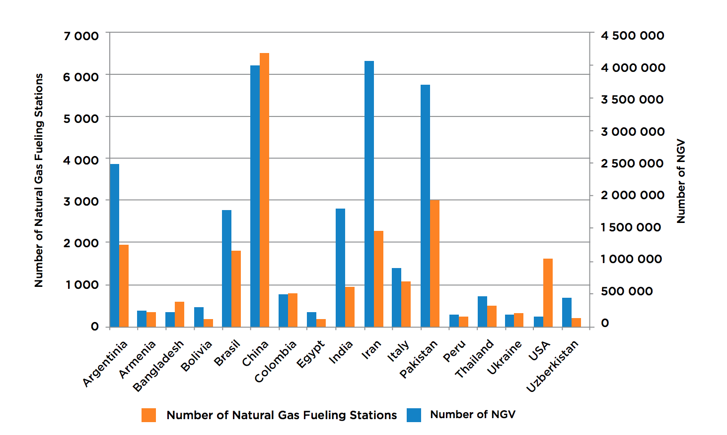
Figure 2: Numbers of natural gas vehicles and filling stations in leading markets

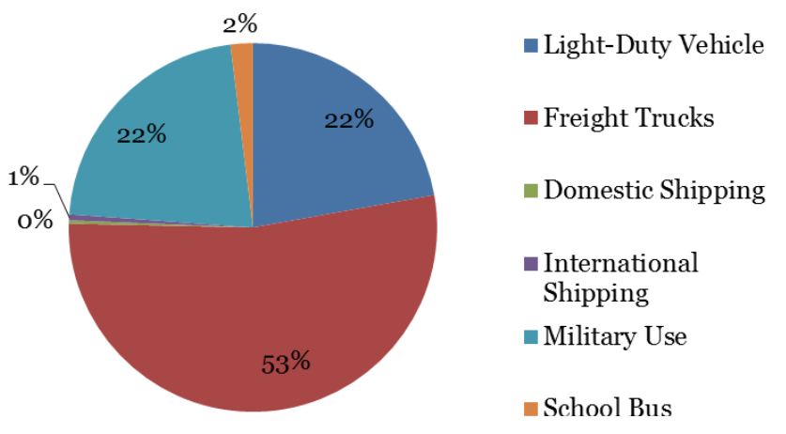
Figure 3: Uses of natural gas in the United States in 2014 by mode of transportation

There are three main types of engines that accept natural gas and therefore also accept biomethane. First, the bi-fuel operation engine can operate on either gasoline or methane. Compared to a gasoline-only engine, the main difference lies in the addition of a second fuel supply system and storage cylinders for the methane, and its typical range is comparable to gasoline only engines (about 250 to 310 miles). Second, the dedicated gas engine is a spark-ignited engine that runs on gas only, whose main advantage compared to a gasoline is its considerably higher knock resistance, i.e. the fuel’s ability to not self-ignite and burn in an uncontrolled way when compressed. As a result, a dedicated gas engine can attain a higher compression ratio than a standard gasoline engine, a feature that offers slightly better energy efficiency than gasoline operation, making dedicated gas engines suitable for light duty commercial vehicles (mainly vans) and city buses. Finally, the dual operation engine uses diesel and gas simultaneously. These engines can easily result from retrofitting diesel only engines and retain the possibility to run 100% on diesel fuel as a backup.

Feasibility

Because the natural gas industry has been rapidly growing in the United States since the advent of hydraulic fracturing, fossil natural gas is expanding its infrastructure, especially in California. As of 2013, there were a quarter million CNG vehicles on the road for use in cars, trucking, and even taxis. There also were 900 CNG fueling stations nationwide (half of which are available to the public); the majority of the CNG vehicles are for commercial fleets or for municipal use.

Passenger Vehicles (Light-Duty)

Natural gas passenger vehicles have proven to be difficult to sell in the United States. In fact, one of the only CNG cars marketed specifically for the United States, the Honda Civic GX, was taken off the market in 2015 due to lack of demand. Natural gas vehicles tend to cost thousands of dollars more than their gasoline counterparts, and the disparity between the costs of natural gas and gasoline differs from region to region. Furthermore, natural gas fueling stations are much sparser than gasoline fueling stations, so refueling becomes less convenient. Systems do exist that can adapt the household natural gas system to refuel CNG cars, but they cost thousands of dollars. An economic feasibility study from Utah State University outlines what needs to be done before CNG passenger vehicles become attractive. First, the price differential of natural gas and gasoline must be high enough for natural gas to be considered a viable alternative fuel to gasoline. Second, the price differential between a CNG vehicle and a gasoline vehicle must be low enough for the choice between these vehicles to be as marginal as possible, as CNG vehicles tend to be more expensive. Third, fueling stations must become widespread enough to offer a convenient fuel source. Until there is a greater demand for natural gas engine passenger vehicles fueled by RNG, it would be beneficial to promote increased utilization of renewable electricity generated from biomethane to charge light-duty Electric Vehicles (EVs).

Trucking (Heavy-Duty)

There is a heightened interest in CNG among trucking fleets, especially in California. Converting trucking fleets to CNG provides huge environmental benefits, since trucking uses more fuel than all airplanes, railways, and marine ships combined, and the fuel used for trucking is often highly polluting diesel. Of the quarter million CNG vehicles in the United States, only 4,000 of them are medium- and heavy trucks.

Recently, the logistical model for trucking has changed from long-distance trips, where trucks deliver cargo directly to its destination, to a hub-and-spoke model where localized sets of fleets deliver modularized containers to adjacent hubs for later shipping and return to their home base. This model has a number of benefits, one being that localized fleets can refuel at their hub, allowing for a centralized fueling system. As a result, a localized trucking fleet is more easily able to adopt a renewable fuel that does not have a wide infrastructure. However, even though there is some incentive to convert commercial trucking fleets to natural gas, there is still little conversion taking place, due to the tight schedules of trucks, the low density of fueling stations, and the possibility of higher maintenance costs associated with natural gas supply chains and vehicles. In addition, only around 200,000 to 240,000 new vehicles are introduced onto the road each year, so competition with diesel vehicles renders the introduction of natural gas vehicles particularly challenging.

On-Site Fueling & Fleet Operations (Medium- & Heavy-Duty)

A directly accessible option for biogas producers is to use the gas to power vehicles and equipment used for site operations. Trucks used at landfills, wastewater treatment plants, dairies and other livestock operations can be converted to or replaced with CNG trucks that are fueled RNG, and they could be fill up using centralized fueling stations. This could eliminate the need for pipeline interconnection in certain locations, reducing costs and lessening how much coordination is needed between RNG transporters and consumers, and allow landfills and dairies to generate revenue by monetizing environmental credits (i.e.., RIN credits and Carbon Credits) supported by federal and State programs like the Renewable Fuel Standard (RFS) the California’s Low Carbon Fuel Standard (LCFS).

However, a new natural gas waste hauler (refuse or garbage truck) are very expensive; the city of San Diego’s conversion could cost around $35,000 more per vehicle, a 13% increase over the cost of replacing with a new diesel fleet. Taking into account the expenses from installing fueling stations and converting vehicles, and the savings from incentive schemes and the lower price of natural gas over diesel, the conversion is expected to take approximately seven (7) years to break even. In addition, natural gas engines and storage systems often weigh one ton more than traditional truck engines, thereby reducing how much material CNG vehicles can haul (this is being addressed legislatively). To help mitigate this issue, California is considering allowing CNG trucks to exceed the current weight capacity limits. After including truck conversion, reduced revenue from hauling lighter loads, and even adding new vehicles to a fleet to accommodate the reduced capacity, fueling vehicles at landfills and recycling centers can cost a significant amount of capital; California’s hope is that investment will pay off through greatly reduced pollution and fuel savings.

In Fair Oaks Dairy Farm in Indiana, a dairy farm which will be discussed in detail later in this report, CNG trucks have been in place since 2011, and they have run on renewable natural gas (RNG) produced by the dairy’s anaerobic digesters since 2013. The dairy farm’s CNG trucks offset approximately 1.5 million gallons of diesel annually, and they can save as much as $2 per diesel gallon equivalent by using RCNG. Using RNG to fuel vehicles is one of the lowest carbon intensive pathways for transportation fuels, achieving a reduction in emissions of 80% compared to gasoline or diesel, and when used to fuel vehicles on-site, RNG can even be carbon-negative.

Municipal Transportation

Another market that natural gas has permeated is municipal transportation fueling. Like truck fleets, bus fleets are receptive to natural gas fueling, since they have circuitous routes and can refuel at a central location. Of natural gas vehicles in California, 60% are currently fueled by RNG. By the end of 2018 when the Los Angeles Metropolitan Transportation Authority (LA METRO) is expected to fuel its entire 2,200 fleet of buses with RNG, almost 91% of California’s natural gas vehicles will be powered by RNG. Since RNG vehicle fuel supply is close to surpassing RNG vehicle fuel demand in California, more vehicles and fleets will need to convert to natural gas engines. Otherwise, RNG providers may export their fuel to different markets.

Case Study: Biogas-Powered Train in Sweden

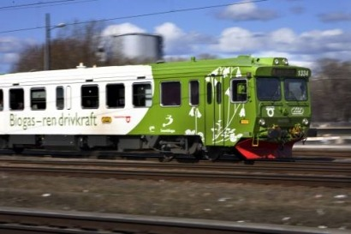
In 2011, Sweden developed “Amanda,” a train that connected the cities of Linkoping and Vastervick (distance of 80 km) and ran solely on biogas. The train used the RNG that originated from a nearby abattoir as engine fuel. Although Amanda was unfortunately discontinued because of an ending contract, the train ran 150,000 km during its 5 years of operation. The train travelled 600 km before needing to be refueled and could reach a maximum speed of 130 km/h.
Figure 4: Image of "Amanda" - a train that ran solely on biogas⁴¹

On-Site Energy Generation

On-site electricity generation once was an attractive option for biogas projects. The electricity generated from combusting biogas has been and can be used to power on-site facility operations, and any excess can be sold to the electrical grid through California’s Bioenergy Market Adjustment Tariff. This electricity can provide baseload power, meaning it can provide a continuous supply of electricity, and dispatchable generation. In other words, its power can be adjusted and used on demand. This makes biogas-derived electricity valuable since it can complement and compensate for the intermittent production of electricity genreated from solar and wind. The flexibility of biogas allows for more efficient electrical generation. Because the biogas used for electricity does not need to be upgraded to the 98% methane concentration required to inject the biogas into the pipeline, the develoment costs for biogas-production facilities are not nearly as capital intensive as RNG production facilities. For better or worse, the current return on investment , in terms of producers’ ability to monetize environmental credits from policies like California’s Renewable Portfolio Standard (RPS) is much lower compared to the value of RNG in the transportation fuel market. To be clear, biogas production facilities are distinct from RNG production facilities both in terms of the capital investment required, the upgrading equipment necessary and their end-use applications.

With respect to biogas production facilities, the US EPA’s Landfill Methane Outreach Project (LMOP) reports that as of February 2018, 469 of the estimated 632 (74%) operational LFG energy projects in the United States use biogas to generate electricity. The EPA estimates that LFG projects are outputting 17 billion kWh a year, contributing to 0.5% of US electricity consumption.

Zero Waste Energy Development Company, a sister company of Zanker Recycling, is a facility that utilizes their biogas for on-site electricity. Dry anaerobic digesters capture the biogas that then fuel two 800 kW combustion engines. Through the BioMAT program, a feed-in tariff discussed in the Regulatory Landscape part of this report, Zero Waste is not only able to fuel their own operations but can also sell excess electricity to PG&E through a long term contract.

Wastewater Treatment Plants (WWTPs) commonly partake in onsite generation, leading to both economic and environmental benefits. The plants capitalize off decreased electrical costs and also greatly reduce the amount of biogas that is flared. San Francisco’s Southeast Water Treatment Plant, for example, is able to meet their entire plant’s electrical demand from their own biogas production.

Because many WWTPs already have the infrastructure of anaerobic digesters that can produce biogas and combustion engines, company Anaergia has attempted to combine the digesters of these WWTPs with excess Municipal Solid Waste (MSW) from landfills to dramatically increase the biogas (and consequently electrical) production of the plant. Anaergia takes anaerobic digesters (ADs) at WWTPs and retrofits them, more than doubling their capacity to allow for increased inputs from waste haulers. Through the BioMAT program, these WWTPs can sign up for a contract online and sell this electricity produced from their own biomass to the grid.

By subscribing to a BioMAT contract, facilities generating electricity from biogas can lock in power purchase agreements lasting up to 20 years, ensuring that they receive low-cost electricity for extended periods of time. This works similarly to net metering, allowing distributed renewable energy producers to receive returns on the electricity they generate.

Companies who deliver waste can also save on tipping fees by bringing their diverted organics to WWTPs. While some WWTPs may not be interested in the partnership opportunity because co-digesting within their digesters would decrease the profits they could earn off RINs (Renewable Identification Number - see Regulatory Landscape part of this report) when converting to pipeline RNG, those looking to generate electricity on-site could dramatically increase their biogas production efficiency upon partnering.

Electricity Generation Options

Multiple options exist for converting the biogas to electricity, but internal combustion engines are the most common, used in 75% of LFG-to-electricity projects. For smaller projects, microturbines are used, and for larger projects, gas turbines are often deployed. The gas is combusted and the released heat is used to provide steam that drives a turbine with an efficiency level ranging from about 15% to 27%.

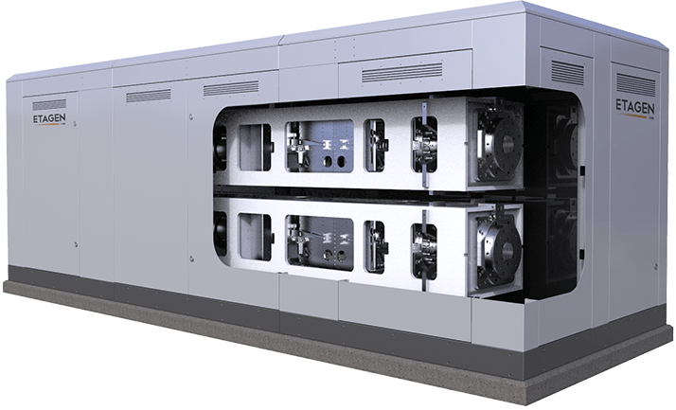
EtaGen, a startup company developing more efficient generator designs, is in the midst of producing a linear generator that provides a number of advantages over conventional generators. EtaGen's 250 kW generators, shown in the figure to the right, will operate at 45-50% efficiency, which is much higher compared to the 30-35% efficiency of current conventional-engine based generators. This is made possible by a longer expansion ratio that achieves a higher efficiency, lower emissions, and lower maintenance costs. In addition to being highly efficient, this linear generator has only two moving parts and uses no oil, so less maintenance is required than for a conventional combustion engine. EtaGen’s generator also produces significantly fewer nitrous oxide emissions than conventional engines due to its adiabatic process that does not require an open flame. Because of all these factors, these engines could be the answer for smaller operations that do not produce enough gas to warrant the installation of traditional, costly electricity generation facilities but still wish to create their own electrical output.
Figure 5: Etagen’s linear generator is efficient and portable

Combined Heat and Power
Combined heat and power (CHP) engines operate by capturing and utilizing the heat that is generated during electricity production and using it to heat anaerobic digesters. This recycles the heat and prevents the usage of excess heating that would be required for an optimal temperature for the digester. CHP engines drastically increase the efficiency of the operations, combining two processes that operate in the same facility to greatly conserve energy. CHP has been shown to run at the highest efficiencies among engines, increasing the overall efficiency of the operation up to 40%. Excess heat from CHP can also be used after heating the AD to dry biosolids and convert them to fertilizer.

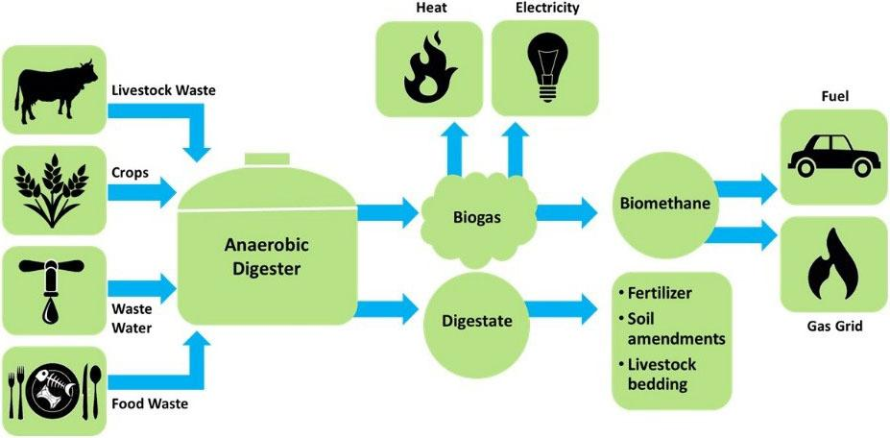
Figure 6:Waste to Energy Conversion Process

Industrial Feedstock/Other

Plastics

Other than transportation fuel and electricity generation, biomethane can also be used for the creation of biodegradable plastics. Methane-sourced polymers have shown promise in gradually replacing conventional petroleum-based plastics, and these biopolymers may soon receive their own recycling number which will allow them to be classified as organic waste and placed in compost bins. The primary advantage of biopolymers coming from waste biomethane is that they are biodegradable, meaning that even if they do end up in the ocean, they will be naturally degraded by microorganisms living in the water.

Mango Materials is a company that uses waste biomethane from the Silicon Valley Clean Water (SVCW) wastewater treatment plant and creates biopolymers. They use these bio-polymers to produce a range of biodegradable products, from plastic cases for cosmetics to biofibers for clothing. 60% of all clothing being made today contains petroleum-based polyester, and only 17% of clothing is recyclable. Finding ways to replace conventional polyester with biofibers increases the amount of clothing that could be recycled and reduces dependence on petroleum in the clothing industry. Legislation supporting the use of these materials is in the making. When these biodegradable materials are no longer used and end up in a waste facility, they produce biomethane themselves which can then be used for the production of more bio-polymers, creating a net-zero carbon cycle. Methanotrophic bacteria used in this process are also capable of converting biogas to PHB, a kind of polyester, in varying ratios, reducing the need for strict biogas filtering systems.

Food for Fungi

Much research is currently being done surrounding uses for the organic waste material itself. Stanford researcher Philip Ross has discovered that mycelium, the vegetative part of a fungi, can have a wide array of purposes. The fungi use natural fibers, like those found in the yard waste or sawdust of organic waste, to grow into the shapes they are molded into. These fungi can break down cellulosic materials like wood that are more difficult to anaerobically digest. Dubbed by Dr. Ross as “mycelium bricks,” the fungi are proven to be fire resistant, stronger than concrete pound for pound, and water and mold resistant. Ross has co-founded MycoWorks, a company that uses mycelium to manufacture synthetic leather. Yet, leather is not the only option for such a versatile product. Fungi that are fed organic waste could potentially serve as a construction material, a furniture base, or even as a future replacement to single-use plastics.

To summarize, a diagram of the possible uses for biogas is shown below.

Raw Biogas
Partially upgraded
Fully upgraded
Flaring
On site electricity generation
Industrial Uses
ex: Conversion to plastics
Renewable Natural Gas
Pipeline injection
On site use
Figure 7: Flowchart of possible biogas uses

Summary of Obstacles to Broader Biomethane Utilization

Pipeline Injection

Currently, there is no uniform set of requirements for pipeline injection implemented throughout the entire United States. The pipeline injection standards in place today often rely on values that were set years ago, without the use of rigorous scientific studies studying gas composition and its effects within the pipeline. This arbitrary standard inhibits the growth of the RNG industry and is not fully proven to protect California’s pipelines, especially since lower quality gas from out-of-state pipelines with more relaxed standards is often accepted into these pipelines with strict injection standards.

Gas/Common Carrier Pipeline Network in California

California is controlled by 4 main natural gas utility companies: Pacific Gas and Electric (PG&E), Southern California Gas (SoCalGas), San Diego Gas and Electric (SDG&E), and Southwest Gas. The backbone of the interstate pipelines, however, are controlled by PG&E in the north and SoCalGas in the south. Traditionally, the pipelines are composed of rigid steel, though new pipelines are incorporating flexible plastic and corrugated stainless steel. Through the pipeline, the gas flows from a high-pressure main line to low pressure local pipes, and this pressure can be adjusted to allow for storage of the gas during periods of low demand. The gas flows along the backbone until it is delivered into the local transmission where it passes through a gate station upon reaching a local gas utility. The current natural gas distribution system in the United States is composed of 318,000 miles of high volume, high pressure lines feeding into more than 2.2 million miles of the Local Distribution Company (LDC) networks that deliver gas to residential and business customers.

Renewable natural gas, if cleaned appropriately, can be injected into the pipelines in the same manner as the natural gas that is produced from geologic formations. However, the pipeline injection of landfill-derived RNG was illegal for almost 30 years; California Assembly Bill 1900 (AB 1900) legislation sponsored by the Coalition for Renewable Natural Gas (RNG Coalition) and signed into law by Governor Jerry Brown in 2012, lifted that restriction and promulgated updated human healthy and safety, and pipeline safety and integrity requirements. Although the ban was lifted, the gas quality standards that were implemented by California’s Public Utilities Commission (CPUC) – regarding siloxanes and minimum heating value in particular - rendered California as the state with the most stringent standards.

California is unique compared to other states in how the pipelines that run through the state are owned by Local Distribution Companies (LDCs) rather than the transmission companies who own the pipelines elsewhere. Because LDCs in California own both the pipelines and the gas that is physically being transmitted across their networks, they are much more attentive to ensuring safety standards for their customers; this is in comparison to the states where the transmission companies who own the pipelines differ from the utilities who own the gas. This leads to more stringent pipeline injection standards in California where the LDCs are directly selling and transferring the gas to the consumers.

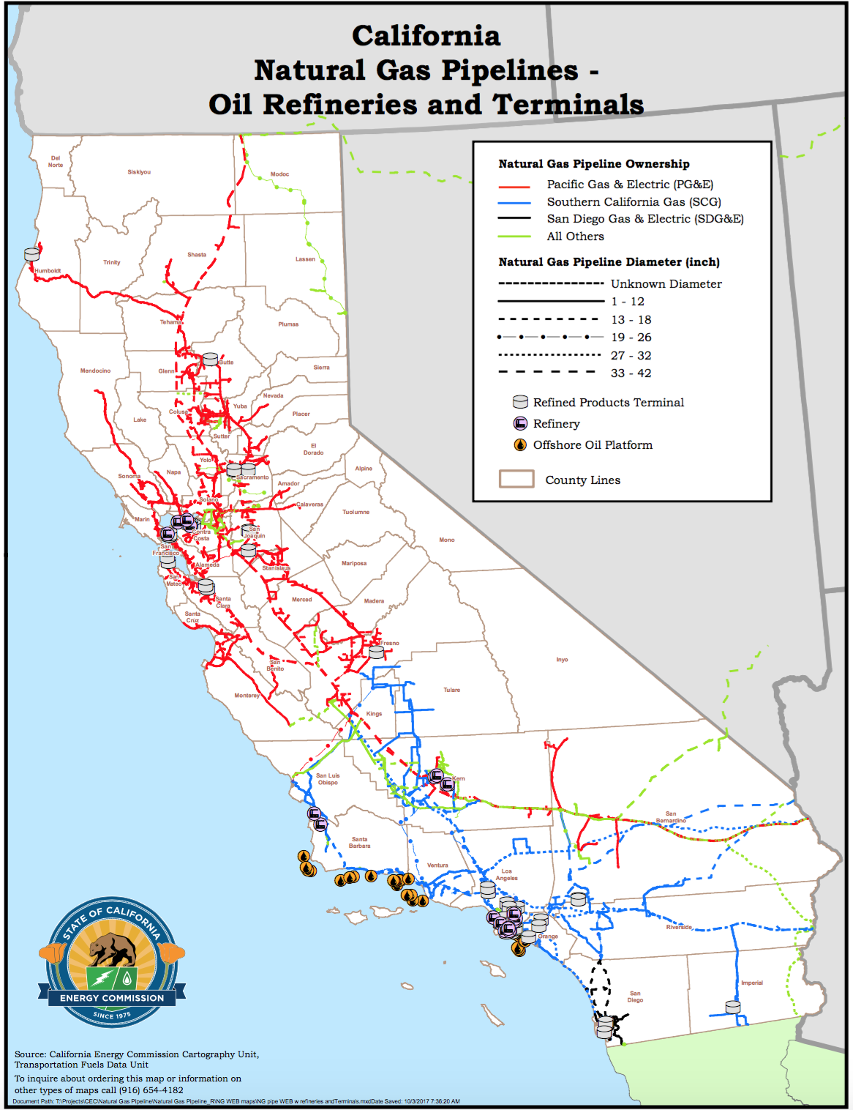
Figure 8: Natural Gas Pipelines in California and the Utilities Who Own Them

Gas Quality Standard Requirements

Natural gas pipeline utility companies impose very stringent requirements on the quality of gas that can be injected into their pipelines. Such requirements are designed to protect the well-being of their equipment as well as minimize safety hazards for the their customers and the general public. Two forms of monitoring are in place to ensure compliance. First, at the point of utility interconnection, carbon dioxide, total inerts, and heating value are continuously monitored and recorded. Second, although technology is not yet available for continuous check of other particulates, quarterly or annual gas sampling takes place in a laboratory to ensure appropriate values of certain particulates, such as siloxane.

In California specifically, AB1900 required the CPUC to adopt rules allowing pipeline injection in California as well as human health and safety, and pipeline safety and integrity standards for injection of biomethane into the common carrier pipelines. The bill also requires that the safety requirements of the gas constituents be reexamined every 5 years. In 2014, with recommendations made by stakeholders alongside the California Air Resources Board and the Office of Environmental Health Hazard Assessment, the CPUC set the requirements for pipeline injection within California, and in 2015, the CPUC decided that the gas producers should bear the full cost associated with the processing and pipeline injection of biomethane.

One of the biggest challenges to pipeline injection is the incongruence between public policies and regulation across different states and provinces. The history behind the natural gas industry, the politics within the industry, and the distinct climates in different regions have greatly contributed to these often conflicting policies that require more stringent gas quality in certain regions than in others. SoCalGas has the strictest regulations across the country for individuals who wish to directly inject within their perimeter. This has caused pipeline injection within Southern California to be delayed in comparison to the rest of the country; it was not until July of 2018 that the waste management company (CR&R) was able to interconnect renewable natural gas produced within the State into the SoCalGas pipeline system. Yet, the same system accepts RNG that was produced out-of-State and introduced onto the system with les stringent pipeline access requirements.

Interconnection Process

To connect an RNG or biomethane production facility to PG&E’s pipeline network, the following three-step process must be completed:

Step 1: Over the course of about three weeks, the utility conducts an initial feasibility study which, given the supply source, location and volume of the production source in question, informs the biomethane producer of the nearest pipeline location capable of accepting their supply.

Step 2: A team of engineers and project planners review the safest and most efficient route to the connection and develop a cost estimate for interconnection.

Step 3: The construction phase materializes the interconnection. This final phase usually lasts from one to two years and costs between $2m and $5m. Variations in costs depend on factors like project scope and location, including special considerations for environmentally sensitive areas, railway or major road crossings, and more.

However, connecting to the pipeline is an arduous process. In fact, there are a number of different factors that could become obstacles to the interconnection process. The four factors most likely to become obstacles for interconnection are the following:

Location of the Plant | Further distances from the pipeline network may increase interconnection costs prohibitively and make the permitting process arduous.
Nearby Pipeline Capacity | If the pipeline closest to the biomethane-producing plant is already near or at capacity, it will not be able to accept more biomethane.
Gas Pressure at the Site of Injection | Injected biomethane needs to match the pressure of the gas currently in the pipeline.
Customer Demand Near Site of Injection | According to the PG&E requirements, there must be “adequate and stable” demand on the gas pipeline for it to accept any biomethane supply. This particular requirement is often hard to fulfill, especially given that many biomethane-producing plants are located on dairy farms, in rural areas. One of the suggested solutions to overcome this obstacle is trucking biomethane, a solution which will be discussed within Problem Area 2 of this report.
Table 4: Specifications to Pipeline Injection of RNG of Differing Utilities
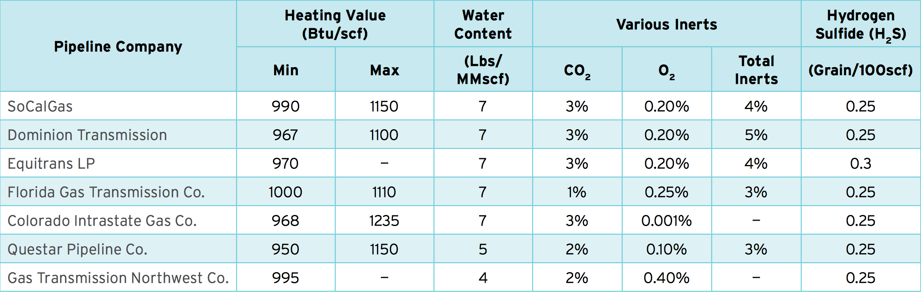

Two of the biomethane gas quality standards that are often given the most emphasis before pipeline injection are (i) the level of siloxanes within the biomethane and (ii) the minimum heating value of the biomethane.

Siloxanes

Siloxanes are present in personal hygiene products such as deodorants and shampoos. As such, when disposed into a landfill or processed by a wastewater treatment plant, biomethane derived from these feedstocks often contain a measure of siloxanes. Siloxanes concern California natural gas utility companies, because when combusted, aa layer of silica (waxy, residue) can coat end-use equipment (stoves and water heater burner-tips, etc.), resulting in the need for increased maintenance, repair or replacement. At uncontrolled levels, siloxanes can cause expensive catalysts to fail or destroy expensive equipment for transporting the gas primarily owned by utilities; such risks have led California-based utility companies to establish stringent siloxane requirements for the pipeline injection of biomethane. The CPUC has established the maximum value for siloxanes at 0.1 mg Si/m³ of biomethane, the most stringent requirement across the country.

Minimum Heating Values

Higher-chain hydrocarbons give a gas its heating value. The heating value of a fuel is defined as the amount of heat produced by the complete combustion of the given fuel. In terms of biogas, the higher the heating value of the gas, the more methane that is present in its composition. Because biogas lacks the higher-chain hydrocarbons present in conventional natural gas, it has to be blended with other fuels (like propane, or natural gas) that posess the missing higher-chain hydrocarbons. Utility companies have put in place stringent minimum heating values for RNG as a prerequisite for pipeline injection, claiming a higher heating value is necessary to ensure the safety of the equipment. The CPUC established regulations in 2006 for minimum heating values of gas injected into the pipeline. “Rule 30” requires gas entering the pipelines of SoCalGas and SDG&E to have a heating value of at least 990 BTU/scf. “Rule 21” requires gas injected into PG&E’s pipelines to have a heating value that meets the standards established by PG&E at each receipt point. These rules were upheld in 2014 after the CPUC stated there wasn’t enough evidence to determine that relaxing the standard would have a negligible effect on end-users.

The RNG Coalition sponsored legislation in 2016 (AB 2773, Quirk) that would have directly addressed industry concerns as it relates to appropriate siloxane levels and minimum heating value requirements, but withdrew the bill at the Governor’s request – and instead supported Senate Bill 840 (SB 840). Among other things, SB 840 aauthorized the CPUC to enter into a contract with the California Council on Science and Technology (CCST) to reasses the pipeline requirements for biomethane, focusing specifically on siloxane standards and minimum heating value.

CCST completed and published the commissioned report in June of 2018 to assess these siloxane and minimum heating value restrictions. The study found that relaxing the minimum heating value to 970 BTU/scf, the most common value for gas pipelines in the US, would be unlikely to impact safety or equipment reliability, and it recommended opening regulatory proceedings examining the option of allowing biomethane with a heating value of at least 970 BTU/scf into the pipeline provided it satisfies all other specifications. Enacting this change could substantially reduce the costs of upgrading biogas to pipeline-quality RNG for all producers of biogas, despite large variability in upgrading costs among biogas sources.

Regarding siloxanes, the report found that the current California standard is based on very little data and broad extrapolation from that data. The study recommends California conduct comprehensive research to understand the operational, health, and safety consequences of various levels of siloxanes in biomethane and come up with a standardized protocol for reliably measuring siloxanes. In addition, the report recommends a reduced and simplified verification process for biomethane sources that are highly unlikely to contain siloxanes, like ADs processing dairy manure, source-separated organic waste, and agricultural waste.

A study recently conducted in the United Kingdom and published in Renewable Energy in July of 2018 tested 7 domestic appliances to examine the effect siloxanes would have on their performance over a 15-year lifetime. Through their tests, they concluded a siloxane specification of 0.23 mg Si/m³ would maintain thermal input at 90% of its maximum for boilers running solely on biomethane for 15 years. To keep carbon monoxide (CO) emissions within public safety levels, a siloxane specification of 0.44 mg Si/m³ could be used, and to prevent the flame safety device from failing, a specification of 0.45 mg Si/m³ would be effective. However, these maximums assume that the equipment would be running solely on biomethane for its entire 15-year lifetime, which is a highly unlikely scenario given the amounts of fossil natural gas in California pipelines. Conducting further research to determine an acceptable maximum siloxane specification given the expected values for biomethane blending could ensure equipment reliability and protect public safety while allowing biomethane producers to reasonably attain the level.

The Regulatory Landscape Surrounding RNG

The Renewable Fuel Standard (RFS)

Created under the federal Energy Policy Act in 2005, the RFS is a federal policy that requires use of a certain amount of renewable fuel to reduce or replace the quantity of petroleum-based transportation fuel, heating oil, and jet fuel. The policy aims to increase the volume of renewable fuels blended with fossil fuels for transportation to 36 billion gallons in 2022. For reference, approximately 10 billion gallons of renewable fuels were blended in 2008. The RFS operates by placing Renewable Volume Obligations (RVOs) on oil refiners and gasoline and diesel importers, requiring them to directly sell their required biofuel volumes or purchase biofuels from parties that exceed their renewable obligations.

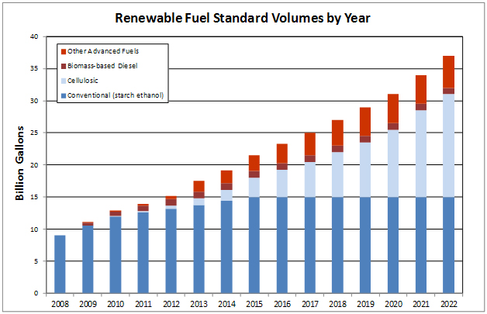
Figure 9: The target projections set by the EPA on the number of gallons that should be blended into petroleum-based fuels

RINs and RVOs

The United State Environmental Protection Agency (EPA) monitors and establishes the volume obligations through an annual rule-making process, which effectively sets the market demand for rseveral categories of renewable fuels. Each ethanol gallon equivalent (EGE) of renewable fuel generates a Renewable Identification Number (RIN). A RIN - a 38-digit number – is the environmental credit that obligated parties retain to serve as proof that their renewable volume requirements have been met, either through fuel production or the purchase of credits. If a company integrates more renewable fuels than mandated, it can monetize RINS by selling them in a free market system (RFS market) to another company who failed to meet the requirements.

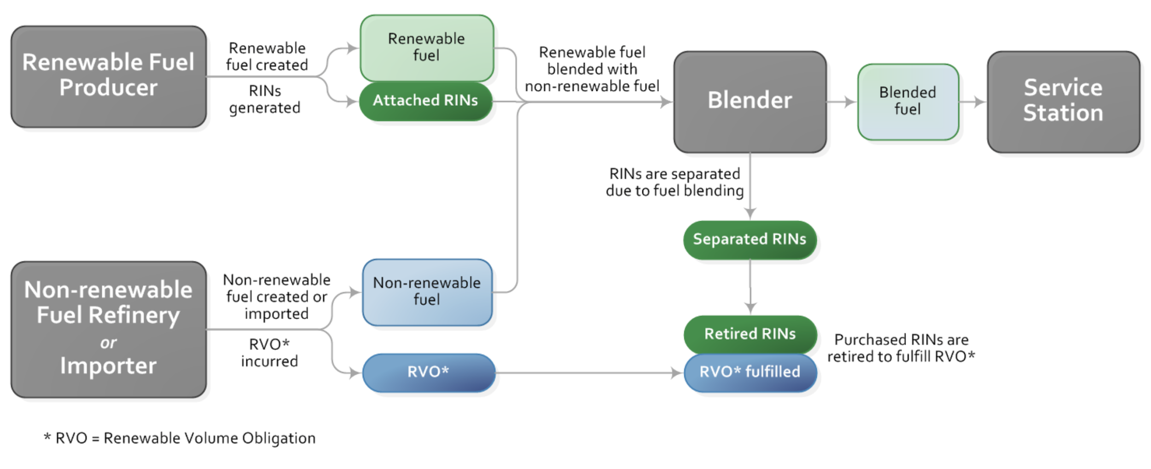
Figure 10: An example of the lifecycle of a RIN as it progresses through obligated parties

The renewable obligations required are divided into 4 major categories; parties must fulfill minimum renewable volume obligations for each distinct category. These categories build upon each other, meaning that if a fuel fulfills the standards of one of the most specific of the categories, it can be applied to fulfill the quota of a broader category. The categories (D3, D4, D5, D6) segregate themselves based off the initial source of the fuel, referred to as the feedstock in the transportation industry, and the percent of greenhouse gas reductions the renewable fuel would achieve by displacing the gasoline or diesel baseline.

Total Renewable Fuel (D6)
Must achieve a 20% GHG reduction from gasoline or diesel baseline
Example: corn ethanol

Advanced Biofuel (D5)
Must achieve a 50% GHG reduction from the gasoline or diesel baseline
Example: sugarcane ethanol

Cellulosic Biofuel (D3)
Must achieve a 60% GHG reduction from the gasoline or diesel baseline
Example: biogas

Biomass-based Diesel (D4)
Must achieve a 50% GHG reduction from the diesel baseline
Example: biodiesel

Figure 11: RVO categories and requirements under the Renewable Fuel Standard

Every year, the EPA sets forth new RVOs, or new volume quotas that parties must fulfill under each category. The specific quotas will also innately determine the prices of RINs on the open market, based on supply and demand. A larger need for a specific type of renewable fuel will increase the demand and consequently the price entities are willing to pay for a RIN. Because RIN volumes are set each year by the EPA and cannot be perfectly predicted, those wishing to invest in RINs face significant uncertainty. Nonetheless, the successful effort by the RNG Coalition which led to EPA’s 2014 re-classification of renewable natural gas as eligible to generate D3 or Cellulosic Biofuel RINs makes RNG extremely sought after by obligated partiesl.

The price of RINs has dramatically risen in recent years, especially in the Cellulosic Biofuel (D3) category because of the relatively small supply compared to the great demand. Fuels from cellulosic feedstocks are also prioritized because cellulosic materials are inedible and do not produce biogas as readily as other types of organic waste. In fact, cellulosic biofuel production has continuously fallen short of meeting federal blending targets; in late 2016, the U.S. Government Accountability Office reported that the RFS targets were “unlikely to be met.” Prior to 2014, D3 RIN generation was at such a low that in July of 2014, the EPA announced that cellulosic biofuel used as transportation fuel could earn D3 RINs. Included in this addition was renewable natural gas, largely incentivizing the growth of the RNG industry. In July of 2014, 4,000 D3 RINs were recorded. In August of 2014 after the EPA’s reclassification, the quantity of D3 RINs skyrocketed to 3.49 million RINs. September of that year yielded 7.56 million D3 RINs, amounting to 33.02 million total D3 RINs for 2014. According to the RNG Coalition, RNG production for transportation fuel purposes has increased ten-fold since 2013. In 2011, nearly 100% of all RNG produced in North America was used to generate reneawble electricity. Today, nearly 80% of all RNG produced in the US and Canada is being used as an ultra low-carbon transportation fuel- driven principally by the RFS, and in part, by California’s LCFS.

In 2018, the average price of a D3 cellulosic RIN is $2.25, and this RIN price is multiplied by a factor of 11.727 per MMBtu of RNG. This raises the value of RNG to an average of $26.33 per MMBtu produced. By comparison, an MMBTU of RNG may only command a value of $7-$10 in the power market. Such large economic incentives created by the RFS have enabled producers to absorb the high cost of upgrading biogas to RNG, interconnecting their production facilities with and transporting their RNG via common carrier pipelines for transportation fuel end- use. The same environmental programs and incentives have also provided environmental and economic motivation for diesel transportation fleet owners – public and private - to convert to natural gas vehicles fueled by RNG.

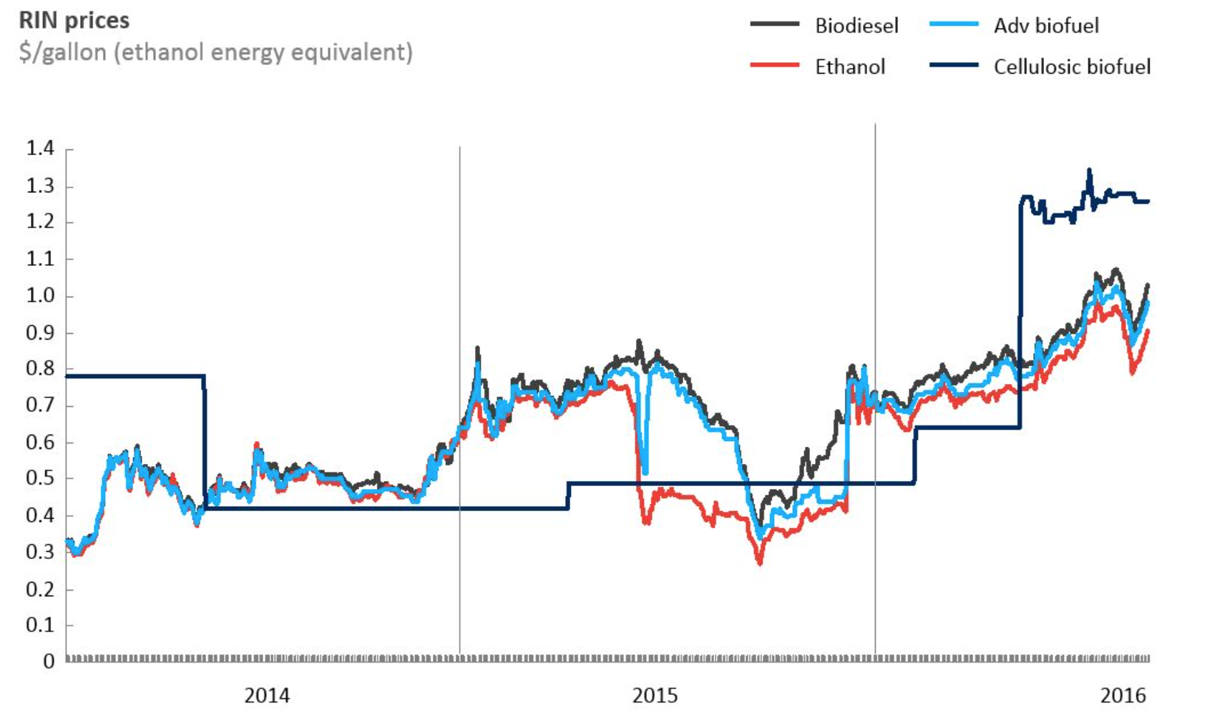
Figure 12: The Price of RINs from 2014 to 2016

Table 5: The proposed renewable volume requirements set by the EPA in billion gallons
 | 2018 | Proposed for 2019 | Proposed for 2020
Cellulosic biofuel | 0.288 | 0.381 | N/A
Biomass-based Diesel | 2.1 | 2.1 | 2.43
Advanced Biofuel | 4.29 | 4.88 | N/A
Total Renewable Fuel | 19.29 | 19.88 | N/A

The “eRIN” Pathway

Currently, the only way for dairies, WWTPs, and landfills to take advantage of D3 cellulosic RINs is to upgrade their biogas to renewable natural gas and deploy it as a dedicated fuel for CNG or LNG vehicles. This can be done by either fueling a vehicle on-site with RNG or injecting the RNG into a natural gas pipeline and transporting the product to a customer for a contracted end-use as transportation fuel. In 2014, the RFS program authorized an eRIN patheway – an opportunity for RINs to be generated when EVs are charged with electricity derived from renewable biomass, including biomethane., To date, EPA has not approved any applications to begin generating eRINs. Because infrastructure already exists for biogas-derived electricity (e.g. 75% of all non-RNG, landfill gas to energy projects generate electricity), an eRIN pathway may further incentivize biogas producers to generate electricity and significantly reduce how much biogas is wasted through flaring.

According to a report analyzing some of EPA’s proposed updates to the RFS, two of the main issues plaguing the eRIN pathway are deciding which of the many related parties should be awarded RINs and avoiding giving more than one RIN to different parties for the same unit of electricity. The EPA has considered giving RINs to EV drivers, EV manufacturers, EV charging station operators, and the facilities that produce the renewable electricity. The EPA should prioritize working with the industry to solve these issues in the eRIN pathway so that waste-to-energy facilities can generate RINs in more ways than solely upgrading biogas to RNG for transportation fuel. They can look to existing RNG pipeline injection pathways and renewable energy certificate programs as models that have overcome similar issues.

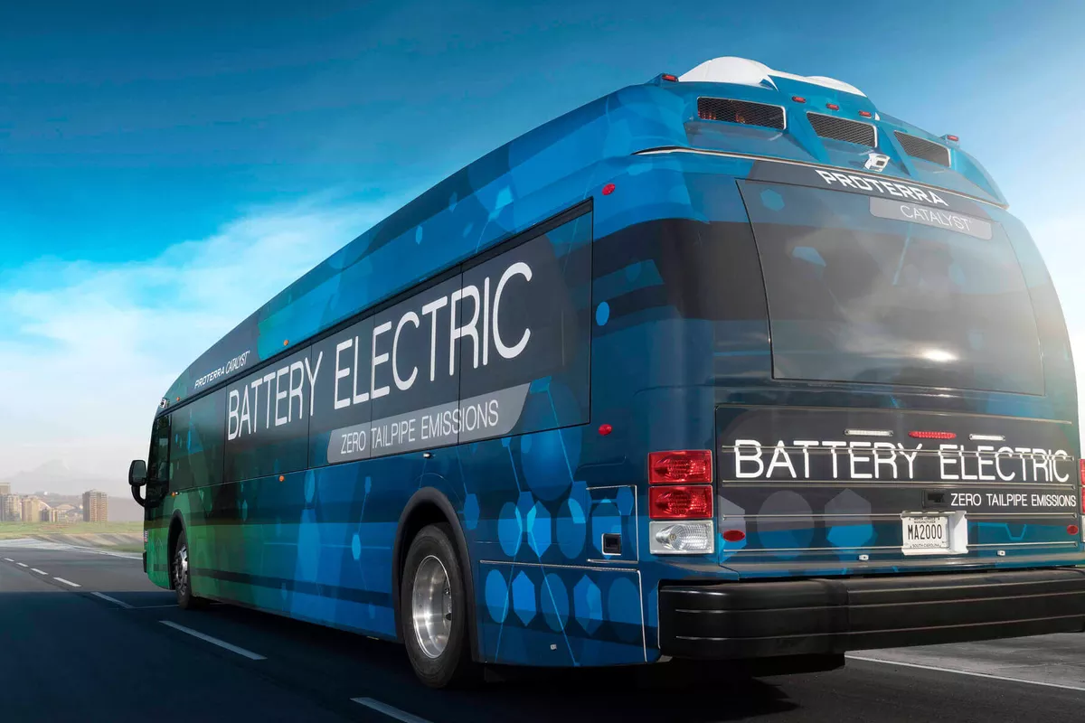
Many RIN pathways have been made possible by RNG producers signing contracts with owners of CNG truck fleets. The RNG producer will make the RNG, sell this RNG to a CNG truck fleet at a lower-than-market rate, and still make substantial profits through RIN generation. The eRIN pathway is ripe with opportunities similar to this; there are many landfills and WWTPs selling excess biogas electricity to the grid at the rate set by the Bioenergy Market Adjust Tariff (see California Senate Bill 1122), and the number of electric bus fleets in California is increasing. If an eRIN pathway is created, biogas producers will invest more into gas capture and electricity production, while existing fleets will invest more in diesel-to-electric bus conversion. Shown to the right is a graphic of an electric bus from Proterra, an electric bus manufacturer.
Figure 13: A depiction of an electric bus made by Proterra

While the EPA is developing a viable eRIN pathway, they should also consider varying the amount of energy it takes to generate one RIN depending on which fuel pathway is used. Currently, one RIN is awarded for each ethanol gallon equivalent of energy that enters a vehicle. This means one RIN is generated when you put 77,000 BTU of CNG or 22.6 kWh of electricity into a vehicle. While this is a simple way to include different fuel types, it fails to reward based on the end goal for any transportation fuel: vehicle miles traveled. The following figure comes from a study conducted by the National Renewable Energy Laboratory (NREL). It shows how far a passenger vehicle could travel with one MMBtu of natural gas using three different technologies: combustion, fuel cell electricity, and plug-in electricity. The percentages show how much energy is conserved from the previous step, while the dotted lines around the percentages highlight key loss steps.

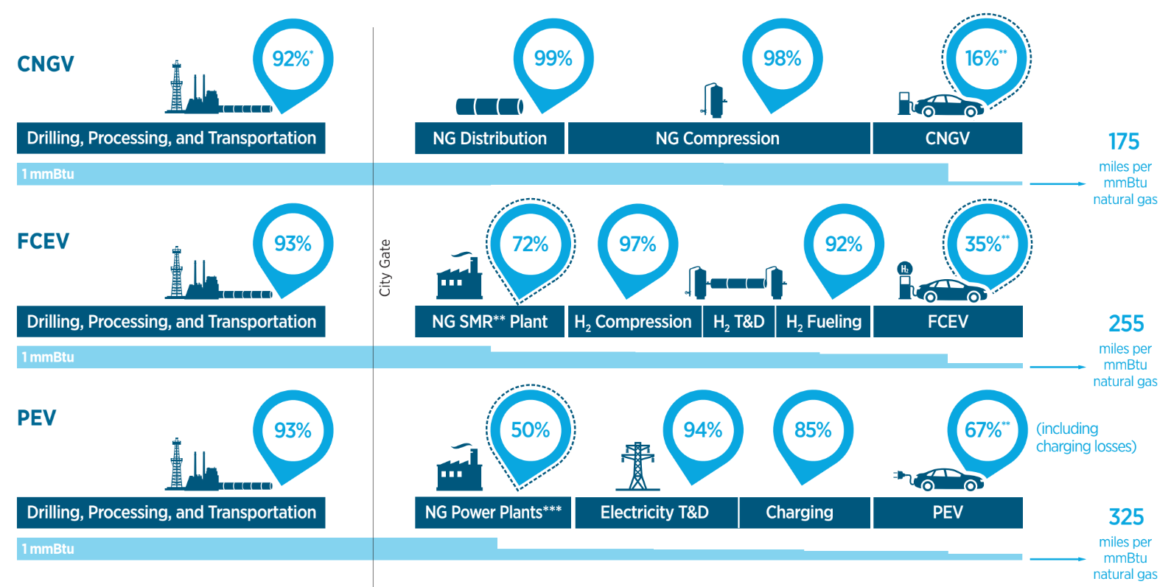
Figure 14: A Well-to-Wheels Comparison of 3 Technologies That Use Natural Gas to Power Vehicles
The three technologies convert natural gas into vehicle miles through very different means, creating variations in fuel efficiencies. This example shows that for the same amount of natural gas to begin with, a plug-in electric vehicle (PEV) will go almost twice as far as the CNG vehicle. These results will vary based on the exact assumptions and on technological developments in efficiency, but electric drive trains have a clear efficiency advantage over internal combustion engines, even though a large amount of energy is lost during electricity production and transmission.

When examining total life cycle greenhouse gas emissions for different vehicle types, the following figure shows that biomethane generates the lowest CO₂e emissions when used to produce electricity for battery electric vehicles. This advantage should be reflected in the RFS so that electricity generation is justly incentivized.
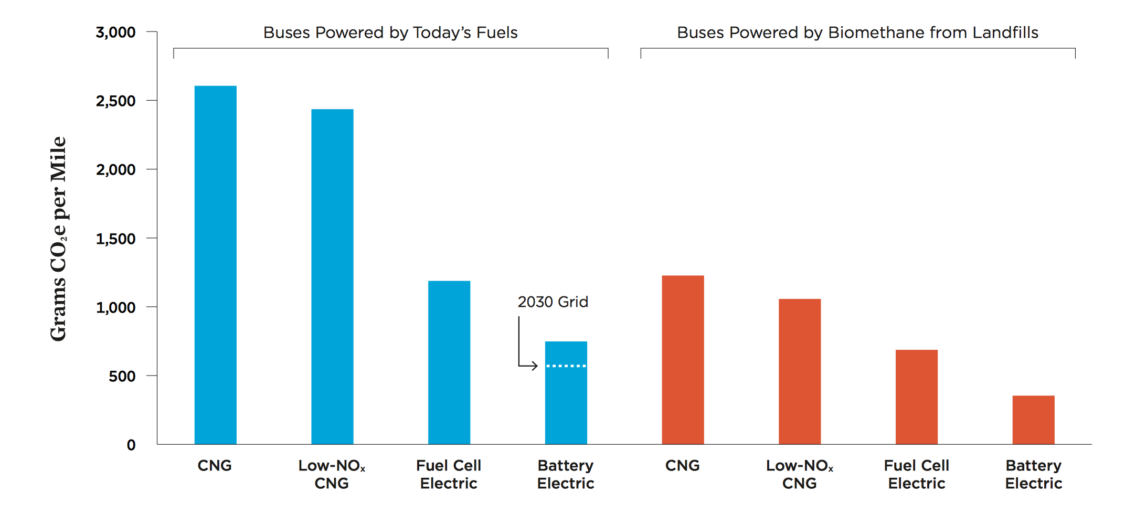
Figure 15: Total GHG Emissions for Buses Powered Through Different Energy Sources. Retrieved from The Union of Concerned Scientists

Ultimately, biomass should not be prioritized over RNG production. Rather, alternate incentives for biomass electricity should be considered without disincentivizing the production of RNG, or undermining the tens of millions of dollars that have already been invested in operating RNG production facilities. Both technologies have significant environmental and social benefits over fossil fuel use; therefore, both should be encouraged.

Low Carbon Fuel Standard (LCFS)

Promulgated by Assembly Bill 32 (2006) and extended by Senate Bill 32 (2016), the Low Carbon Fuel Standard is administered by the California Air Resources Board (CARB) with a goal of reducing the carbon intensity of transportation fuel in-State by 10% by 2020 as compared to 2010. Producers of RNG who interconnect with and transport their product via common carrier pipelines to transportation customers in California may benefit from both RFS’ RINs and LCFS carbon credits. In a fashion similar to the RFS, petroleum refiners, importers, or wholesalers can either develop their own low carbon fuels or buy LCFS carbon credits from those who are producing and selling the fuels. The LCFS defines carbon intensity (CI) as the overall GHG emissions associated with a fuel per unit of transportation energy delivered. Fuels that have lower emissions generate credits while those with higher emissions create deficits; a producer with deficits must then buy credits from the free market in order to stay within compliance. The number of credits generated for a given fuel is proportional to how low the fuel’s CI is. The following diagram shows the carbon intensities for certified pathways in the LCFS.

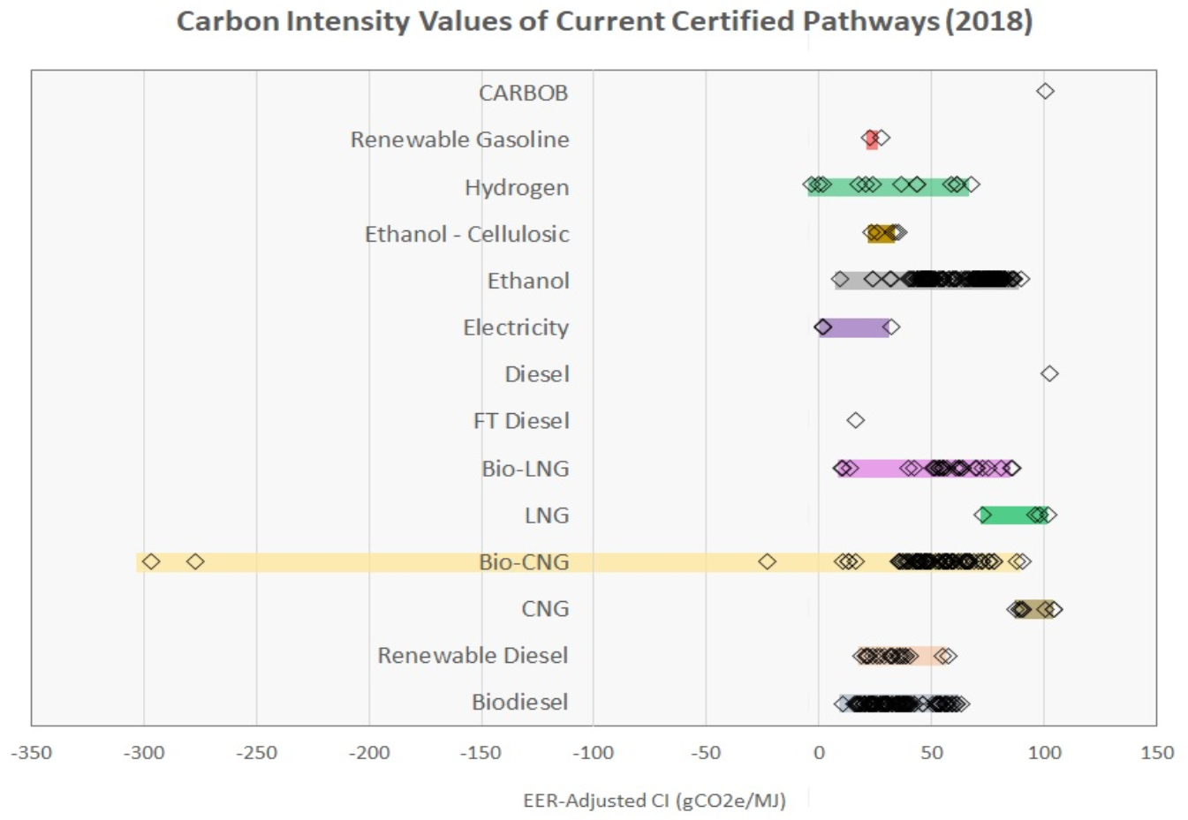
Figure 16: Carbon Intensity Values of Certified Pathways within the LCFS (2018)

RNG qualifies for LCFS credits, specifically through 3 main pathways: (1) produced and used onsite for natural gas-fueled vehicles, (2) injected into the natural gas pipeline for use as a feedstock to produce vehicle fuel, or (3) provided directly to a facility that produces transportation fuel.

In order to benefit from LCFS credits, alternative fuel producers can opt into the program as a Regulated Party (RP). From here, the production of the fuel is tracked through the LCFS Reporting Tool, where these credits can then be transferred or used; the credits are ultimately retired when they are used to cover deficits per the annual obligated compliance reports. These credits do not expire and can consequently constantly be traded or held onto for future use by a company who may have overproduced renewable fuels for the year. Apart from a steep decline in the summer of 2016 over rumors of the LCFS’s future, credit prices have remained fairly stable, hovering at an approximate $100/MT. The value of the LCFS credits generated in the past two years has reached $1 billion per year. Because the LCFS does not operate on requirements of distinct fuel categories, ethanol is currently the greatest single contributor to the LCFS fuel pool.

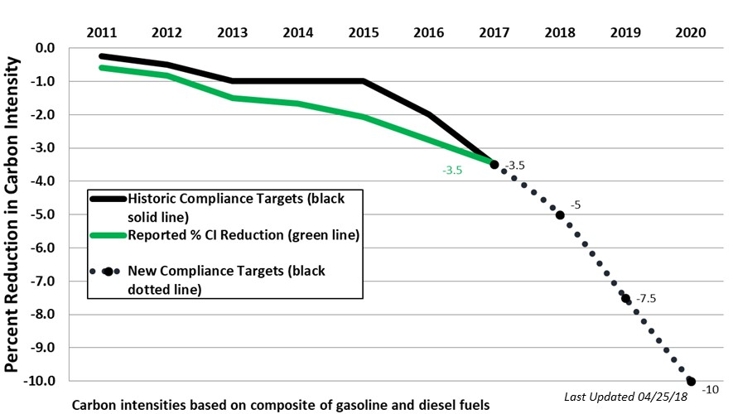
Figure 17: Performance of the Low Carbon Fuel Standard from 2011 to 2017

California Senate Bill 1122

California Senate Bill 1122 (SB 1122) launched the Bioenergy Marketing Adjusting Tariff (BioMAT), also known as the Bioenergy Feed-In Tariff Program. This bill was signed into law by California’s governor in 2012, and it began implementation in 2015 once investor-owned utilities (IOUs) started accepting applications. BioMAT offers renewable bioenergy (biogas and biomass) generators with up to 5 MW in nameplate capacity the ability to sell their electricity at standardized rates to the state’s three largest IOUs: Pacific Gas & Electric, Southern California Edison, and San Diego Gas & Electric, who comprise 75% of California’s electricity supply., California’s amendment to SB 1122, AB 1923, passed on August 28, 2017 states renewable bioenergy generators may not deliver more than 3 MW to the grid at any one time. In addition, the amendment requires the 3 major IOUs to collectively procure 250 MW of renewable bioenergy from these 3 categories:
- Category 1: 110 MW from biogas from WWTP, municipal organic waste diversion, food processing, and co-digestion
- Category 2: 90 MW from dairy farms and other agricultural bioenergy
- Category 3: 50 MW from bioenergy using byproducts of sustainable forest management, including fuels from high hazard zones (as in bioenergy from wood)

Using the BioMAT program, entities like landfills, WWTPs, and dairies can sell excess electricity produced from the biogas they collect at standardized rates through a power purchase agreement (PPA). However, this is a market distortion, and it is paid whether or not the electricity is used. The BioMAT program has contributed to the growth of bioenergy in California; in 2017, 3% of the state’s electricity was produced from bioenergy.

Rural Energy for America Project

The Rural Energy for America Project (REAP), created in 2008, provides loans and grants to agricultural producers and rural small businesses for renewable energy and energy efficiency projects. This funding can be used to purchase, install, and construct renewable energy systems and improve energy efficiency in non-residential buildings and facilities. Costs of energy audits and renewable energy development assistance can also be covered. Grants can range from $2,500 to $500,000 for renewable energy systems and $1,500 to $250,000 for energy efficiency improvements. Loans can range from $5,000 to $25 million. For the 2018 financial year, $600 million in loans and grants have been awarded. More information regarding specifications and eligibility for this grant can be found at the US Department of Energy (DOE) website and the USDA website.

Problem Area 1: Organics Diversion from Landfills

California Senate Bill 1383

California’s Senate Bill 1383 (SB 1383) has been the driving force behind many of the efforts to mitigate methane emissions and replace conventional natural gas with renewable natural gas. SB 1383 was signed in September 2016 by Governor Brown codifying the State’s Short-Lived Climate Pollutant Reductions Strategy being administered by the Air Resources Board (ARB) and California’s Department of Resources, Recycling and Recovery (CalRecycle). SB 1383 aims to reduce statewide emissions of methane by 40%, hydrofluorocarbon gases by 40%, and anthropogenic black carbon by 50% below 2013 levels by 2030. It furthermore established targets to achieve a 50% reduction in the level of the statewide disposal of organic waste from the 2014 level by 2020, and a 75% reduction by 2025. Such aggressive reductions in a period of time spanning only 17 years have been considered unrealistic by many; they do, however, bear witness to the state’s commitment to realize a significant reduction of GHG emissions and to divert organic waste from landfills. The regulatory framework provided by CalRecycle provides requirements and recommendations needed in order to achieve the goals outlined above, including requirements to recover at least 20% of edible food that is currently disposed of by 2025.

The connection between SB 1383 and biomethane is two-fold. First, methane emissions from the decomposition of organic waste in landfills are a significant source of GHG emissions, which the bill looks to reduce. If capturing landfill gas (methane) and upgrading it to RNG instead of allowing it to escape into the atmosphere became a common, statewide practice, the GHG emissions from landfills would be significantly reduced. Second, one of the most significant goals set by SB 1383 is the diversion of organics from landfills. As explained above, the anaerobic digestion of diverted organics can be a large source of RNG. Therefore, it becomes clear that the production and use of RNG could be a significant pathway toward the completion of SB 1383’s goals.

In California, 22% of methane emissions come from landfills, all of which result from the anaerobic digestion of organic materials in our renewable waste streams. If landfills did not have organic waste in them, they would not produce much methane,if any. This is the reasoning behind SB 1383’s organic waste diversion from landfill targets of 50% by 2020 and 75% by 2025.

There are many options for what to do with organic waste besides dumping it in landfills, but the two sustainable alternatives are (i) anaerobic digestion in digesters to capture all the gas and produce electricity or transportation fuel, or (ii) compost. There are pros and cons for each alternative that depend largely on the unique circumstances of the area in question, the volume of waste in place, and desired end-use, so a mix of both of these processes will likely be necessary to accommodate all of this diverted organic waste and achieve the State’s goals.

What Happens to Waste Now?

Waste is classified into three major categories by the EPA: municipal solid waste (MSW), industrial waste, and hazardous waste. Municipal solid waste is generated by households, and industrial waste is generated by businesses, like restaurants, and construction and demolition (C&D). These two categories of waste are typically dealt with separately, but waste management organizations and companies may combine them into a single service. Finally, hazardous waste is defined as waste that is potentially harmful to human health or the environment; common examples of hazardous waste can include paint, batteries, electronic appliances, solvents, cleaning agents, and pesticides.

Sorting Waste With Bins

Americans generate approximately 4.5 pounds of waste per day per person. In California, this household waste is usually collected through a 2-bin or 3-bin system. In a 2-bin system, waste is sorted by the consumer to be either recycled or landfilled. In a 3-bin system, like in San Francisco, there is an additional bin for compostable materials, like leftover food and yard waste. Using a 3-bin system, San Francisco diverts 80% of its waste from landfills, which is well above New York City’s 20% diversion rate and Chicago’s 10% diversion rate. Some businesses, like Peninsula Sanitary Service on Stanford University’s campus, deploy a 4-bin system. In this system, there are 2 bins designated for recyclables: one for mixed paper products, and one for other recyclable materials. This 4-bin system improves mixed paper recycling, since the paper does not get contaminated by foods, liquids, and oils from plastic, metal, and glass containers.

Waste Collection

The waste from each of these bins is typically collected by separate trucks that bring the waste to transfer stations. The different types of waste will then be loaded onto larger trucks before being brought to a materials recovery facility (MRF) or a landfill. In some instances, the transfer station and recycling center are combined, like with the South Coast Recycling & Transfer Station.

Recyclables and Waste Designated for Landfill

Recyclable material is usually brought to a “clean” MRF that accepts and sorts waste that has been designated for recycling. Most commonly, these are single-stream facilities which sort all recyclables and typically take waste that is source-separated into two streams: one with mixed paper and cardboard, and another with plastics, metals, and glass. These materials are sorted and cleaned, then compacted and sold. Some facilities directly sell the materials to manufacturers, while others sell them to places like paper mills to be processed and reproduced.

Depending on the area, waste designated for landfill may be taken to a “dirty” MRF, where they will sort the waste by aspects like weight and material and try to recover as much recyclable material as possible. Otherwise, the landfill waste will simply be compacted and brought to a landfill to be buried underground.

Most household waste in California is taken to a materials recovery facility before it is landfilled. However, not all entities sort waste that has been put in the landfill bin, especially those that have systems for separating waste at the source. For example, CR&R Environmental Services, who serves over 3 million people in southern California, takes recyclables directly to a MRF and waste in the landfill bin to a landfill.

Organic Waste

In many parts of California, organic waste is not separated from landfill waste, but the resulting biogas is collected after the organic waste has been landfilled. Some cities, like San Francisco, deploy a source-separated composting program where special bins collect organic waste and deliver it to nearby composting facilities.

For edible food, food rescue programs are often a solution for uneaten food. Many programs match uneaten food to consumers like food shelters and event planners. And, while CalRecycle does not currently count these food transfers towards the organics diversion requirement, plans to do so are in the works. Other locations take uneaten food and use it for composting and AD.

Composting is a common practice since it creates a product with an established market. While it isn’t always sold in a contracted manner, like PPAs for electricity from biogas, the compost can be sold for higher prices depending on the grade. With feedstock like sewage in WWTPs, the biogas from the sewage can be extracted using AD first; the remaining solids can then be dried and sold as high-quality compost and secondary product. In landfills and composting facilities, the organic waste may be separated into food waste and green waste prior to AD.

Even though green waste is highly cellulosic and qualifies as a D3 RIN, it is often directly composted because such yard trimmings contribute to much lower amounts of biogas that are often not worth the effort or the cost of digestion. Green waste also results in higher quality compost than food waste, since green waste typically is less contaminated by human interaction. While California has not set regulations on the end product from composting, CalRecycle regulates the processes to ensure composting meets health and safety requirements. They also assure that compost producers follow quality assurance and control measures and report on feedstock materials and independent lab analyses of the compost.

Finally, certain enterprises take food waste and produce valuable products. SFGreasecycle coordinates with over 890 restaurants in San Francisco to collect fats, oils, and grease (FOGs). This effort helps reduce the $3.5 million spent annually on unclogging pipes, while upcycling a valuable resource into biodiesel, a renewable fuel also eligible under the RFS and LCFS, that helps fuel fleets across California.SFGreasecycle has also set up 8 locations for residents to drop off their used home cooking oil. Interested parties can read more and sign up for these programs for free on SFGreasecycle’s website.

Another group, Sustainable Alternative Food Enterprises, takes and turns food waste into pellets for feeding livestock. By retrofitting organic waste bins and hauler trucks, they can separate food waste from other organic waste with little contamination. Using technology that can be located at transfer stations or MRFs, the food scraps are converted into a mash and non-foods are removed. They then remove oils to sell to buyers, dehydrate the mash, and sell the dry meal as non-ruminant livestock feed or pet food, reducing the amount of food that has to be directly grown to feed animals.

Landfills: The Final Destination for Waste

Organic waste that decomposes in landfills contributes around 105.19 MMT CO₂e, or 16% of annual U.S. methane emissions. Landfills are typically required to capture this biogas and then dispose of it in some way.

LFG Collection

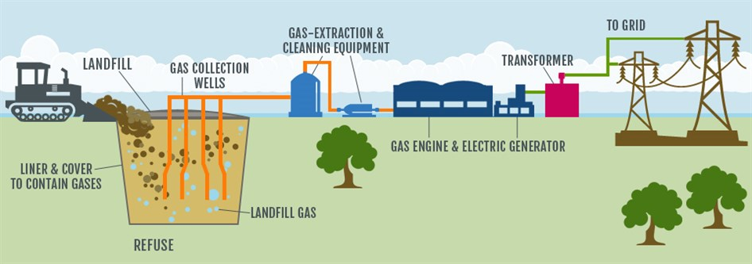
1 million tons of waste in the US produce around 12,233 cubic meters of landfill gas a day and will continue producing this gas for around 30 years after waste stops being deposited in the landfill. To deal with this biogas, most landfills in the US simply vent their biogas into the atmosphere. This lowers the chances of an explosion taking place by decreasing methane build-up, but this venting greatly pollutes local air. In California, the EPA requires gas collection wells to decrease this air pollution; these wells are typically drilled vertically, horizontally, or in combination, with a wellhead attached to a centralized blower or vacuum pump system. Each individual wellhead can be adjusted to change the pulling power. A simple diagram of LFG collection is shown to the right.
Figure 18: Diagram of the Landfill Collection Stream

Vertical wells are generally easier to install on covered or inactive parts of landfills, whereas horizontal wells are easier to put in active sites since they can be laid in between new layers of waste. However, horizontal wells pose an operational challenge because they often collect water. Creating a combination of vertical and horizontal wells is possible but difficult to manage without creating a tough-to-navigate network of piping.

As of February 2018, the EPA estimated there to be 632 operational LFG-to-energy projects in the United States and 73 in California alone – the vast majority of these produce electricity to power on-site operations, they do not produce RNG. Many of these projects are privately operated. Landfills commonly agree to sell their gas rights to private companies, like Waste Management, who will take care of the gas collection and upgrading facilities.

Opportunities for Higher Landfill Gas Recovery

Currently, a major issue facing LFG projects are low methane capture rates. According to the EPA, landfills with gas collection infrastructure will capture around 60-90% of LFG emissions over the landfill’s lifetime. A capture rate of 60%, however, is poor because emissions will still be significant, and the lost LFG means that the landfill will miss out on potential revenue from the fugitive biogas.

The wide range of collection percentages is dependent on the type of gas monitoring system used.

Many landfills depend on manual monitoring of the LFG. In this system, an LFG operator will check the LFG collection wells at a set time, typically every week or month. The operator will adjust the flow of each LFG collection well based on available data, which may include the current gas composition and outdoor conditions. If there is too much pulling force at a given well, atmospheric air might get pulled through as well which could cause underground fires due to the mixture of oxygen and CH₄. If there is not enough pulling force, LFG will escape into the atmosphere and may add odor pollution to the surrounding communities. This manual LFG monitoring is labor intensive and relatively inefficient since adjustments at each well are only made once or twice per month.

Loci Controls, a member of the RNG Coalition, is a company that provides an automated gas collection system for landfills to maximize their methane collection. Automation of this gas collection process allows for constant monitoring of the gas composition and adjustment to flow rates, and Loci has offered a solution that does just that. Sensors at each wellhead monitor the biogas being generated full-time and can easily and automatically adjust to the current gas composition and atmospheric conditions. This allows the system to take in more biogas when the methane composition is high and less biogas when the composition is low while also allowing the system to adjust for changes in the atmospheric pressure and weather. This leaves a safer system with less outdoor pollution.

A case study analyzing Loci Controls’ operations at an Oklahoma landfill found that they increased methane production by 55% relative to the previous year. This elevated methane production increased net revenue by $250,000 per month, with a return on investment of 800%.

The Problem with Flaring

Flaring is the most basic regulated way of dealing with fugitive biogas emissions. In flaring, landfills and other sources collect their biogas and burn it on-site using a gas flare. This method converts the methane into CO₂ and water vapor, which are less potent GHGs than the methane in the fugitive biogas itself. Although convenient, flaring the biogas prevents the plant from gaining the potential energy that can be harnessed from the gas and used to offset more polluting fuels.

Beginning in 2017, the Air Quality Management District (AQMD) implemented a rule that forced LFG electricity generators to meet the same emissions standards as traditional natural gas power plants. While this was an important measure to protecting local air quality, especially in terms of smog-forming NO_{x}, it forced the El Sobrante landfill in Riverside, CA to start flaring their LFG instead of using it to produce electricity because they could not afford the cost of compliance. Another Californian landfill in Simi Valley reverted to flaring because of this tighter regulation and competition from other, often heavily subsidized, renewable electricity. Evan Williams, president of LFG-to-energy company Cambria Energy, said that these two factors will cause many more electricity-producing landfills to switch to flaring.

Even when it is not profitable to turn biogas into energy, the biogas poses a methane emission problem that needs to be addressed. Flaring is one way to address this problem, but harnessing the biogas as a fuel can be advantageous from a global warming perspective as it often offsets the use of fossil fuels. The government should help biogas producers cost effectively use the energy in biogas without damaging local air quality instead of burning this resource away.

How Much Organics Diversion Is Already Taking Place?

Of the 76.5 million tons of waste generated in California in 2016, 12% was composted or mulched, as shown by Figure XX. The most recent and comprehensive data for the number of composting and mulching facilities comes from a 2008 CalRecycle survey. This survey certified that 115 composting facilities and 115 mulching facilities were active in 2008, but there were likely a few more active sites whose operators did not respond to the survey. Compared to the number of composting and mulching facilities, there were much fewer ADs. The American Biogas Council found that there were only 5 operational food waste biogas systems in California as of 2015.

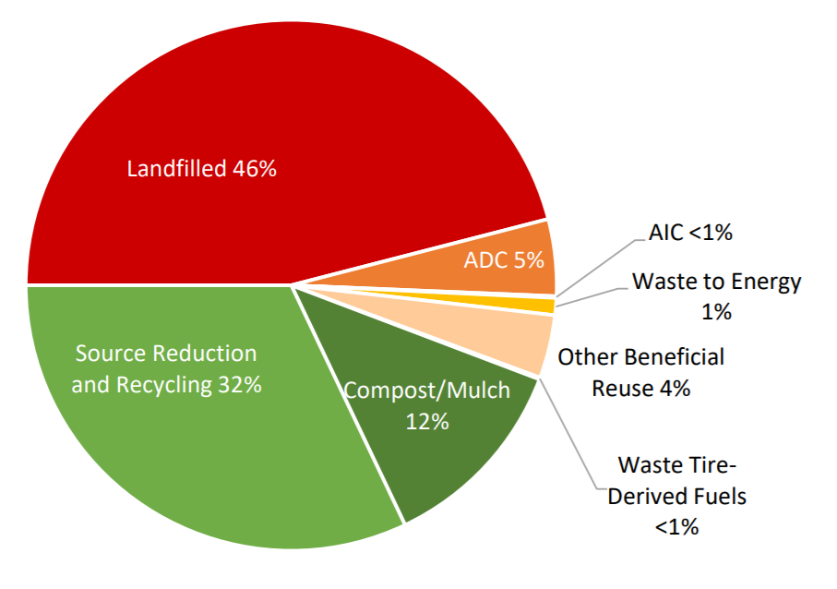
Figure 19: Percentage of Disposal and Recycling in California in 2017 with data from CalRecycle

How Things Need to Change

The following diagram shows how California’s waste stream needs to change by 2025 to comply with SB 1383’s 75% organics diversion and Governor Brown’s 75% recycling, composting, or source reduction of solid waste. For simplicity, it is assumed that the total amount of waste will remain constant. Since 34% of California’s landfill stream was organic waste in 2014, composting, mulching, and ADs will need to process an additional 9 million tons (MT) of waste to meet SB 1383’s target. Recycling and source reduction would then need to increase by 14.5 MT to meet Governor Brown’s overall 75% landfill diversion.

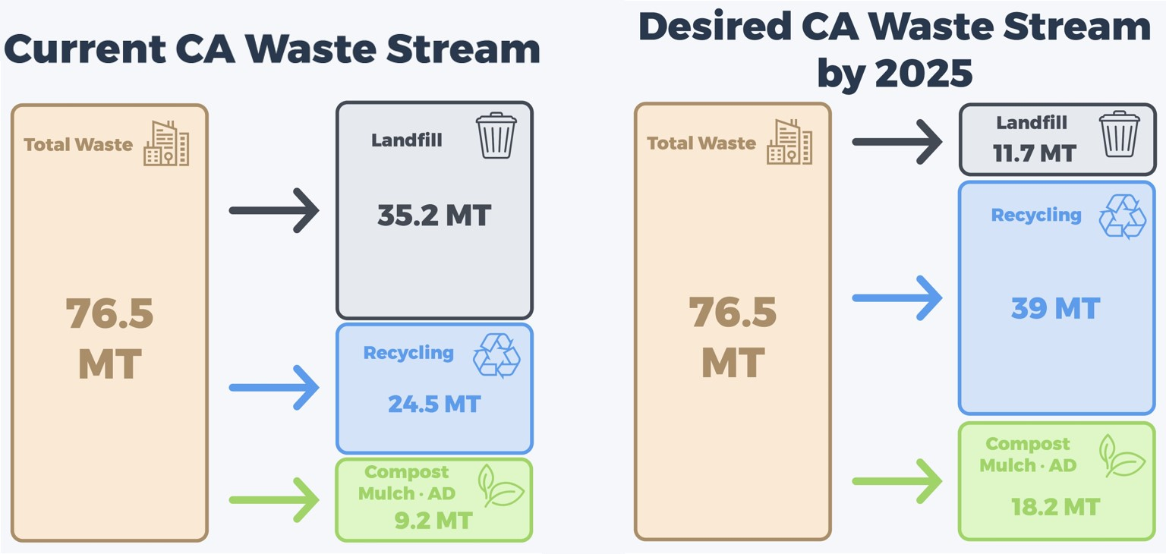
Figure 20: California’s current and 2025 waste stream in million tons (MT) based on statewide waste diversion goals
Numerous estimates approximate that, depending on size and location of plants, 50-150 new organics recycling facilities will need to be built. This figure includes retrofitting existing facilities to increase their capacity. Retrofitting, along with building facilities on existing landfill sites, is desirable because plants already have some of the necessary permitting and more land would not need to be set aside for development. A rough estimate of the capital investment cost to build and expand all these facilities is $2-3 billion.

Alternative Daily Cover as Green Waste Recycling

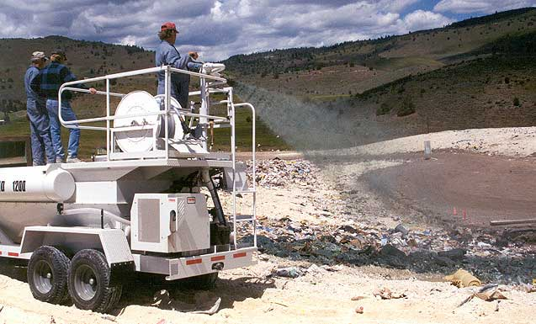
At the end of every work day at landfills, landfill operators must cover all their new waste with some type of cover. This is done to address many issues, including pest invasion, odor emission, and litter spread. Typically, soil is used for this cover, but federal regulations allow certain alternatives to be used in place of soil. These different options are collectively referred to as alternative daily cover (ADC). Shown in the image to the right is a type of ADC that is sprayed over the waste.
Figure 21: Image of spray-on ADC

One popular type of ADC comes from green waste. Currently, green waste used as ADC counts towards recycling instead of landfill disposal. This boosts the recycling rates of waste disposal centers. However, with recent emphasis on diverting organic waste from landfills, beginning in 2020, CalRecycle will no longer consider green waste used as ADC recycling. This change will impact most jurisdictions’ recycling rates, some much more than others.

According to CalRecycle’s Disposal Reporting System (DSR), a system that tracks what goes into landfills in California, 1.28 MT of green waste were used as ADC in California landfills. This means that in 2020, when green waste ADC is no longer considered recycling, the amount of organic waste that needs to be diverted from landfills will increase by 14% to 10.28 MT. This statutory redefinition of green waste recycling imposes yet another hurdle for California to meet the targets prescribed by SB 1383, but it is an important change toward ensuring organic waste get put to its best use.

Once there is pressure for landfill operators to divert their ADC green waste from landfills, they will have to find a different way to cover their waste. There is plentiful soil that can be used as daily cover, but this material can prove cost-prohibitive under certain circumstances. Because of this, many alternatives have been developed. Landfills can use many other ground up wastes like construction and demolition waste and old tires. There are also specialized tarps and spray-on foams that can be used as ADC; these would have the added benefit of taking up much less space than the other daily cover options. Air space is one of the most valuable commodities at a landfill. If a landfill spends less of its air space on daily cover, then it will stay open longer and allow for more lifetime revenues. Landfill operators that use green waste as ADC need to be aware of this legislation, as they will need to find another option for daily cover within the next few years.

The Co-Digestion Opportunity

Combining food waste with human or animal waste for anaerobic digestion (AD), known as co-digestion, is a viable option for AD facilities. Combining food waste or MSW with wastewater sludge or manure in an anaerobic digester can increase the biogas production efficiency of the feedstock compared to separate digestion for each category of organic waste. One example of a WWTP that has seen positive impacts from utilizing co-digestion is the East Bay Municipal Utility District’s (EBMUD). They take 20 to 40 tons of food waste from the district’s food scraps processing facility and co-digest it with the district’s sludge. Through this program, EBMUD became the first WWTP in North America to produce more energy than they need to meet their entire facility’s needs. EBMUD sells the excess energy to the grid, saving them an approximate $3 million a year.

The possibility for huge biogas production gains with co-digestion is supported by the following figure that demonstrates the biogas yield from various feedstocks. While there are many food wastes that have a yield comparable to wastewater sludge and manure, there are some food wastes like animal fat that produce several times more biogas per wet ton of feedstock.

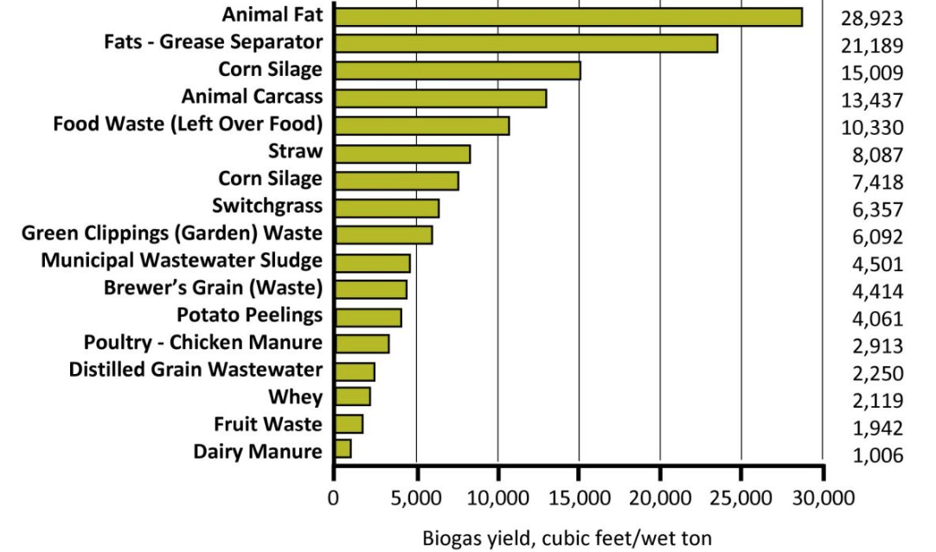
Figure 22: The Biogas Yield from Different Organic Feedstock Materials

Another benefit of co-digestion is the possibility for WWTP ADs with excess capacity to absorb some of the organic waste that needs to be diverted from landfills under SB 1383. Based on initial calculations from Greg Kester of the California Association of Sanitation Agencies (CASA), WWTP ADs in California have enough excess capacity to accept around 75% of California’s food waste. If WWTPs are able to take advantage of some of this excess capacity, fewer new waste processing facilities would need to be built. Additionally, it should be easier for WWTPs than it would be for a greenfield site to get the necessary permitting because of the permits that WWTPs already have in place.

Despite the huge potential of co-digestion, this practice poses a serious problem for AD operators that are interested in creating transportation fuel to take advantage of RINs. In the eyes of the RFS, adding food waste to sludge changes the feedstock type of the entire batch, demoting the RIN classification from D3 to D5 and resulting in a significant drop in value for the biogas. This is a huge disincentive for WWTP operators to co-digest. The EPA needs to update the RFS so that co-digestion is not penalized. One idea for changing the RFS would be to allow AD facilities to reap the D3 RIN credits from the portion of the feedstock that is human or animal waste and D5 RIN credits from the portion of the feedstock that is food waste.

Another problem with co-digestion is the variability in the food waste streams. AD operators want a highly consistent feedstock to keep their systems running optimally. They also need a very clean feedstock since contamination can greatly disrupt the bacteria and equipment. Continued research into optimizing co-digestion is highly encouraged. In addition to this research, more work must be done to improve source-separating habits to keep food waste streams uncontaminated.

Edible Food Recovery

When considering different ways to help divert organics from landfills, it is very important to think about potential ways to bring about a positive social impact with this diversion.
The EPA published the following pyramid describing the more preferred and least preferred ways to deal with the food waste part of organic waste.

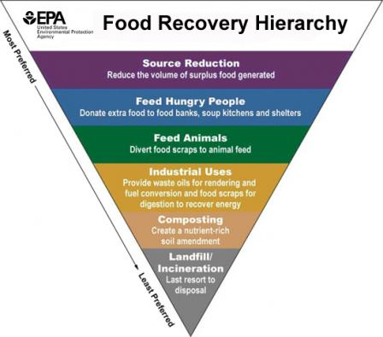
Figure 23: EPA’s Food Recovery Hierarchy

As demonstrated through the EPA’s Food Recovery Hierarchy Pyramid above, preventing food waste and recovering edible food seem to be prefered method to meet SB 1383’s 50% and 75% reduction of organic waste goals by 2020 and 2025 respectively. The EPA’s top three prefered methods of food recovery are source reduction, feeding people in need, and feeding animals.

In other words, one of the ways to divert organics from landfills is to reduce the food waste created in the first place, removing the discussion of disposal. Edible food recovery programs find themselves in the second spot of the pyramid, and they aim to provide disadvantaged communities with edible food, therefore serving both disadvantaged communities and reducing food waste.

Following the shocking revelation that about 40% of food is wasted in the United States, a number of different edible food recovery programs have started to materialize. In California alone, more than 6 million people are food insecure, meaning that they lack reliable access to a sufficient quantity of affordable, nutritious food. In order to help these programs come to life, a number of legislative measures have been taken in the State of California. First, AB 1219 is an expansion of the good samaritan law to food donations, protecting those who choose to donate food that is edible and safe from being sued in case of food poisoning on the part of the receiving end. Second, SB 557 aims to reduce food waste and facilitate food donations from schools. Finally, AB 954 standardizes food labeling with regards to the expiration dates. All three of these laws were passed in the latter half of 2017.

Yet there are still many obstacles to food donation, the most critical of which concerns the legality and liability connected with food donation. Hopefully, AB 1219 will help neutralize these concerns. Other obstacles to food donation include lack of awareness on the scope of the problem, inconsistent guidance to both individual and commercial units attempting food donation, and inadequate infrastructure.

Many companies and Non-Govvernmental Organizations (NGOs) are trying to overcome these obstacles. Copia is a San Francisco-based company that attempts to address the issues of food waste and hunger in the city, which are believed to be inextricably linked. Businesses that use Copia can schedule pickups of their surplus food at a time that is convenient to them, while Copia provides them with the tools needed to efficiently prepare and package the meals. The food is then delivered to a local non-profit recipient in need. Copia also provides companies with help in tracking their surplus trends and making better decisions to reduce their waste. Most importantly for many businesses, using Copia provides them with access to tax reductions. Copia is used not only by food companies like Foxtail Catering and the Lifeworks Restaurant Groups but also by a number of companies (Lyft, Cisco, Pinterest, etc.) that provide food for their employees on a daily basis.

The Problem with Sorting

Unfortunately, organics diversion and increased recycling rates face challenges from historically low and inaccurate sorting rates. The recycling rate within the United States is staggeringly small, lagging behind many other developed countries. In 2014, of the 258 million tons of Municipal Solid Waste (MSW) that were generated in the United States, 34.6% was recycled. The EPA, however, has stated that 75% of this waste can be recycled or composted.

For reference, South Korea’s recycling and composting rate has just exceeded 83%. Germany and Austria each respectively recycle or compost 62 and 63% of their MSW. And the European Union has announced that it wishes to raise the average recycling and composting rate of member countries from 43 to 50% by 2020.

While average rates within the United States are extremely low, there are American cities whose rates far exceed the country’s average. For example, San Francisco now boasts an impressive 80% rate after mandatory recycling and composting dramatically changing public habits. Guillermo Rodriguez of San Francisco’s Department of the Environment details the city’s policy: “the more material you send [to the landfill], the more expensive your garbage bill is. The more material you send to the organic bin, the more your bill goes down.” Even with these programs, however, San Francisco claims that at least half of the 20% currently directed towards landfills can still be filtered out.

These staggeringly low recycling and composting percentages pose a difficulty for co-digestion as the organics diverted to anaerobic digesters are not clean enough for the machinery, posing risks for the microorganisms and machinery. When the contamination rates of some recycled materials are seen by the recycling plants, such materials are sent directly to the landfill, wasting the potential of the material.

Outreach and economic incentives can improve the at-source separation rates of Americans and result in more effective ADs. Dr. Neil Seldman, an author at the Institute for Local Self-Reliance, reported, “the only difference I see [between high-recycling communities and low-recycling communities] is that the cities moving toward 90% have a very active grassroots network that consistently pushes for increased recycling and, in recent years, zero waste.” Communities must adopt policies that best target their local populations, and individuals should be taught practices of proper disposal and the consequences that arise from failure to do so. Field trips of primary school students to landfills, recycling plants, or composting facilities could offer this first-hand exposure that would allow the youth to garner an awareness for their disposal habits from a young age.

CalRecycle’s SB 1383 indicates that mandated recycling and composting programs will become commonplace. Current opt-in programs, like the one Monterey Regional Waste Management District (MRWMD) had implemented, have already proven that such programs can be extremely successful. Under Monterey’s opt-in program, households could choose to source-separate and consequently receive lower tipping fees from their compost and recycling bins (when compared to their waste bins). Recyclables go a MRF, organics to an AD before being composted, and the remainder is transported to landfills. The source separation programs depend highly on people sorting their trash, since sending landfill waste to a MRF no longer becomes economically sensible. This upstream investment in waste saves the facility much work and allows them to invest minimally in post-collection sorting, as they are not filtering their biogas as stringently after AD. With opt-in source separation programs, one challenge is balancing the number of waste bin streams and program participation. By adding more streams for recyclables and organics, the number of people opting in will lower, but the recovered waste will be cleaner and less contaminated.

Now that China is refusing to take much of the world’s waste due to high contamination levels, contamination reduction is key to reusing and effectively managing the influx of waste the US will experience.

Organic waste disposal centers should conduct their own studies to determine which practices are most financially rewarding based on the contamination levels of their organic waste streams and their markets for biogas, biomethnane, compost, and or mulch.

One way some countries in Europe encourage sorting is through significantly higher tipping fees, or the price waste management companies pay for each ton of waste they bring to a landfill. In California, tipping fees are usually around $50 a ton, but in Europe, they often range from $150-200 per ton. This strongly incentivizes European groups to sort out as much organic and recyclable waste as possible.

Implications for Open Landfills and LFG-to-Energy Projects

SB 1383’s organics diversion targets will have serious impacts on landfills that currently accept waste, and as a result, on Biogas or RNG production facilities operating at those open landfills sincethe decomposition of organic materials is what produces biogas. When landfills receive 75% less organic waste, they will eventually produce much less biogas. This shift could dramatically change the financial analysis for landfills that collect biogas for electricity generation or renewable natural gas production.

However, this reduction in biogas production will be gradual, over time. Organic waste that is disposed in a landfill can produce biogas for more than 25 years after initial disposal . According to the Agency for Toxic Substances and Disease Registry (ATSDR), peak biogas production occurs around 5 to 7 years after disposal with continued but declining biogas production for many years after that. This extended period of biogas production leaves plenty of time for investment in RNG production infrastructure to be recouped because of the high value of RINs.

Regardless of what is done with the biogas, all landfills will see a decrease in tipping fee revenue because they will be receiving much less organic waste. To what degree tipping fee revenue will be impacted will depend on each landfill’s proportion of organic waste. Considering that California had 34% organics in its 2014 waste stream, an average landfill would accept roughly 25% less waste once they are meeting SB 1383’s 75% organics diversion goal. If all other factors remain the same, this would have a negative impact on tipping fee revenue. On the other hand, accepting less waste every year means it will take longer for landfills to reach capacity. This could have positive impacts on landfill financial models.

Additionally, landfill gas projects can provide economic benefits for the surrounding communities. Jobs are created for landfill gas projects involving electricity generation and pipeline gas injection through the direct construction and operation of the projects in addition to economic ripple effects throughout the communities involved. The EPA’s Landfill Methane Outreach Project provides estimates for the expected job creation from on-site biogas projects. According to the Coalition for Renewable Natural Gas, each RNG production facility attracts up to $100 million of capital investment and creates up to 173 direct and indirect jobs .

Table 6: Projected job creation from landfill gas projects
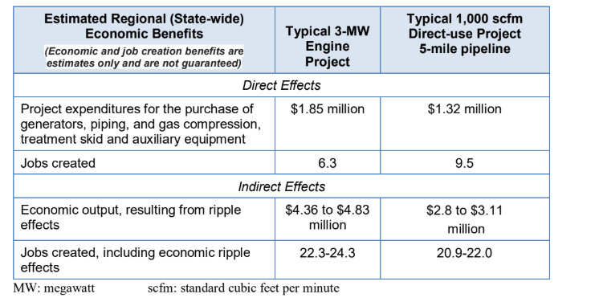

Organics Diversion: Conclusion

The waste stream in California is facing significant pressures to change under SB 1383. Landfills have a difficult time sorting mixed waste streams, even with efforts to source separate waste. Currently, these waste streams, especially the organics waste stream, is contaminated and typically goes straight into a landfill, as opposed to being diverted for a more beneficial use. Solutions that are currently being investigated include waste education programs, enforcement of waste separation, lowering organic waste costs compared to garbage costs, and food recovery programs.

With increased organics diversion, the amount of biogas produced from landfills will decrease, but there are opportunities to improve biogas yield overall. Co-digestion is a method that can significantly boost biogas production, combining multiple organic waste streams (manure, food waste, etc.). This method is economically unfavorable to wastewater treatment plants and dairies, as combining food waste to these streams will change the biofuel classification under the RFS program from D3 cellulosic to D5 advanced, decreasing the value of the associated RINs or environmental credits.

Current regulations require that landfills limit their methane emissions. As such, landfills are effectively required to flare the collected gas to prevent methane from being released to the atmosphere. There are better uses for this gas, such as electricity generation through combustion engines and or the production of RNG. These uses are hard to capitalize on because of prohibitive costs of equipment from high regulatory standards from the Air Quality Management District and pipeline utilities. There are multiple solutions that help curb this problem, such as distributed systems to monitor and control gas flow from landfills for higher landfill gas yield, but flaring is likely to continue unless a more economic regulatory landscape is adopted.

Problem Area 2: Dairies

Problem with Manure

Cattle production is one of the largest markets in the country. In 2015, for the second year in row, the largest percentage of agricultural commodities came from cattle and calves, with a gross income of $78.8 billion. California currently has the largest dairy industry in the United States, home to more than 1,400 registered dairies that contain nearly 1.8 million milk cows and heifers.

As a result, the immense amount of manure produced by these cows causes an abundance of problems. Dairy cows produce an average of 80 pounds of manure per day. However, the gas emitted from cow manure is made up of 55-70% methane, a greenhouse gas that made up 10% of all gas emissions in 2016 in the US. Within California, dairy manure, dairy enteric, and non-dairy livestock account for 55% of in-state methane emissions.

The amount of manure, as well as its hazardous contents, make its disposal a nuisance. A significant amount of farms simply dispose of their manure by placing them in lagoons that can be as big as 15 acres large and 10 feet deep. Not only does this cause strong odors to emit from a concentrated space, the lagoons take up valuable land space and are also deadly to farm employees, with several deaths on record attributed to manure lagoons.⁶⁰ Fortunately, manure from dairy cows is easier to collect than from beef cows on a ranch, since dairy cows are typically more sedentary and can be led into a manure collection room.

California is at the forefront of tackling short-lived climate pollutants when they enacted SB-1383. Legislation, like this one, is prompting Californians, and eventually other Americans, to conjure up solutions for the methane emissions of dairy cows, which in 2014, made up 26% of emissions in the state. In fact, SB-1383 specifically mentions that dairies in California will be forced to control their methane emissions as early as 2024. The bill outlines how the California Air Resources Board, in consultation with the California Energy Commission and California’s Public Utilities Commission, must establish the infrastructure and the policies to encourage dairy farms to reduce methane emissions by up to 40% from 2013 levels by 2030.

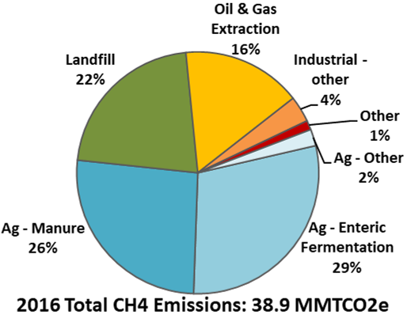
Figure 24: Total CH4 Emissions by Source

Anaerobic Digesters in Dairies

Dairies have begun using anaerobic digesters as a solution to curb the large amounts of methane emitted from manure. As a result of the technology, up to four products can be generated from this digester process: methane, which can be turned into RNG, liquid waste, which can become organic fertilizer, fibrous matter that can be used as cow bedding, and byproduct heat that can be utilized to warm facilities. Farms can generate electricity with the biogas, thus saving money, or upgrade the biogas into pipeline quality natural gas, generating another source of revenue in the process. Classified as a D3 cellulosic feedstock, biomethane could generate around $30/MMBtu through the RIN program, plus an additional $53/MMBtu under California’s LCFS. Dairies can also save costs by producing their own fertilizer and cow bedding instead of purchasing these materials. Additionally, the digestion process rids the manure of its smell.

The cost of building an anaerobic digester depends on several factors. In Vermont, the cost for a digester is usually about $2 million per farm with a payback period of about 7-10 years. There are, however, grants in place to aid dairies in investing in the digesters. One farm in the state received $750,000 in federal, state, and utility grants to cover the cost. Another farm’s digester cost $1.1 million but managed to get 60% of the cost covered by state and federal grants.

In most cases, anaerobic digesters on dairies are profitable on their own. A report conducted by Washington State University concluded through several case studies that the only scenario in which an anaerobic digester on a dairy would be economically infeasible is one where no substrates are used or no tipping fees are acquired. The same study found that transporting manure from several neighboring dairies to a local digester, even at minimal distances, routinely overwhelmed any revenue generated.

Unfortunately, anaerobic digesters on dairies are, at times, unsuccessful. The costs associated with building the infrastructure for the digesters can also be prohibitive, especially for smaller dairies who do not have the funds for such a large investment. Of the 4.63% of dairies in the United States that have anaerobic digesters and produce CNG,there is a 76% success rate, with many failures associated with economic troubles. Dairies seeking loans to aid in paying for capital costs are hindered by the variability of the credits, as profits are not assured and legislation regarding credits may change in the future. This additional risk prevents banks from offering dairy farms the financial support that is necessary for their digester investments.

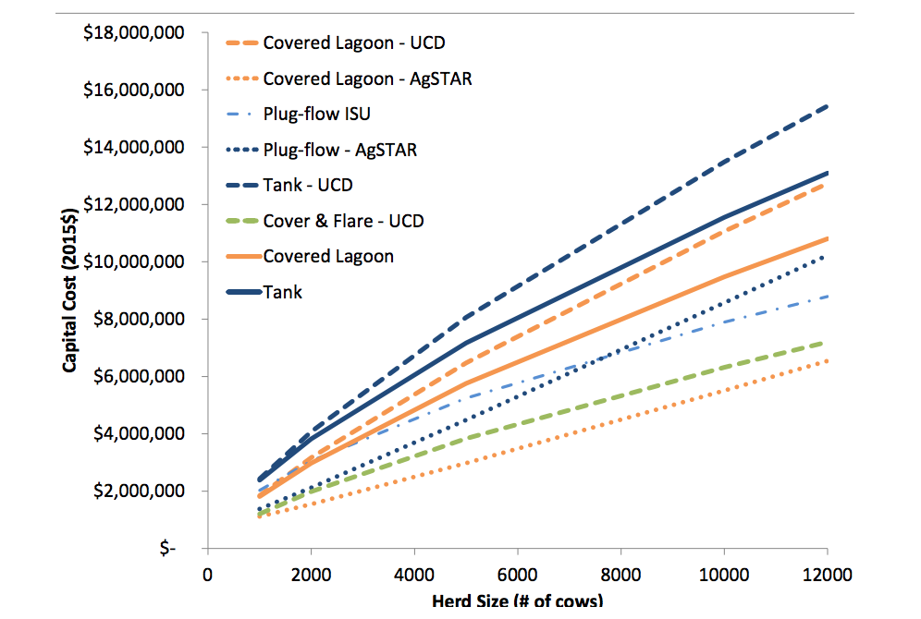
Figure 25: Estimates of capital costs for dairy digesters
Substrates, and the tipping fees that come along with them, offer a promising contribution to anaerobic digesters. It has been shown that co-digestion of food waste and manure yield 26% more methane than the sum of the individual digestions of food waste and manure. Since, co-digestion of various feedstocks does not guarantee enhancement of biogas and methane production, consideration needs to be given to sustaining a homogeneous mixture for the microorganisms for a guaranteed more efficient system.

In 2011, California’s State AB 109 appropriated $99 million from the Greenhouse Gas Reduction Fund to California’s Department of Food and Agriculture (CFDA) to invest in methane emission reductions from dairy and livestock farms. CFDA has announced its plan to allocate 65 to 80% of these funds as incentives to support the creation of digesters on California’s dairies. In 2017, these grants gave $35.25 million to 17 anaerobic digester projects; of these 17 projects, 11 plan on injecting their biomethane into the pipeline. The California Public Utilities Commission appears to wish to continue amplifying such projects, setting forth an initiative in December of 2017 to subsidize infrastructure costs for 5 dairy pilot projects looking to invest in anaerobic digesters. SoCalGas, PG&E, San Diego Gas & Electric, and Southwest Gas Corporation issued a joint Request for Proposals that would require dairies to introduce their specific projects; the utilities will then choose 5 projects to find biogas treatment facilities, collection lines, and the pipeline extensions to the utility’s interconnection point for pipeline injection to become feasible for the dairies.

Such pilot projects are planned to follow a “hub and spoke” model, one where a “hub” would be a central location where raw dairy biogas is gathered from a cluster of dairy farms in the area. The hub would contain the infrastructure to clean and upgrade the biogas to RNG, to be used for either electricity generation or transportation fuel. The “hub” would receive the raw gas from “spokes” that would interconnect the cluster. In these pilot projects, the utilities will use trucks to transport the RNG from the dairies to the nearest pipeline (i.e., virtual pipelines). This practice has the potential for significant savings, eliminating the need for pipeline interconnection. While pipeline interconnections cost between $2-5 million per mile in California, you can utilize a virtual pipeline and transport RNG via a trailers for around $500,000 per project..

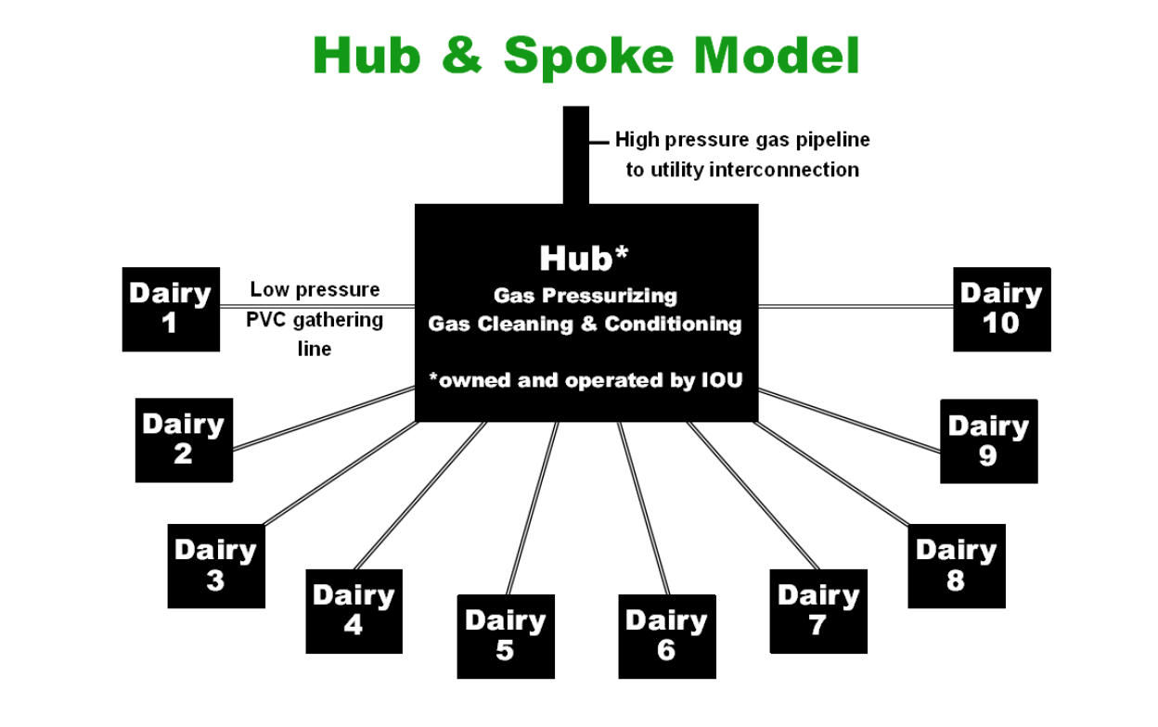
Figure 26: Diagram of how the pilot Dairy projects will operate

Montauk Energy, a Pennsylvania-based firm that has developed commercial-scale renewable energy facilities for 30 years – includeing a biogas-to-electricity facility at the Bowerman Landfill in Irvine, California, is also in the process of developing RNG from biogas collected at dairies. While Montauk has already been involved in converting the biogas from landfills into transportation fuel, the firm entered a joint venture agreement with a California dairy in July of 2018. As part of the agreement, Montauk will own and operate a dairy digester and build, own, and operate an RNG facility for 20 years. Montauk will own an 80% interest in the joint venture , potentially ilustrating how the involvement of a third-party RNG developer can reduce the financial risk a dairy farm has to take on itself. If successful, Montauk could be paving the way for more dairies to use digesters as solutions to their methane emissions. According the RNG Coalition, several of its members intend to deploy hundreds of millions of dollars to mitigate methane emissions at dairies by investing in and developing RNG production facilities at these farms.

Trucking Biomethane

One of the main reasons there is a need for a “hub and spoke” model is that pipeline interconnection is very costly – especially for dairy clusters or individual dairy projects. Many of the obstacles associated with interconnecting a dairy-RNG project are exacerbated by the fact due to their remote and rural locations, they are not in close proximity to a natural gas pipeline and farther away from the demand.. Expanding the pipeline network to cover every biomethane producer is virtually impossible, particularly when taking into account the fact that pipeline expansion is a very expensive process, estimated by PG&E to cost about 3 million dollars per mile. Trucking biomethane to a more convenient location has been presented as a viable alternative for certain projects to immediate pipeline injection at the site of production. Specially equipped trucks could transport biomethane to a number of different locations, either for pipeline injection at a more convenient location with immediate access to the grid, or for direct use, at a CNG vehicle fueling station for example.

Trucking RNG presents a number of benefits, including the possibility of creating a closed loop where the trucks delivering RNG are also fueled by RNG. However, the solution of trucking RNG doesn’t come without an appreciable cost. Longer distances that need to be travelled translate into higher trucking costs, and greater tailpipe emissions, which increase the carbon footprint and reduce the value of the biomethane (at least under California’s LCFS program).

Manure Storage

Proper storage, maintenance, and treatment of manure is necessary to ensure that maximum value is taken from the nutrients in the manure while minimizing contamination. Dairy farms have the initial option of storing or spreading the manure. Those who choose to spread the manure distribute the manure collected from the day onto cropland, hayland, or pasture. Those who choose to store, however, stockpile the manure until it is used as spread or until it is transported elsewhere. The benefits of storage include reduced emissions from hauling, waiting to use manure as a fertilizer until the land and climate is suitable, and more. Yet, the costs of storage are extremely high, with a large capital cost going into the creation of an initial “manure pit” and the removal of manure. Unfortunately for the farms, manure storage also creates GHG emissions and odors. A variety of methods help reduce these methane, ammonia, and nitrous oxide emissions, including the mechanical separation of solids and liquids, compaction of the manure, and proper covering.

Dry Storage
Dry storage units handle the separated solid manure from the cattle as well as the scraped solids from other operations (such as bedding). Because dry storage is so high in solids content, the dry manure contains higher nutrient retention, fewer odors, less runoff potential, and occupies a smaller volume. However, dry storage requires much more labor and equipment maintenance for manure collection.

Liquid Storage
Lagoons are pools used for liquid storage, requiring a large capacity and specific soil, rock, or bedrock characteristics to ensure a stable structure. Lagoons also require the land on which they are built to meet permeability standards. A nearby source of water might also be necessary to dilute the manure. While liquid storage is cheaper per head of cattle, they have relatively high greenhouse gas emissions and nitrogen losses.

Slurry Storage
Slurry storage units contain manure that is 5-10% dry matter and are built to be either above or below ground. When above ground, the facilities are usually concrete or coated metal with a glass lining, and the manure is usually deposited through a pump, transporting the manure from a reception pit. Farms with large amounts of manure generally opt for slurry due to the lowest price, but much planning must go into their construction and into maintaining odor control.

Countering Emissions from Enteric Fermentation

While anaerobic digestion can capture the methane from cattle manure and harness its energy, it doesn’t address the anaerobic digestion that occurs in cows’ stomachs. The first stomach of a cow, the rumen, produces 50-70% of cows’ total methane emissions, a gas that cannot be readily captured.,

Scientists from the National Institute of Agricultural Technology in Argentina have used methane collecting tanks to calculate the emissions directly from cows. The “backpack” is attached to the cow’s stomach through a tube and directly collects gas. While this technology is unlikely to be used on an industrial scale due to economic and ethical reasons, the backpacks allow scientists to test a variety of diets on the cows and analyze changes in methane production.

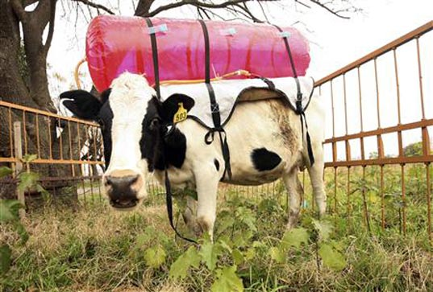
Figure 27: A cow with a methane-capturing backpack in Argentina

Red Seaweed

One diet supplement that is showing promise of reducing enteric methane emissions is Asparagopsis taxiformis, commonly known as red seaweed. A case study in Australia, a native habitat of the plant, found that adding red seaweed to cows’ feed reduced their methane emissions by 99%. These findings were reproduced in lab testing at the University of California Davis under the initiative of Joan Salwen. The red seaweed works by inhibiting a reaction in the cow’s rumen. Methane production in the rumen requires a certain coenzyme to bind to Vitamin B12. Red seaweed contains bromoform, which chemically resembles the coenzyme. When bromoform is present, Vitamin B12 combines with it rather than the coenzyme, which causes methane production to stall.

While limited supplies of Asparagopsis taxiformis kept it from being used in field testing, a near cousin, Asparagopsis armata, produced positive results. Asparagopsis armata has lower levels of bromoform, so it inhibits methanization to a lesser degree, yet in the first round of results, it reduced methane production in Holstein dairy cows by 58% when supplemented 1% of cows’ daily feed. Compared to current tested supplements that only reduce methane emissions by 10-20%, red seaweed shows larger promise and success. The red seaweed supplement also increased the cows’ feed-conversion efficiency by 20%, meaning cattle could produce more milk with the same amount of food.

However, the EPA considers bromoform a "probable" human carcinogen, meaning further testing is needed to determine how much remains in the milk and meat of the cattle. Additionally, while the red seaweed supplement only needs to constitute 0.5-2% of dairy cow feed to be effective, the portion may be more costly than a cow’s daily feed.

Algae-Based Water Treatment

In 2015, Quantitative Biosciences Inc. collaborated with the Van Ommering dairy farm in Lakeside, CA to install a microalgae facility on the farm. Essentially, the farm took the liquid effluent from the anaerobic digester and, via a series of lagoons and ponds, managed to promote algae growth to treat the water. Not only does this technology produce clean water that can be used for irrigation, the algae biomass is also utilized as a slow release fertilizer and as a tool that removes excess nutrients from the water stream. The algae also aids in the removal of greenhouse gases, with the potential of displacing 261,878 metric tons of CO₂ per year. Additionally, the algae acts as a nutrient rich feed for the cows themselves, saving money for the farmers in the process.

This technology has been studied by various researches, among them Yebo Li, a professor from Ohio State University. He has demonstrated that liquid waste from an anaerobic digester can be used for algae feed. In theory, since Asparagopsis taxiformis is a form of algae, it can be harvested with the methods described above. Further research should be conducted to see if red seaweed can be successfully grown in the scenario discussed.

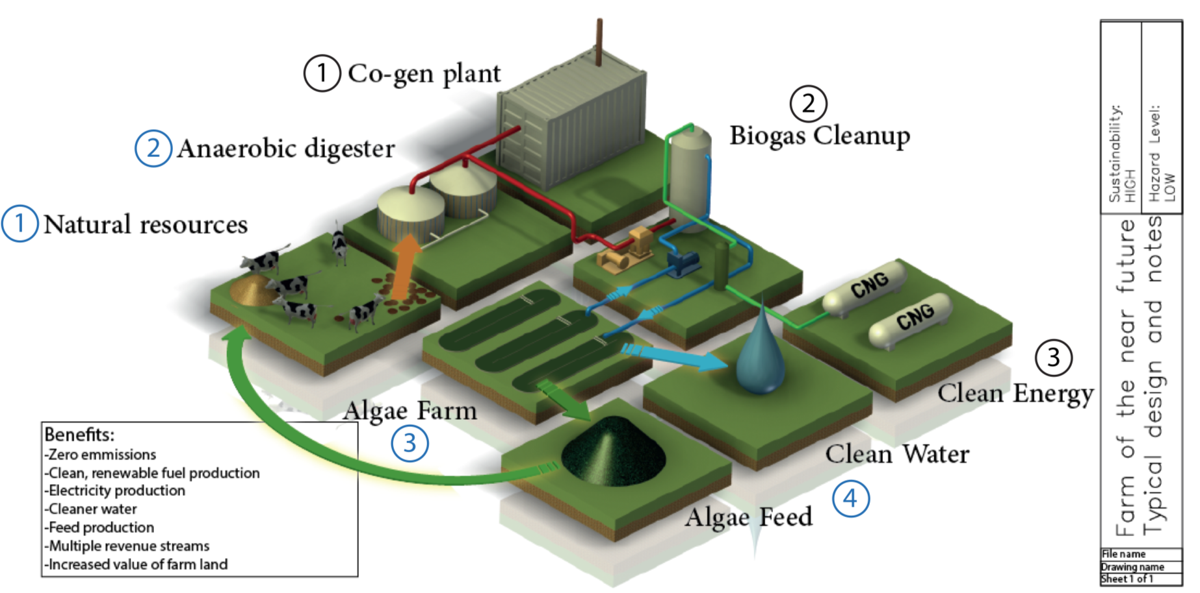
Figure 28: Diagram of an Algae-Based Water Treatment Plant

Case Study: Fair Oaks Farm

Located in northwest Indiana, Fair Oaks Farm was founded in 1999 by Mike McCloskey and his wife Sue. The farm encompasses 30,000 acres and falls into the largest 1% of U.S. dairy farms. The farm prides itself on solely relying on renewable fuel to run the operations of the dairy farm, leading to no net increase in carbon dioxide. The farm achieves this by running an anaerobic digester that converts the biomethane released from cow manure into either electricity that is used to power the farm or into renewable natural gas that is used to power the dairy’s transportation fleet. The waste heat that is produced is recycled to heat the digester. As of August 2017, the farm has a fleet of 42 CNG trucks fueled by RNG that deliver 53 loads of milk daily, amounting to more than 90 million gallons per year.

The conversion to natural gas vehicles has not only drastically decreased the farm’s carbon footprint, but it has also led to drastic financial savings for the farm. The change has displaced an approximate 1.5 million gallons of diesel a year, amounting to an approximate 33 million pounds of carbon dioxide reduction. While the savings on fuel vary, Fair Oaks could be saving $2 per diesel gallon equivalent on RNG used. Excess gas has also served to power a 1 MW generator, and the on-site generation of the RNG has also served to reduce the dependence on imported fossil fuels. Because of the pathway established by the RFS that rewards biofuel usage for transportation, the farm also generates revenue through the sale of cellulosic D3 RINs. In February 2017, with a D3 RIN valuing $2.60, Fair Oaks was making $33.42/ MMBtu of RNG.

The anaerobic digester runs on the liquid manure produced from the cows where a truck with a suctioning tool collects the manure 3 times a day. Contaminants (sand, grit, etc.) are removed before the waste enters the digester. Through this process, 1.5 million pounds of manure are collected daily. One of the major challenges facing the farm is finding a consistent source of organic wastes that can be blended with the manure to yield higher biogas production. A steady co-digestion rate of manure and organic substrates would dramatically yield better results from the digester, but Fair Oaks has noted difficulty in finding a reliable source of homogeneous substrates.

The plant was fortunate to have government subsidies facilitating the building of the infrastructure, with the American Recovery and Reinvestment Act of 2009 giving the farm $750,000 to be used for building two CNG fueling stations. Indiana’s State Energy Program then gave the farm a $2 million grant to cover the incremental cost of CNG storage tanks for the fleet.

The farm very effectively partnered with external companies to facilitate the creation and running of the project. Anaergia was given the contract for gas upgrading while Clean Energy Fuels was given the responsibility of building and operating the CNG fueling stations. The fueling stations are open to the public as of August 2017, with the public representing 10-20% of the station sales. AmpCNG, a member of the RNG Coalition, buys the upgraded gas from the farm for a fixed price and transports the RNG through the natural gas pipeline to CNG/RNG fueling stations. Given rare situations where the digesters fail to work, the local utility of NIPSCO provides supplemental gas required to meet demand. NIPSCO also buys excess RNG when the anaerobic digester creates a supply that exceeds demand.

Using their anaerobic digesters to make RNG, the Fair Oaks Dairy Farm has paved the way for dairies to engage in similar operations, not only capitalizing on the economic opportunity but also realizing significant environmental benefits, sustainably reducing the greenhouse gas emissions otherwise associated with producing and delivering a gallon of milk by approximately 43%.

Dairies: Conclusion

Cows in California make up more than half of the state’s methane emissions. With additional burdens such as manure storage and emission reducing government legislation, individuals are now looking at solutions at tackling these problems. Luckily, now many are seeing anaerobic digesters as a possible key instrument. With government incentinves, LCFS Carbon Credits and RFS RINs available for farmers to generate, anaerobic digesters are being assembled across the country. However, issues such as pipeline interconnections and excessive regulatory costs are a barrier to increased development of RNG production facilities at dairies in California.

Anaerobic digesters are not alone in dealing with the issue at hand. Farmers are getting crafty and some are attempting to contain the emissions at the source with ideas such as gas collection from a cow’s stomach, seaweed feed for the cows to drastically lower their gas production, or even algae facilities within farm grounds.

There are farms such a Fair Oaks farm in Indiana that are paving the way for the farm of the future. Eventually, through the tools being proposed, farms will be a crucial aspect in emission reduction in the country.

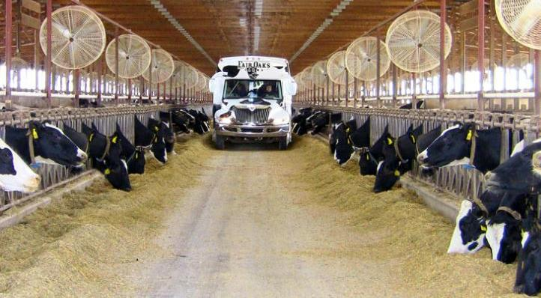
Figure 29: A Truck Running on RNG at Fair Oaks Farm

Economics

Biogas vs. Fossil Natural Gas

There are several key differences between the raw biogas generated from landfills, dairies or other livestock, wastewater treatment plants and fossil natural gas (FNG) . First, the composition of biogas and natural gas differs greatly. Biogas must be treated and conditioned to remove impurities. Because there are fewer impurities in natural gas, the process for treating natural gas is less expensive. Also, the hydrocarbon content – which give a gas its heating value - is much higher in natural gas, because these higher-chain hydrocarbons are not found in raw biogas. Still, biogas can be treated to remove unwanted gas constituents,t o achieve a near-pure methane content (>95%+), arrive at the same Wobbe index and meet pipeline quality or transportation fuel grade specifications:

Table 7: Properties of Biogas and Fossil Natural Gas
Substance | Biogas | Fossil Natural Gas
Methane | 50-85% | 83-98%
Carbon Dioxide | 15-50% | 0-1.4%
Nitrogen | 0-1% | 0.6-2.7%
Oxygen | 0-0.01% | -
Hydrogen | Traces | -
Hydrogen Sulfide | Up to 4000 ppm | -
Ammonia | Traces | -
Ethane | - | Up to 11%
Propane | - | Up to 3%
Siloxane | 0-5 mg/m³ | -
Wobbe Index | 6.4-9.1 | 11.3-15.4%

Since the shale gas boom in 2008, FNG has become an incredibly cheap source of energy. As of July 30, 2018, the price of FNG is $2.78/MMBtu, while the cost of biomethane ranges from $7/MMBtu to $70/MMBtu Landfills tend to produce biomethane at cheaper rate than a municipal solid waste facility or wastewater treatment plant and much cheaper than a dairy.

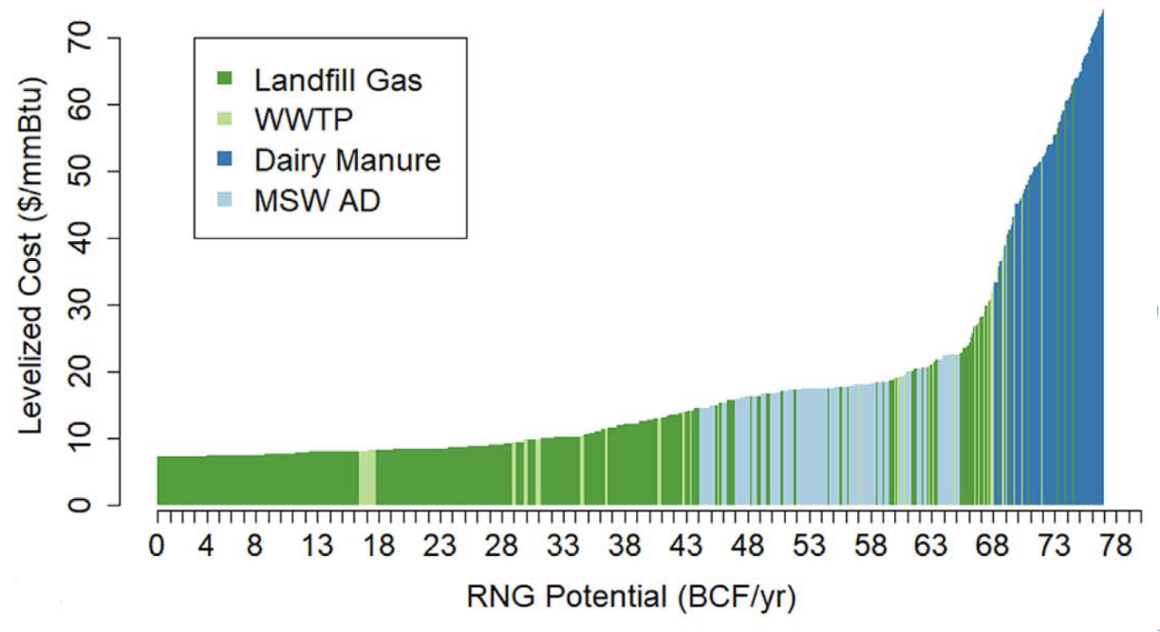
Figure 30: Supply Curve of RNG by Source
Landfills | Ladnfill gas rights owner in California are able to command a price between $6.50-$15.00/MMBtu for the electricity they produce. Because larger landfills can collect and process higher volumes of biogas using relatively inexpensive and fixed price equipment, these landfills represent the lowest cost or most economic sources of RNG – and RNG from these sources can be developed for between $6.00 - $10.00/MMBtu. However, as organic waste is diverted away from landfills, as the waste in place shrinks in size and or as new landfills are commissioned further away from natural gas pipelines, the same equipment will process less raw biogas and could become more expensive. Also, through RFS RINs and LCFS credits, landfills in California can receive as few as $3.75/MMBtu to keep the cost of producing biogas lower.
Wastewater Treatment Plants (WWTP) | At a development cost of $9.00/MMBtu, only two wastewater treatment plants (WWTP) in California profitably produce RNG. Together, these two plants in Los Angeles would produce 1.5 BCF/year of RNG, which is a significant amount of the RNG potential from WWTPs in California. However, the same equipment must be used in other for WWTPs to collect and process biogas, so it becomes more expensive to incorporate WWTPs that are smaller and further from a pipeline. WWTPs can produce more biogas if organic waste is co-digested, but less valuable RINs will be generated, as the category of the biofuel changes from cellulosic to advanced.,
Municipal Solid Waste (MSW) | At a development cost of $15.00/MMBtu, municipal solid waste (MSW) can generate about 1.3 BCF/year. However, at $18.00/MMBtu, MSW can generate 10 BCF/year. The lowest cost MSW operations have high tipping fees and high volume. The conditions for these low cost operations assume that the cost for landfilling is significantly higher than dumping organics to an MSW operation.
Dairies | At a development cost as high as $20.00/MMBtu, dairies would make the production of 1 BCF economically viable. For this price, we assume clustering, where necessary, for small dairies and ubiquitous use of tank digesters. This is the lowest-cost scenario for dairies, but in reality, only a fraction of dairy biogas projects utilize clustering and tank digesters. Clustering may reduce the price by about 60%, but the cost of anaerobic digesters and upgrading equipment causes the price of producing RNG from biogas to skyrocket. As dairies become smaller, more sparse, and further from pipelines, cost continue to escalate. Dairies can produce more biogas if organic waste is co-digested, but less valuable RINs will be generated, as the category of the biofuel changes from cellulosic to advanced.,

Assuming the price of natural gas is $3.00/MMBtu, we can determine how much support is necessary for each source of RNG to become economically viable. Landfills - the most cost-effective feedstock for RNG production – still need to make up a cost delta of $3.00+/MMBtu to break even. Wastewater treatment plants need $6.00+/MMBtu, MSW plants need $12.00+/MMBtu, and dairies need $17.00+/MMBtu to break even with the cost of production, before realizing any return on capital investment used to develop the project.

If RNG could be sold for $10/MMBtu, then 32+ BCF/year could be produced (mostly by landfills and a couple wastewater treatment plants). However, this production is not likely to be sustained without the support of public policy, as the price of fossil natural gas has not risen above $10/MMBtu since the shale gas boom in 2008. Over the last 5 years, natural gas prices have fluctuated between $1.50/MMBtu and $6.15/MMBtu. Over the last 2 years, the price ranged from about $2.50/MMBtu to about $3.80/MMBtu. In light of this, it is unlikely that natural gas prices will ever rise above $10/MMBtu.

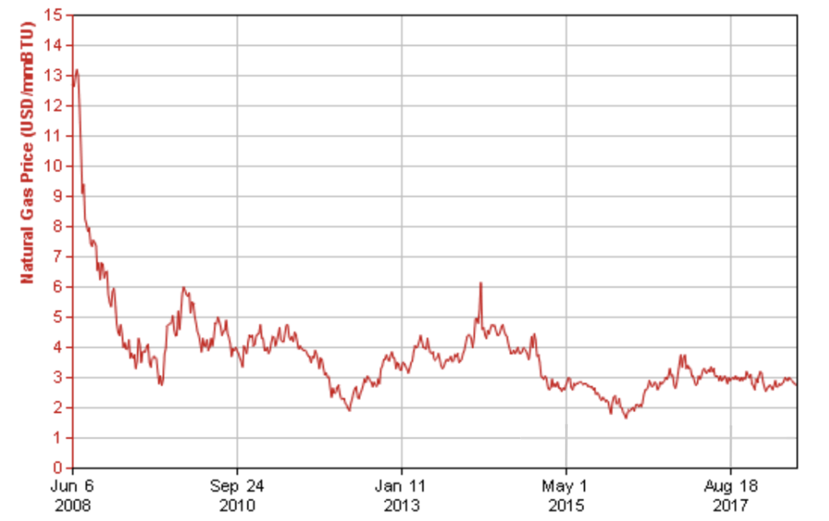
Figure 31: Price of Natural Gas in the United States from June 6, 2008 to July 30, 2018

A Note on Energy Companies

Many of the issues regarding the cost of producing RNG from biogas revolve around economies of scale. Technology and capital equipment in this industry tend to be unsophisticated and inefficient. Large landfills are more economically viable for producing RNG than smaller landfills. Clustering dairy farms around centralized anaerobic digesters is more economically viable than installing anaerobic digesters on every dairy farm. Large energy companies, with significant research and development efforts, may be able to spot and correct inefficiencies, especially those that arise from economies of scale.

Large energy companies have publicly expressed some interest in RNG projects. Chevron is interested in creating a substance as close to crude oil as they can out of crops and plant-based waste so that they can transport it through the existing pipeline. In 2017, BP acquired Clean Energy Renewables’ RNG production assets,. Today, BP is partnering with 10 landfills, supplying biogas-derived RNG to three California transit companies and 70 natural gas fueling stations. BP has also invested in a company that makes jet fuel from household waste and is currently investing tens of millions of dollars into renewable energy research at various universities. In addition, Shell has expressed interest in creating a competitive waste-to-energy RNG transportation fuel plant in Bangalore, and they hope to produce RNG at $2.00/gallon (2012 USD).

Even though these large energy companies express interest in these areas, it’s unclear whether or not their investments will spur large amounts of future project development across the RNG industry. In the United States, there are gas-to-energy projects at approximately 2,000 sites (landfills, WWTP, livestock operations) The cumulative RNG production potential from the more than 25,000+ sites in the United States where biogas is not being upgraded is 351 million MMBtu/year. Developing all of the 23,000+ potential sites would require an estimated investment of $33+ billion for construction and capital, excluding additional costs for gas transport (pipeline, trucking, etc.) and planning.

On the other hand, natural gas projects are far more attractive to large energy companies because of their larger returns. For example, Chevron’s Wheatstone and Gorgon LNG projects in Australia can produce 450 million barrels of oil equivalent a day (around 2.5 million MMBtu/day), the equivalent of 911 million MMBtu/year. This means that Chevron can produce over 2.5 times more natural gas per year than all potential RNG sites in the United States combined with an $81 billion investment in just these two projects. As a result, large energy companies typically look for large, centralized, fossil fuel ventures like these because Chevron can operate with quicker timelines, perform less maintenance, use lessons from similar projects, and have more stable predicted returns, and the company can produce cheaper natural gas for consumers and investors alike.

RNG vs. Other Renewables

According to the Intergovernmental Panel on Climate Change (IPCC), climate scientists agree that natural gas will act as a bridge fuel to renewable sources of energy. The IPCC predicts natural gas production and usage will undermine coal plant operations, with natural gas production peaking around 2050.

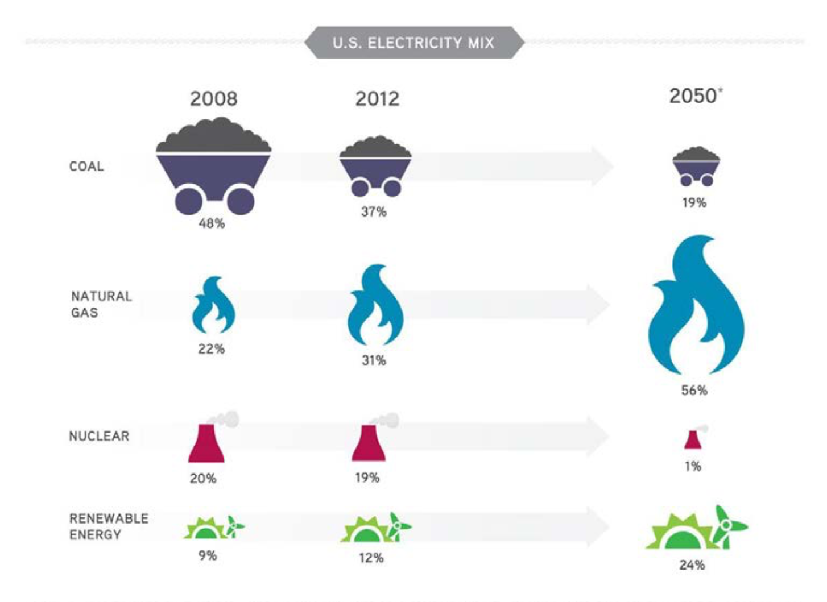
Figure 32: Past and Predicted Contributors to the US Electricity Mix
Over the last decade, worldwide demand for natural gas has increased dramatically. Between 2006 and 2016, demand for natural gas increased around 631 million tons of oil equivalent, larger than the growth of oil, nuclear, solar, and wind power put together. However, depending on the regional energy markets, this high growth may be undercut by the rapidly decreasing prices of renewable energy. In places like the United States and Europe where natural gas is becoming very cheap, natural gas will soon displace coal as an energy source. In a region like China, where coal prices are extraordinarily low, a direct transition from coal to renewable energy is more likely.

Natural gas plants hold strong advantages over wind and solar operations because natural gas plants can supply baseload power, meaning they run continuously to meet the minimum demand. Natural gas peaker plants can also be used to meet energy demands that exceed baseload production. On the other hand, wind and solar are intermittent, meaning they may not meet energy demands at all times of the day. When energy demands exceed energy production at a given time of day, peaker plants fire to meet the heightened demand. Peaker plants often run on natural gas because natural gas is easily dispatchable, meaning it can output electricity at a moment’s notice. However, using peaker plants is costly since they run sporadically and are built for quick output, not efficiency. Because natural gas can be used as baseload power and dispatchable power, local governments across the United States see natural gas as a vital component of their electricity generation portfolios.

In recent years, there has been a very significant shift in economic incentives for wind and solar power, especially in states of the US using regulatory measures to incentivize renewable power generation. One of the biggest examples of this is California’s Renewable Portfolio Standard (RPS) requiring 50% of all power generation in the state to come from renewable sources. With these increased incentives, fewer natural gas plants are being constructed in favor of cheaper wind and solar projects that are easier to install.

A recent Lazard report analyzing the levelized costs of renewable and non-renewable energy sources finds that wind turbines and solar photovoltaics (PVs) for utility, residential, and community purposes typically have higher capital costs than fossil fuels. Disregarding fuel costs and dispatchability advantages, natural gas engines cost as little as $650/kW and peaker plants cost as little as $800/kW, while utility scale solar PVs cost at least $1100/kW, communal PVs cost at least $2000/kW, and residential solar panels cost at least $3000/kW.

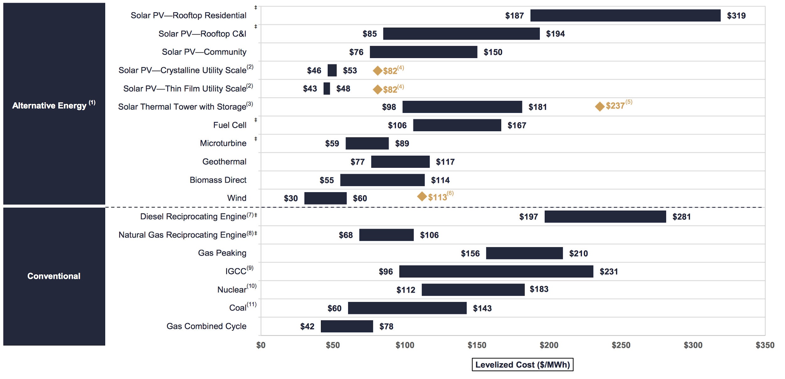
Figure 33: Unsubsidized Levelized Cost of Energy Comparison
The unsubsidized cost of the energy coming off of these sources is also worth noting (Figure XX). Natural gas burned in a combined cycle process can cost as little as $42/MWh, while utility solar power costs as little as $43/MWh and wind may cost as little as $30/MWh (residential solar power, $187/MWh, and communal solar power, $78/MWh, are much more expensive). Electricity from utility solar power costs roughly as much as power from natural gas and wind power is cheaper than natural gas power. As a result, wind and solar projects can be more attractive, as they can potentially sell more electricity and be an environmentally sustainable energy solution. However, power from wind and solar sources is not easily able to be stored and is, therefore, not dispatchable, so there will still be a need for natural gas peaker plants costing $156/MWh.

Various parts of the United States are better suited for wind or solar energy than others. The Southwestern states, which are more consistently sunny and closer to the equator, have cheaper solar power rates than all other United States regions. Wind power is also more viable in the Southwestern states and Texas, where wind patterns are more predictable. Since renewable energy sources continue to decrease in cost, both in capital costs and operating costs, more regions will be able to incorporate these renewable sources. Although natural gas as a fuel has been decreasing in price, the capital equipment has not undergone any serious improvements, and it is possible that both solar and wind will become more competitive than fossil natural gas.

These figures assume the use of FNG transported by pipeline. However, RNG has faced issues with pipeline injection, not only because of cost prohibitive regulations, but also the incentive to use biogas for other purposes, like on-site electricity generation (see Pipeline Injection section). Because FNG is constantly facing competition from wind and solar energy, RNG will always need subsidies in order to survive as an energy source. The sources that generate biogas will, however, always be generating methane and air pollutants that cause a negative externality if left uncaptured. As a result, subsidies to support biogas capture and RNG production can be justified, since RNG projects actively correct this externality, while FNG projects only contribute to it.

A Study of the Growth of the Solar Energy Industry

The examination of solar energy’s rapid growth from a marginal source of energy to its current 60 GW-sized industry could teach us some important lessons about the policies and the economic landscape contributing to this rapid growth.

Although there are many differences between RNG and the solar industry, many of the fundamental characteristics of these two renewable sources of energy are comparable. The goal of the following section is to draw parallels between solar energy and renewable natural gas and find ways to help RNG grow into a reliable and economically viable source of energy.

The growth of solar energy has been remarkable: between 2008 and 2013, residential, commercial, and institutional rooftop solar grew an average of more than 50% per year. From 2010 to 2013, the price of a typical household system dropped by almost 30%, while the capacity of such systems across the United States more than tripled.

Like with RNG, the solar market started with a focus on on-site electricity generation. Most of the first photovoltaic (PV) systems were largely focused on providing electricity for the building to which they were attached, often a residence. Integrating rooftop solar into the grid came later and took time to materialize, similar to pipeline interconnection for RNG. One of the most important benefits of connecting solar to the grid was that distributed solar provided electricity when and where that power was most valuable - to businesses and residences during the hottest times of the day to power their air conditioning. Furthermore, rooftop systems reduced strain on electricity distribution and transmission equipment by allowing homes and businesses to first draw power on-site instead of relying on the grid. The benefits of this are twofold: the use of on-site power avoids the inefficiencies of transporting electricity over long distances, and on-site systems can allow the utility to postpone expensive infrastructure upgrades.

However, integrating PV systems into the grid also presented many difficulties. First, solar generation’s intermittency presented challenges because, unlike many non-renewable power plants, solar generation could not be flipped on whenever it was needed. Still, much of this variability inherent in solar generation is predictable and manageable. Hours of daylight and seasonal changes are highly predictable, and weather forecasts can help grid operators plan for when cloud cover may hinder rooftop solar systems. Since distributed solar power flows from customers to utilities, utilities had to make upgrades to transmission lines that were accustomed to operating in only one direction, which is an issue that has also affected biogas-to-electricity projects.

Gradually, though, solar power began making financial sense. Rooftop solar became increasingly cost-effective for homeowners, business owners, and their communities thanks to reductions in technology prices, innovative financing, and growing networks of solar installers and financial partners.

The graph below shows the falling prices of Solar PV in the US by sector between 2007 and 2013, a time period during which the solar industry experienced rapid growth. As can be seen in the graph, prices for PV systems in the United States have dropped by 50% or more in recent years, with the sharpest declines for large-scale projects.

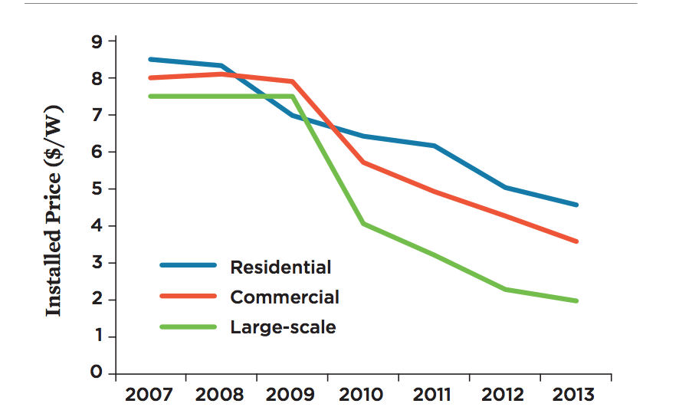
Figure 34: The Falling Price of Solar PV by Sector in the US, 2007-2013
The dropping prices of PVs can be attributed mostly to economies of scale and technological advances. Between 2010 and 2013, global panel production increased almost twofold, while developing standards that cut down on individual process evaluations were put forward by local agencies, streamlining the permitting process for PVs. Generally, most of the efforts by local agencies and local governments have focused on reducing “soft costs”, the term used for costs related to sales, permitting, inspection, connection to the electricity grid, and retailers’ and installers’ profit margins.

Another important factor enabling solar power to become mainstream were the innovative approaches toward ownership options. Namely, homeowners and businesses started taking advantage of third-party ownership options for their PVs. Through solar leases or power purchase agreements, electricity customers could pay little to no upfront costs for rooftop systems, then get electricity from the systems at attractive fixed rates over long periods of time. Systems and maintenance remain the property and responsibility of the developers, who could be third-party companies or the utilities themselves. Today, two-thirds of new residential solar systems are third-party-owned.

Solar also began developing a more economically diverse customer profile. During 2011 and 2012, the largest numbers of rooftop systems were installed in neighborhoods with median incomes of $40,000 to $50,000 in Arizona, and $30,000 to $40,000 in New Jersey. Furthermore, some states, including California, have policies to specifically target low-income or disadvantaged populations.

The positive economics of the solar industry could not be examined without looking at favorable policies on the federal, state, and local levels. Some examples of such policies include:

Net metering | Net metering policies give system owners credit on their utility bills for excess electricity generation. Forty-three states and the District of Columbia have net metering in place. In at least 34 of those states, customers are credited for net generation at the full retail rates of electricity, not the lower wholesale rates.
Feed-in tariffs | Some places around the United States have implemented feed-in tariffs, similar to those that have helped drive substantial renewable energy development in Europe. Under feed-in tariffs in place in at least seven states, homeowners and businesses are paid under standardized contracts offering fixed prices for solar generation, over an established and often long-term period. One of the main issues obstructing the growth of the RNG industry is price instability and the precarious nature of investing in RNG technology and infrastructure due to greatly oscillating gas prices. Although a system comparable to solar tariffs exists for electricity generation from biomethane, in the form of the BioMAT tariff, it would also be beneficial to consider using a similar type of tariff for biomethane upgrade to RNG and use for either pipeline injection or on-site vehicle fueling.
Value-of-solar tariffs | System owners can also be paid based on the calculated value of the broad suite of benefits that solar systems provide. Such value-of-solar tariffs quantify not only the benefits of providing electricity but also the value of providing instantaneous power to the grid, a solar installation’s contribution toward delaying or avoiding system upgrades, and specific environmental benefits from avoiding the use of fossil fuels. The city of Austin, TX, pioneered this approach in 2012, and other jurisdictions have since initiated similar efforts (see Minnesota Department of Commerce 2014).
Solar carve-outs | Some states target small-scale solar within their broader efforts to increase investments in renewable energy. Sixteen states require utilities to invest in solar energy and/or distributed generation as part of their broader renewable electricity standards. Colorado and New Jersey, for example, each require that at least 3% of the state’s electricity come from distributed generation (primarily solar) by 2020. Such “carve-outs” offer solar system owners potential additional revenue. This policy works similarly to Renewable Volume Obligations within the Renewable Fuel Standard, requiring a certain percentage of vehicle fuel sold to be renewable.
Tax incentives and subsidies | In addition to the 30% federal tax credit, 45 states and the District of Columbia have tax incentives for homeowners and businesses for renewable energy purchases, and some local governments offer incentives such as property tax exemptions. Under property-assessed clean energy (PACE) programs, participating municipalities provide financing for purchases of solar systems (or other renewable energy or energy efficiency projects) on homes or commercial properties, then recover the costs through property taxes over time.

All of the aforementioned policies and financial regulations were catalysts in the fast rise of solar energy and should be taken into account when examining what needs to be done in order to help biomethane as a source of energy achieve similar growth. It could be argued that the need to take advantage of biomethane is even more pressing compared to solar. If left unchecked, methane emissions from all of the sources described above have a detrimental effect to our environment, and they are going to continue to exist, unless methane is captured and used. Despite the fact that the needs of solar and RNG might be different, the financial and legislative actions that were taken to boost solar energy can be used as a general model for RNG, bearing in mind that the long term goal for all renewable forms of energy would be for them to be able to operate as a free market without the need for government subsidies.

Conclusions & Recommendations

General - RNG

- Create a renewable natural gas procurement program for Californias natural gas corporations

It is urgent and time sensitive that California create a viable market alternative to the federal RFS that will enable the RNG industry to access investment capital necessary to develop RNG production facilities in-State. These projects will sequester carbon, mitigate methan emissions and help with our State’s climate change goals and renewable energy objectives. To create RNG market certainty, a certain procurement requirement should be set for certain gas corporations, whereby the obligated gas corporations are required to enter into procurement for their proportionate share of RNG, with procurement contract terms of no less than ten-years in length, at prices that will support project development and ensure adequate cost containment and ratepayer protection.

- Ensure cooperation between different government entities for the adoption of unified standards to meet the goals of SB 1383

It is crucial to establish that all relevant agencies are closely aligned and on the same timetable with regards to meeting the goals of SB 1383. Often, RNG production facilities face obstacles because of the considerable differences between the permitting processes in different parts of the state. We recommend the creation of statewide standardized permitting templates for RNG production facilities with the potential for automatic approvals for technologies that have been approved in one region to be approved in other regions. A task force could be created to identify and resolve conflicting regulations, eliminate or modify outdated specifications or requirements, and form a database for approved equipment, designs, processes, and procedures. These measures would lead to an expedited permitting process for RNG projects.

- Revisit regulations for RNG pipeline injection standards

Research has found that the siloxane and minimum heat standards for RNG pipeline injection in California are so stringent that they often become insurmountable. Furthermore, the existing fossil gas gas in California’s pipelines often fails to meet the specifications set for RNG anyway. Consequently, RNG - gas that has been conditioned and could improve the quality of and decarbonize the gas in the pipeline - is still being rejected. It is important to conduct additional research before making a decision to, throough overly stringent standards, effectively prohibit the injection of RNG into California’s common carrier pipelines.

- Increase capacity for RNG by incentivizing the conversion of diesel fleets and increased deployment of medium- and heavy-duty natural gas vehicles to be fueled by RNG

It would be very useful to involve all stakeholders (engine & truck manufacturers, truckers/haulers, regulators, CNG/RCNG providers, etc.) in a detailed review of the advantages and the disadvantages of converting diesel trucks and fleets to Low-N0x natural gas engines fueled by RNG..Once this report has been created, strategies to overcome barriers of diesel conversion to natural gas engines can be developed. Furthermore, initiatives and incentives to upgrade state, county, city, and municipal fleets can be created. Finally, in order to allow the conversion of diesel fleets to CNG vehicles fueled by RNG, it is necessary to resolve issues surrounding the expansion of on-site, private and public CNG fueling stations.

- Guarantee the value of RINs and other financial incentives

One of the largest obstacles impeding RNG adoption is the financial precarity of the RIN market, which is susceptible to non-negligible price fluctuations. Stability in RNG values would encourage investment in RNG.

- Encourage co-digestion

Co-digestion of different types of feedstock has proven to significantly improve the efficiency of anaerobic digesters and increase the production of biogas as a feedstock for RNG. However co-digestion is a complex process that would benefit from further research, especially given the fact that when done incorrectly, co-digestion can worsen the performance of anaerobic digesters. For it to be successful, it’s important that the feedstock composition remains consistent. Aside from further research to perfect co-digestion strategies, it is also crucial to financially incentivize co-digestion. An important obstacle to wider use of co-digestion is that it alters the RIN (credit) category and market value of the RNG it produces. Allowing RNG created from co-digestion to qualify for the RIN category (D3, D5, etc) given the proportion of each category of feedstock within the digester would solve this problem and encourage co-digestion. Such a measure would be crucial to encourage wastewater treatment plants to accept food waste, and therefore an important step in diverting organics from landfills.

- Establish a viable “eRIN” pathway in the RFS

The RFS allows for the possibility of creating RINs through the combustion of biogas that generates electricity for charging EVs. However, all applications for pathways of this nature have been unsuccessful. Since electricity generation is one of the most common uses for biogas and there is a rapidly growing number of EV fleets, the EPA should collaborate with industry players to resolve the issues with the “eRIN” pathway. This would help the RFS spur even more investment in biogas energy projects.

- Provide grants and subsidies for emissions cleaning to prevent flaring

Flaring biogas is a common practice because it is a relatively cheap and easy way to clean up biogas and curb harmful atmospheric emissions. However, it is a waste of a biofuel that has many uses, as this report outlines. It would be helpful to introduce grants or subsidies for technologies that would allow biogas-producing facilities using only flares to instead harness the biogas energy and still pass local air quality standards.

9. Support the development of advanced technologies to increase methane capture, and increase biogas-derived RNG production from existing facilities

Many existing facilities have the capacity to substantially improve their methane capture methods and increase their RNG production. Federal, state, and local financial and technical support should be provided to already existing RNG production facilities such as landfills, waste water treatment plants, dairy farms and other livestock operations with digesters, etc.

Organics Diversion

- Create a quick, streamlined permitting process for new ADs and composting facilities

It is estimated that 100 new composting and AD facilities will need to be constructed for California to meet 75% organic waste diversion. A faster, easier permitting process is necessary for all of these new facilities to be built on SB 1383’s aggressive timeline.

- Optimize organic waste management based on a map of current and potential waste streams and waste treatment facilities

It would be useful to create a statewide map identifying current and potential organic waste streams as well as current AD and composting facilities. This map could be used to optimize the process of directing organic waste streams to the appropriate AD or composting facility, while minimizing transportation and the costs associated with it. Furthermore, it could be used to identify areas which lack the necessary infrastructure and suggest sites for new facilities or highlight existing facilities that could increase their capacity through retrofitting.

- Create a detailed timeline for retrofits, new construction and permitting

Based on the map outlined in the point above, it would also be useful to develop a detailed timeline, bearing in mind SB 1383’s goals, to establish when and where retrofitting and new construction should occur. This timeline will provide government agencies a useful outline to establish when and where their efforts are most needed.

- Develop impactful programs to reduce contamination of organic waste streams

One of the most crucial aspects of organics diversion is source separation. Facilities that receive source-separated organics with low contamination rates are able to produce more biogas and/or better quality compost. There are many ways to incentivize effective waste separation. One idea would be to install cameras in waste collection trucks to enable rapid customer feedback and education using real-time waste analysis. Households or commercial units with contamination rates higher than a certain percentage could be sent warning emails with recommendations on how to lower their waste contamination. Fines could be issued to repeat offenders. Alternatively, waste management facilities could implement a sliding scale for tipping fees depending on contamination rates. Another very important aspect of the effort for reducing contamination fees is education outreach, particularly at a young age. This could take the form of obligatory school field trips to waste management centers. Further research should be conducted on how best to educate communities on the importance of source separation. Methods of putting the onus of these measures on haulers should be explored since they enjoy the highest profit margins in the waste management industry.

- Encourage and financially incentivize compostable packaging and compostable alternatives to single-use plastics

One of the most effective ways to keep waste out of landfills is to design the products we use to be disposed of in an environmentally friendly manner. When it comes to diverting organics, one useful measure would be to financially incentivize the production and use of compostable packaging and compostable alternatives to single-use plastics, such as utensils and cups.

- Encourage WWTPs to accept food waste into their ADs

As mentioned before, co-digestion presents a lot of potential for increased efficiency and RNG production. Currently, few WWTPs are accepting food waste for co-digestion because of the variability it can introduce to the process. The inconsistent food waste feedstock could have adverse effects on biogas production. Therefore, continued research on co-digestion in WWTPs is necessary to determine the methods and technologies needed to optimize this process. The results of this research would inform estimates of cost, permitting requirements, and RNG off-take options for upgraded wastewater treatment plants.

- Redirect green waste to compost facilities and food waste to ADs

It is important to recognize that not all organic waste is best used in the same way. While food waste is the ideal feedstock for ADs, green waste should be directed immediately to compost facilities.

Dairies
- Identify potential pipeline interconnection and injection sites for large dairy operations

RNG potentials for all dairy farms need to be identified in order to determine the viability of either direct pipeline injection from single dairies or from dairy clusters. The clustered model involves dairies that are close to each other individually collecting their biogas and trucking it to a central location where it is processed and then injected into the pipeline. This method needs to be studied further in order to be optimized.

- Encourage the co-digestion of manure from dairy farms with organic waste

There is a large opportunity for greater biogas production at a higher quality when food waste is combined with manure inside the bio-digester. Consequently, opportunities for partnerships between dairy farms and surrounding restaurants or other food processing operations should be explored. This could help improve the economics of a biogas energy project. It would also provide a nearby sink for organic waste streams.

- Create an expedited project approval and permitting process for biogas energy projects at dairies

The regulatory burdens that are currently placed upon dairies paired with the financial difficulties many of them are already facing are preventing many farms from becoming involved in the RNG and biogas capture industry. These regulatory burdens should be minimized to encourage the formation of new infrastructure and dairies’ involvement in the industry, specifically through the creation of an expedited project approval and permitting process.

- Expand the loan and grant programs available for biogas projects for agricultural and rural businesses

There need to be greater financial opportunities for smaller dairies and businesses who wish to invest in digesters at both the state and federal level. This would allow the dairies who are currently unable to enter the market because they lack the necessary capital for building the initial infrastructure for biogas energy projects to get involved in the biomethane industry.

- Research methods to reduce methane emissions from cattle

Although research is already in place to find ways to reduce the methane emitted from cattle, further study should be conducted. Cattle diet has already shown significant promise in decreasing such emissions and should be given particular attention.

"The Biogas." Advantages of Anaerobic Digestion. http://www.biogas-renewable-energy.info/biogas_composition.html
Vaidyanathan, Gayathri. "How Bad of a Greenhouse Gas Is Methane?" December 22, 2015. https://www.scientificamerican.com/article/how-bad-of-a-greenhouse-gas-is-methane/
"Overview of Greenhouse Gases." EPA. April 11, 2018. Accessed August 15, 2018. https://www.epa.gov/ghgemissions/overview-greenhouse-gases.
World Energy Council. 2016. "Waste To Energy 2016."
U.S. Environmental Protection Agency Office of Resource Conservation and Recovery. 2018. "Documentation For Greenhouse Gas Emission And Energy Factors Used In The Waste Reduction Model (WARM)". EPA. https://www.epa.gov/sites/production/files/2016-03/documents/warm_v14_management_practices.pdf
"State-Of-The-Art Dry And Wet Anaerobic Digestion Systems For Solid Waste.” 2018. Biogasworld. https://www.biogasworld.com/news/dry-wet-anaerobic-digestion-systems/.
"Types Of Anaerobic Digesters | US EPA". 2016. US EPA. https://www.epa.gov/anaerobic-digestion/types-anaerobic-digesters.
"State-Of-The-Art Dry And Wet Anaerobic Digestion Systems For Solid Waste.” 2018. Biogasworld. https://www.biogasworld.com/news/dry-wet-anaerobic-digestion-systems/.
Shwartz, Mark. 2018. "New Study Confirms The Ecological Virtues Of Organic Farming | Stanford News Release". Stanford News. https://news.stanford.edu/pr/2006/pr-organics-030806.html.
Sage Publications. "Compost Can Turn Agricultural Soils Into A Carbon Sink, Thus Protecting Against Climate Change." ScienceDaily. ScienceDaily, 27 February 2008. www.sciencedaily.com/releases/2008/02/080225072624.htm
U.S. Environmental Protection Agency Office of Resource Conservation and Recovery. 2016. "Documentation For Greenhouse Gas Emission And Energy Factors Used In The Waste Reduction Model". Organic Materials Chapters. ICF International. https://www.epa.gov/sites/production/files/2016-03/documents/warm_v14_organic_materials.pdf.
Owen, Justin J., William J. Parton, and Whendee L. Silver. Long-term Impacts of Manure Amendments on Carbon and Greenhouse Gas Dynamics of Rangelands. Report no. Doi: 10.1111/gcb.13044. Department of Environmental Science, Policy & Management, University of California Berkeley. John Wiley & Sons, 2015.
Ibid
Ibid
Personal communications with Manon Fisher, Resource Recovery Specialist, and Karri Ving, Business Services Manager at Southeast Treatment Plant in San Francisco
Personal communications with Michael Gross, Director of Sustainability at Zanker Recycling in San Jose
"How Much Electricity Does An American Home Use? - FAQ - U.S. Energy Information Administration (EIA)". 2018. US Energy Information Administration. https://www.eia.gov/tools/faqs/faq.php?id=97&t=3.
Sheehy, Philip, and Jeff Rosenfeld. 2017. "Design Principles For A Renewable Gas Standard". White Paper. ICF.
Chen, Xiao & Vinh, Hoang & Avalos Ramirez, Antonio & Rodrigue, Denis & Kaliaguine, Serge. (2015). Membrane gas separation technologies for biogas upgrading. RSC Adv.. 5. 10.1039/C5RA00666J.
Lang, Patricia. Solid-state Anaerobic Digestion for Integrated Ethanol Production. Master's thesis, University of Saskatchewan, 2011.
Kenney, Robert S. Gas Rule 21. April 24, 2009. California, San Francisco. This Rule describes the general terms and conditions that apply whenever PG&E transports Customer-owned gas over its system. Customers who wish to transport gas must sign the applicable Agreement.
Petersson, Anneli, and Arthur Wellinger. Biogas Upgrading Technologies – Developments and Innovations. Task 37. IEA Bioenergy. October 2009. https://www.iea-biogas.net/files/daten-redaktion/download/publi-task37/upgrading_rz_low_final.pdf .
Public Utilities Commission of the State of California. 2013. "Decision Regarding the Biomethane Implementation Tasks in Assembly Bill 1900". http://docs.cpuc.ca.gov/PublishedDocs/Published/G000/M086/K466/86466318.PDF
"Overview Of Greenhouse Gases | US EPA". 2018. US EPA. https://www.epa.gov/ghgemissions/overview-greenhouse-gases.
"Methane (CH4)." California Air Resources Board. June 22, 2018.. https://www.arb.ca.gov/cc/inventory/background/ch4.htm.
Navigant Consulting. 2018. "Analysis Of The Role Of Gas For A Low-Carbon California Future". Boulder, CO: SoCal Gas. https://www.socalgas.com/1443741887279/SoCalGas_Renewable_Gas_Final-Report.pdf
U.S. Department of Agriculture, U.S. Environmental Protection Agency, U.S. Department of Energy. 2014. "Biogas Opportunities Roadmap". Voluntary Actions To Reduce Methane Emissions And Increase Energy Independence. USDA. https://www.energy.gov/sites/prod/files/2014/08/f18/Biogas%20Opportunities%20Roadmap%208-1-14_0.pdf.
Ibid.
IRENA: International Renewable Energy Agency. 2017. "Biogas For Road Vehicles: Technology Brief". Abu Dhabi: IRENA. http://www.irena.org/-/media/Files/IRENA/Agency/Publication/2017/Mar/IRENA_Biogas_for_Road_Vehicles_2017.pdf.
IRENA: International Renewable Energy Agency. 2017. "Biogas For Road Vehicles: Technology Brief". Abu Dhabi: IRENA. http://www.irena.org/-/media/Files/IRENA/Agency/Publication/2017/Mar/IRENA_Biogas_for_Road_Vehicles_2017.pdf.
Jaffe, Amy Myers. The Feasibility of Renewable Natural Gas as a Large-Scale, Low Carbon Substitute. Report no. 13-307. Sustainable Transportation Energy Pathways, University of California Davis.
IRENA: International Renewable Energy Agency. 2017. "Biogas For Road Vehicles: Technology Brief". Abu Dhabi: IRENA. http://www.irena.org/-/media/Files/IRENA/Agency/Publication/2017/Mar/IRENA_Biogas_for_Road_Vehicles_2017.pdf.
Jaffe, Amy Myers. The Feasibility of Renewable Natural Gas as a Large-Scale, Low Carbon Substitute. Report no. 13-307. Sustainable Transportation Energy Pathways, University of California Davis.
Ibid
Transportation Sector Energy Consumption. PDF. US Energy Information Administration, 2016.
Ibid
Nikolewski, Rob. "The Cost of the Energy Conversion of SD’s Fleet." The San Diego Union-Tribune, March 10, 2016. Accessed August 15, 2018. http://www.sandiegouniontribune.com/sdut-sd-city-fleet-conversion-2016mar10-htmlstory.html.
Personal communications with Michael Gross, Director of Sustainability at Zanker Recycling in San Jose
Tomich, Matthew, and Marianne Mintz. Cow Power: A Case Study on Renewable Compressed Natural Gas as a Transportation Fuel. Report. Energy Systems Division, Argonne National Laboratory. 2017.
Personal communications with Johannes Escudero, CEO and Executive Director of the Coalition for Renewable Natural Gas
Price, Toby. 2018. "Biogas - Scandinavia Boasts". Renewable Energy Magazine, At The Heart Of Clean Energy Journalism. https://www.renewableenergymagazine.com/biogas/scandinavia-boasts-world-s-first-biogaspowered-train.
Ibid
The Local. "All aboard World's First Biogas Train." The Local. October 24, 2005. https://www.thelocal.se/20051024/2356.
Lauer, Markus and Daniela Thrän. “Flexible Biogas in Future Energy Systems—Sleeping Beauty for a Cheaper Power Generation.” Energies 2018, 11(4), 761; doi:10.3390/en11040761. http://www.mdpi.com/1996-1073/11/4/761/htm#B9-energies-11-00761
United States. Environmental Protection Agency. Landfill Methane Outreach Project. Epa.gov. June 2017. https://www.epa.gov/sites/production/files/2016-11/documents/pdh_full.pdf.
"What Is U.S. Electricity Generation By Energy Source? - FAQ - U.S. Energy Information Administration (EIA)". 2018. Eia.Gov. https://www.eia.gov/tools/faqs/faq.php?id=427&t=3.
Personal communications with Michael Gross, Director of Sustainability at Zanker Recycling in San Jose
“Omnivore Anaerobic Digester Systems and Services". 2018. Anaergia.Com. https://www.anaergia.com/services/municipal/waste-water/co-digestion.
United States. Environmental Protection Agency. Landfill Methane Outreach Project. Epa.gov. June 2017. https://www.epa.gov/sites/production/files/2016-11/documents/pdh_full.pdf.
World Energy Council. 2016. "Waste To Energy 2016."
“Etagen Technology”. 2017. Etagen.com. http://www.etagen.com/technology/.
Personal communications with Shannon Miller, Chief Executive Officer and Founder of EtaGen
"Technology - EtaGen". 2018. EtaGen. http://www.etagen.com/technology/.
World Energy Council. 2016. "Waste To Energy 2016."
"Anaergia | Breaking Barriers to Sustainability". 2018. Anaergia.Com. https://www.anaergia.com/services/municipal/waste-water/bio-solids-management.
Piccirilli Dorsey, Inc. 2018. "Fact Sheet - Biogas: Converting Waste To Energy | White Papers | EESI". Eesi.Org. http://www.eesi.org/papers/view/fact-sheet-biogasconverting-waste-to-energy.
"Applications: Textiles". 2018. Mango Materials.http://mangomaterials.com/applications/
Puiu, Tibi. "How a Mycologist Is Making 'living' Bricks out of Mushrooms That Are Stronger than Concrete." ZME Science. May 19, 2017. https://www.zmescience.com/science/living-bricks-mushrooms-0423432/.
"Pipeline Injection Of Biomethane In California." BioCycle. July 16, 2018. https://www.biocycle.net/2018/03/12/pipeline-injection-biomethane-california/.
California Energy Commission Cartography Unit, Transportation Fuels Data Unit. California Natural Gas Pipelines - Oil Refineries and Terminals.
"Renewable Natural Gas Produced in California by CR&R Flows into SoCalGas Pipelines for First Time." Sempra. https://www.sempra.com/newsroom/press-releases/renewable-natural-gas-produced-california-crr-flows-socalgas-pipelines.
"Interconnecting Biomethane Suppey". 2018. PG&E. https://www.pge.com/en_US/for-our-business-partners/interconnection-renewables/interconnections-renewables/biomethane.page?WT.mc_id=Vanity_biomethane&ctx=business.
"Interconnecting Biomethane Suppey". 2018. PG&E. https://www.pge.com/en_US/for-our-business-partners/interconnection-renewables/interconnections-renewables/biomethane.page?WT.mc_id=Vanity_biomethane&ctx=business.
RNG Gas Quality Standards. Report. SoCalGas. https://www.socalgas.com/1443740736978/gas-quality-standards-one-sheet.pdf.
Gregory Von Wald, Adam Brandt, Deepak Rajagopal, and Austin Stanion. Biomethane in California Common Carrier Pipelines: Assessing Heating Value and Maximum Siloxane Specifications. Report. California Council on Science and Technology.
Ibid
Gersen S, Visser P, van Essen M, Brown M, Lewis A, Levinsky H, Impact of silica deposition on the performance of gas-fired domestic appliances caused by the combustion of siloxanes in the fuel, Renewable Energy (2018), doi: 10.1016/j.renene.2018.07.143
"Overview for Renewable Fuel Standard." EPA. June 07, 2017. https://www.epa.gov/renewable-fuel-standard-program/overview-renewable-fuel-standard.
US Department of Energy. "Renewable Fuel Standard." Alternative Fuels Data Center. https://www.afdc.energy.gov/laws/RFS.html.
2018. Epa.Gov. https://www.epa.gov/sites/production/files/2015-08/example_lifecycle_of_a_rin_0.png.
2018. Gao.Gov. https://www.gao.gov/assets/690/681347.pdf.
"Ethanol Producer Magazine – The Latest News And Data About Ethanol Production". 2018. Ethanolproducer.Com. http://www.ethanolproducer.com/articles/12003/the-2014-d3-rin-leapundefinedfor-biogas.
"Welcome - Ecoengineers". 2018. Ecoengineers. https://www.ecoengineers.us.
"Decoding The US Refiner’s Exposure To Rins". 2018. Mckinseyenergyinsights.Com. http://www.mckinseyenergyinsights.com/insights/us-renewable-fuel-credits/.
"Proposed Volume Standards for 2019, and the Biomass-Based Diesel Volume for 2020." EPA. July 10, 2018. https://www.epa.gov/renewable-fuel-standard-program/proposed-volume-standards-2019-and-biomass-based-diesel-volume-2020.
Batres-Marquez, Patricia. "EPA Proposes Updates to the Renewable Fuel Standard: The Renewables Enhancement and Growth Support." Ag Marketing Resource Center. https://www.agmrc.org/renewable-energy/renewable-energy-climate-change-report/renewable-energy-climate-change-report/november-2016-report/epa-proposes-updates-to-the-renewable-fuel-standard-the-renewables-enhancement-and-growth-support/.
"EPA’S Plan For Electric Vehicles Could Upend RFS Politics - Governors' Biofuels Coalition". 2018. Governorsbiofuelscoalition.org. http://www.governorsbiofuelscoalition.org/epas-plan-for-electric-vehicles-could-upend-rfs-politics/.
"Electric Buses Are Coming, And They’re Going To Help Fix 4 Big Urban Problems". 2018. Vox. https://www.vox.com/energy-and-environment/2017/10/24/16519364/electric-buses.
Ibid
Natural Gas for Cars. PDF. US Department of Energy, December 2015.
"The Promises and Limits of Biomethane as a Transportation Fuel." Union of Concerned Scientists, May 2017. https://www.ucsusa.org/sites/default/files/attach/2017/05/Promises-and-limits-of-Biomethane-factsheet.pdf.
California Air Resources Board. "LCFS Pathway Certified Carbon Intensities." California Environmental Protection Agency Air Resources Board. https://www.arb.ca.gov/fuels/lcfs/fuelpathways/pathwaytable.htm
Seymour, Kendra. 2018. "LCFS 101 - An Update - Stillwater Associates". Stillwater Associates. https://stillwaterassociates.com/lcfs-101-an-update/.
California Air Resources Board. 2018. "Dashboard | California Air Resources Board". Arb.Ca.Gov. https://www.arb.ca.gov/fuels/lcfs/dashboard/dashboard.htm .
"SB 1122: Bioenergy Feed-In Tariff". 2018. Cpuc.Ca.Gov. http://www.cpuc.ca.gov/SB_1122
"Differences Between Publicly and Investor-Owned Utilities." California Energy Commission. 2018. Accessed August 15, 2018. http://www.energy.ca.gov/pou_reporting/background/difference_pou_iou.html
California Legislature. 2016. "Assembly Bill No. 1923 CHAPTER 663 An Act To Amend Section 399.20 Of The Public Utilities Code, Relating To Energy." https://leginfo.legislature.ca.gov/faces/billNavClient.xhtml?bill_id=201520160AB1923
"Waste To Energy & Biomass In California". 2018. Energy.Ca.Gov. http://www.energy.ca.gov/biomass/
"USDA - Rural Energy For America Program (REAP) Grants | Department Of Energy". 2018. Energy.Gov. https://www.energy.gov/savings/usda-rural-energy-america-program-reap-grants.
"Rural Energy for America Program Renewable Energy Systems & Energy Efficiency Improvement Loans & Grants." www.rd.usda.gov.
“SB-1383 Short-lived climate pollutants: methane emissions: dairy and livestock: organic waste: landfills” Bill Text, California Legislative Information, 2015. https://leginfo.legislature.ca.gov/faces/billNavClient.xhtml?bill_id=201520160SB1383
“SB 1383 Statutory Background and Primary Regulatory Policies” 2018.
"Methane (CH4)." California Air Resources Board. June 22, 2018. Accessed August 15, 2018. https://www.arb.ca.gov/cc/inventory/background/ch4.htm
"Learn The Basics Of Hazardous Waste | US EPA". 2018. US EPA. https://www.epa.gov/hw/learn-basics-hazardous-waste.
Advancing Sustainable Materials Management: 2015 Fact Sheet. Report. Environmental Protection Agency. 2018. https://www.epa.gov/sites/production/files/2018-07/documents/2015_smm_msw_factsheet_07242018_fnl_508_002.pdf.
Brigham, Katie. 2018. "How San Francisco Sends Less Trash To The Landfill Than Any Other Major U.S. City". CNBC. https://www.cnbc.com/2018/07/13/how-san-francisco-became-a-global-leader-in-waste-management.html.
Personal communications with Julie Muir, Zero Waste Manager at PSSI/Stanford Recycling
"What Happens To Trash? - Trash - Less Is More". 2018. Lessismore.Org. http://www.lessismore.org/materials/177-what-happens-to-trash.
"Where Does Trash Go?". 2018. Calrecycle.Ca.Gov. https://www.calrecycle.ca.gov/publiced/earthday/where.
"CR&R Frequently Asked Questions". 2018. CR&R Environmental Services. http://crrwasteservices.com/faq/.
"Compost Quality Program". 2018. Calrecycle.Ca.Gov. https://www.calrecycle.ca.gov/Organics/GreenTeam/Target5/.
Personal communication with Manon Fisher, Resource Recovery Specialist, and Karri Ving, Business Services Manager of Southeast Treatment Plant in San Francisco
"Sfgreasecycle". 2018. San Francisco Water Power Sewer. https://sfwater.org/index.aspx?page=156.
"Safe | SAFE Solution". 2018. Safe. https://www.forktofeed.com/solution.
"Greenhouse Gas Inventory Data Explorer | US EPA". 2018. Www3.Epa.Gov. https://www3.epa.gov/climatechange/ghgemissions/inventoryexplorer/index.html#allsectors/allgas/gas/all.
World Energy Council. 2016. "Waste To Energy 2016."
Landfill Gas Primer - An Overview For Environmental Health Professionals. 2001. USA.gov. https://www.atsdr.cdc.gov/HAC/landfill/PDFs/Landfill_2001_ch5.pdf
"Landfill Gas-To-Energy". 2018. Advanceddisposal.Com. https://www.advanceddisposal.com/for-mother-earth/education-zone/landfill-gas-to-energy.aspx.
Personal communications with Sarah Rizk, Director of Business Development and Sales at Loci Controls
"Project And Landfill Data By State | US EPA". 2018. US EPA. https://www.epa.gov/lmop/project-and-landfill-data-state.
United States. Environmental Protection Agency. Landfill Methane Outreach Project. Epa.gov. June 2017. https://www.epa.gov/sites/production/files/2016-11/documents/pdh_full.pdf.
Rizk, Sarah. (Director of Business Development and Sales, Loci Controls), in discussion with the authors. August 2018.
Bingham, Bill, and Peter Britton. 2018. "Automated Landfill Gas Collection Increases Landfill Gas Flow And Quality At Oklahoma City Landfill". Loci Controls & Aria Energy.
Vartabedian, Ralph. "Tapping Landfills to Generate Power Seemed Smart. So Why Is the Industry Threatened?" Los Angeles Times. October 23, 2016. http://www.latimes.com/local/california/la-me-methane-gas-conundrum-20161021-snap-story.html#
Third Assessment of California’s Compost- and Mulch-Producing Infrastructure — Management Practices and Market Conditions
"Biogas State Profile: California." American Biogas Council. August 7, 2015. Accessed August 15, 2018. https://www.americanbiogascouncil.org/State Profiles/ABCBiogasStateProfile_CA.pdf.
Matthew Rodriquez, and Scott Smithline. State of Disposal and Recycling in California 2017 Update. Report. CalRecycle.
"Mandatory Commercial Organics Recycling." California Department of Resources Recycling and Recovery (CalRecycle). July 20, 2018. https://www.calrecycle.ca.gov/Recycle/Commercial/Organics/.
Matthew Rodriquez, and Scott Smithline. State of Disposal and Recycling in California 2017 Update. Report. CalRecycle.
"Emerald ADC Landfill Mulch." Landfill Mulch - Alternate Daily Cover for Landfills - Hydroseeding Supplies. 2010. http://www.emeraldseedandsupply.com/hydroseeding/mulch_wastecover.html.
California Department of Resources Recycling. "Alternative Daily Cover (ADC)." California Department of Resources Recycling and Recovery (CalRecycle). April 29, 2015. http://www.calrecycle.ca.gov/lgcentral/basics/adcbasic.htm.
"Disposal Reporting System." California Department of Resources Recycling and Recovery (CalRecycle). June 13, 2017. http://www.calrecycle.ca.gov/LGCentral/DRS/.
Loneman, James. "Considering the Alternative." Waste360. May 03, 2011. https://www.waste360.com/Landfill_Management/alternative-daily-landfill-covers-200907.
"East Bay Municipal Utility District :: Recycling Water And Energy". 2018. Ebmud.Com. https://www.ebmud.com/wastewater/recycling-water-and-energy/.
Tetra Tech Inc. 2011. "Tillamook County Bioenergy Feasibility Study Report". Pittsburgh. http://www.co.tillamook.or.us/gov/SolidWaste/(1)Documents/TillamookBioenergyFSFinalReport(03-12).pdf.
Personal communications with Greg Kester, Director of Renewable Resource Program at California Association of Sanitation Agencies
"Food Recovery Hierarchy." EPA. February 19, 2017. https://www.epa.gov/sustainable-management-food/food-recovery-hierarchy.
"About California Farm To Fork". 2018. Cafarmtofork.Com. http://cafarmtofork.com/foodinsecurity.htm.
Malan, Justin. 2017. "Edible Food Recovery". Presentation, Cal Recycle SB 1383 Workshop.
Copia, 2018 https://www.gocopia.com/problem
"Advancing Sustainable Materials Management: Facts And Figures | US EPA". 2018. US EPA. https://www.epa.gov/facts-and-figures-about-materials-waste-and-recycling/advancing-sustainable-materials-management-0.
"Americans Are Really Bad At Recycling. But Only Because We’Re Not Trying Very Hard.". 2018. Green America. https://www.greenamerica.org/rethinking-recycling/americans-are-really-bad-recycling-only-because-were-not-trying-very-hard.
Gross, Michael. (Director of Sustainability, Zanker Recycling), in discussion with the authors. August 2018.
"Landfill Gas Basics." https://www.atsdr.cdc.gov/HAC/landfill/PDFs/Landfill_2001_ch2mod.pdf.
"Mandatory Commercial Organics Recycling." California Department of Resources Recycling and Recovery (CalRecycle). https://www.calrecycle.ca.gov/Recycle/Commercial/Organics/.
United States. Environmental Protection Agency. Landfill Methane Outreach Project. Epa.gov. June 2017. https://www.epa.gov/sites/production/files/2016-11/documents/pdh_full.pdf.
ibid
Overview of the United States Cattle Industry. Report. Mann Library, Cornell University. National Agricultural Statistics Service (NASS), Agricultural Statistics Board, United States Department of Agriculture (USDA). https://usda.mannlib.cornell.edu/usda/current/USCatSup/USCatSup-06-24-2016.pdf
Coker, Craig. "Pipeline Injection Of Biomethane In California." BioCycle. March/April 2018. Accessed August 15, 2018. https://www.biocycle.net/2018/03/12/pipeline-injection-biomethane-california
USDA. "Animal Manure Management." Natural Resources Conservation Service. Accessed August 15, 2018. https://www.nrcs.usda.gov/wps/portal/nrcs/detail/null/?cid=nrcs143_014211
EPA. "Overview of Greenhouse Gases." EPA. April 11, 2018. Accessed August 15, 2018. https://www.epa.gov/ghgemissions/overview-greenhouse-gases
Coker, Craig. "Pipeline Injection Of Biomethane In California." BioCycle. March/April 2018. Accessed August 15, 2018. https://www.biocycle.net/2018/03/12/pipeline-injection-biomethane-california
Craig, Tim. "Deaths of Farmworkers in Cow Manure Ponds Put Oversight of Dairy Farms into Question." The Washington Post. September 24, 2017. Accessed August 15, 2018. https://www.washingtonpost.com/national/deaths-of-farmworkers-in-cow-manure-ponds-put-oversight-of-dairy-farms-into-question/2017/09/24/da4f1bae-8813-11e7-961d-2f373b3977ee_story.html?noredirect=on&utm_term=.2af1e8e33864
"Methane (CH4)." California Air Resources Board. June 22, 2018. Accessed August 15, 2018. https://www.arb.ca.gov/cc/inventory/background/ch4.htm
"The Promises and Limits of Biomethane as a Transportation Fuel." Union of Concerned Scientists. Accessed August 15, 2018. https://www.ucsusa.org/sites/default/files/attach/2017/05/Promises-and-limits-of-Biomethane-factsheet.pdf
"Methane (CH4)." California Air Resources Board. June 22, 2018. Accessed August 15, 2018. https://www.arb.ca.gov/cc/inventory/background/ch4.htm
Zezima, Katie. "Electricity From What Cows Leave Behind." The New York Times. September 23, 2008. Accessed August 15, 2018. https://www.nytimes.com/2008/09/24/business/businessspecial2/24farmers.html
Ibid
Ibid
Yu, Alan. "Waste Not, Want Not: Why Aren't More Farms Putting Poop To Good Use?" NPR. April 23, 2017. Accessed August 15, 2018. https://www.npr.org/sections/thesalt/2017/04/23/524878531/waste-not-want-not-why-arent-more-farms-putting-poop-to-good-use
Bishop, C., C. Frear, R. Shumway, and S. Chen. Economic Evaluation of Commercial Dairy Anaerobic Digester. Report. Center for Sustaining Agriculture and Natural Resources, Washington State University. 2010. http://csanr.wsu.edu/wp-content/uploads/2013/02/CSANR2010-001.Ch04.pdf
Ibid
"Livestock Anaerobic Digester Database | US EPA". 2018. US EPA. https://www.epa.gov/agstar/livestock-anaerobic-digester-database.
Ibid
Jaffe, Amy Myers. The Feasibility of Renewable Natural Gas as a Large-Scale, Low Carbon Substitute. Report no. 13-307. Sustainable Transportation Energy Pathways, UC Davis.
Zamanzadeh, Mirzaman, Live Heldal Hagen, Kine Svensson, Roar Linjordet, and Svein Jarle Horn. 2017. "Biogas Production From Food Waste Via Co-Digestion And Digestion- Effects On Performance And Microbial Ecology". Scientific Reports 7 (1). doi:10.1038/s41598-017-15784-w.
"Pipeline Injection Of Biomethane In California - Biocycle". 2018. Biocycle. https://www.biocycle.net/2018/03/12/pipeline-injection-biomethane-california/.
Lewis, Dave. (Director of Wholesale Marketing and Business, PG&E), in discussion with the authors. August 2018.
2018. Archive.Epa.Gov. https://archive.epa.gov/region9/organics/web/pdf/cba-session2-econ-feas-dairy-digester-clusters.pdf.
"Montauk Energy Strikes Biogas Deal With US Dairy Farm". 2018. https://www.businesslive.co.za/bd/companies/energy/2018-08-02-montauk-energy-strikes-biogas-deal-with-us-dairy-farm/.
Lewis, Dave. (PG&E), in discussion with the authors. August 2018.
Holly, Michael A., Rebecca A. Larson, J. Mark Powell, Matthew D. Ruark, and Horacio Aguirre-Villegas. 2017. "Greenhouse Gas And Ammonia Emissions From Digested And Separated Dairy Manure During Storage And After Land Application". Agriculture, Ecosystems & Environment 239: 410-419. doi:10.1016/j.agee.2017.02.007.
Perazzolo, Francesca, Gabriele Mattachini, Fulvia Tambone, Tom Misselbrook, and Giorgio Provolo. 2015. "Effect Of Mechanical Separation On Emissions During Storage Of Two Anaerobically Codigested Animal Slurries". Agriculture, Ecosystems & Environment 207: 1-9. doi:10.1016/j.agee.2015.03.023.
Chadwick, D. 2005. "Emissions Of Ammonia, Nitrous Oxide And Methane From Cattle Manure Heaps: Effect Of Compaction And Covering". Atmospheric Environment 39 (4): 787-799. doi:10.1016/j.atmosenv.2004.10.012.
"Methane (CH4)." California Air Resources Board. June 22, 2018. Accessed August 15, 2018. https://www.arb.ca.gov/cc/inventory/background/ch4.htm
"Greenhouse Gas Inventory Data Explorer | US EPA". 2018. Www3.Epa.Gov. https://www3.epa.gov/climatechange/ghgemissions/inventoryexplorer/index.html#allsectors/allgas/gas/all.
"Cow Burps Help Argentines Study Climate Change". 2018. U.S.. https://www.reuters.com/article/us-argentina-cows/cow-burps-help-argentines-study-climate-change-idUSN0830630220080709.
"Burp Catching Backpack Traps And Contains Methane Released By Cows". 2018. Inhabitat.Com. https://inhabitat.com/spiffy-backpack-traps-bovine-gas/.
"UC Davis Ranked No. 1 In World For Ag — UC Davis College Of Agricultural And Environmental Sciences". 2018. Caes.Ucdavis.Edu. http://www.caes.ucdavis.edu/news/articles/2015/04/uc-davis-ranked-no-1-in-world-for-ag.
Personal Communication with Joan Salwen, Stanford Distinguished Careers Institute Scholar.
Roque, Breanna, Joan Salwen, Rob Kinley, and Ermias Kebreab. 2018. "Supplementation Of Asparagopsis Armata Reduces Enteric Methane Production And Intensity By Over 40%."
Ibid
Ibid
United States. California Energy Commission. California Energy Commission.By Quantitative BioSciences, Inc. July 2015. Accessed August 15, 2018. http://www.energy.ca.gov/2015publications/CEC-500-2015-068/CEC-500-2015-068.pdf
Ibid
Ibid
Ibid
Ibid
Espinoza, Mauricio. "Algae Farming Technology Yields Renewable Fuel, Uses Waste as Fertilizer." College of Food, Agricultural, and Environmental Sciences. January 9, 2013. Accessed August 15, 2018. https://cfaes.osu.edu/news/articles/algae-farming-technology-yields-renewable-fuel-uses-waste-fertilizer
Quantitative BioSciences, Inc. 2015. "Microalgae Facility For Integrated Treatment of Dairy Wastewater". Securing Energy Efficient Water Use For California’S Main Agricultural Commodity. http://www.energy.ca.gov/2015publications/CEC-500-2015-068/CEC-500-2015-068.pdf.
2018. Afdc.Energy.Gov. https://www.afdc.energy.gov/uploads/publication/cow_power_case_study.pdf.
Tomich, Matthew, and Marianne Mintz. Cow Power: A Case Study of Renewable Compressed Natural Gas as a Transportation Fuel. Report no. ANL/ESD-17/7. Energy Systems Division, Argonne National Laboratory.
"Farm To Fleets: Manure Helps Chicago Startup Build Natural Gas Network". 2018. Chicagotribune.Com. http://www.chicagotribune.com/bluesky/originals/ct-ampcng-opens-more-filling-stations-20160317-story.html.
IEA Bioenergy Task 40 and Task 37. 2014. "Biomethane Status And Factors Affecting Market Development And Trade". IEA Bioenergy. http://task40.ieabioenergy.com/wp-content/uploads/2013/09/t40-t37-biomethane-2014.pdf.
Chart, Historical. 2018. "Historical Natural Gas Prices And Price Chart". Infomine. http://www.infomine.com/investment/metal-prices/natural-gas/all/.
Jaffee, Amy. 2018. "Final Draft Report On The Feasibility Of Renewable Natural Gas As A Large-Scale, Low Carbon Substitute". STEPS Program, Institute of Transportation Studies, UC Davis. https://www.arb.ca.gov/research/apr/past/13-307.pdf.
Ibid
Ibid
Ibid
"East Bay Municipal Utility District :: Recycling Water And Energy". 2018. Ebmud.Com. https://www.ebmud.com/wastewater/recycling-water-and-energy/.
Jaffe, Amy Myers. The Feasibility of Renewable Natural Gas as a Large-Scale, Low Carbon Substitute. Report no. 13-307. Sustainable Transportation Energy Pathways, UC Davis.
Ibid
"East Bay Municipal Utility District :: Recycling Water And Energy". 2018. Ebmud.Com. https://www.ebmud.com/wastewater/recycling-water-and-energy/.
Jaffe, Amy Myers. The Feasibility of Renewable Natural Gas as a Large-Scale, Low Carbon Substitute. Report no. 13-307. Sustainable Transportation Energy Pathways, UC Davis.
Chart, Historical. 2018. "Historical Natural Gas Prices And Price Chart". Infomine. http://www.infomine.com/investment/metal-prices/natural-gas/all/.
Ibid
Chevron Policy, Government and Public Affairs. 2018. "Biofuels: Turning Trash Into Treasure". Chevron.Com. https://www.chevron.com/stories/biofuels.
2018. Bp.Com. https://www.bp.com/en_us/bp-us/media-room/press-releases/bp-and-clean-energy-partner-to-expand-us-renewable-natural-gas-transportation-fueling-capabilities.html.
2018. Bp.Com. https://www.bp.com/en_us/bp-us/where-we-operate/bp-california.html.
Leung, Pat, and Mike Demaline. n.d. "IH^2". Cricatalyst. https://s04.static-shell.com/content/dam/shell-new/local/business/cri-catalyst/downloads/pdf/cri-ih2.pdf.
U.S. Department of Agriculture, U.S. Environmental Protection Agency, U.S. Department of Energy. 2014. "Biogas Opportunities Roadmap". Voluntary Actions To Reduce Methane Emissions And Increase Energy Independence. USDA. https://www.energy.gov/sites/prod/files/2014/08/f18/Biogas%20Opportunities%20Roadmap%208-1-14_0.pdf.
2018. Chevroncorp.Gcs-Web.Com. https://chevroncorp.gcs-web.com/static-files/c469c974-72ed-4978-9d2b-ffd47dd909d3.
Working Group III of the IPCC. 2018. The Energy Systems Chapter Addresses Issues Related To The Mitigation Of Greenhouse Gas Emissions (GHG) From The Energy Supply Sector. Potsdam Institute for Climate Impact Research (PIK). https://www.ipcc.ch/pdf/assessment-report/ar5/wg3/ipcc_wg3_ar5_chapter7.pdf
Union of Concerned Scientists. 2014. "The Climate Risks Of Natural Gas". https://www.ucsusa.org/sites/default/files/legacy/assets/documents/clean_energy/Climate-Risks-of-Natural-Gas-Full-Infographic.pdf.
Fickling, David. "How Renewables Can Save Natural Gas." Bloomberg. September 07, 2017. Accessed August 15, 2018. https://www.bloomberg.com/gadfly/articles/2017-09-07/how-renewables-can-save-natural-gas
Penn, Ivan. "It's the No. 1 Power Source, but Natural Gas Faces Headwinds." The New York Times. March 28, 2018. Accessed August 15, 2018. https://www.nytimes.com/2018/03/28/business/energy-environment/natural-gas-power.html
"The Opportunity In Climate Action – Primal Group". 2018. Primalgroup.Com. https://www.primalgroup.com/commercial-opportunity-climate-action/.
Lazard's Levelized Cost of Energy Analysis—Version 11.0. Report. Lazard. 2017. https://www.lazard.com/media/450337/lazard-levelized-cost-of-energy-version-110.pdf
GTM Research and Solar Energy Industries Association (SEIA). 2014. “U.S. solar market insight report 2013 year in review.” Boston, MA, and Washington, DC.
Rogers, John, and Laura Wisland. 2014. "Solar Power On The Rise: Technologies And Policies Behind A Booming Energy Sector". Renewables: Energy You Can Count On. Union of Concerned Scientists. https://www.ucsusa.org/sites/default/files/attach/2014/08/Solar-Power-on-the-Rise.pdf
Rogers, John, and Laura Wisland. 2014. "Solar Power On The Rise: Technologies And Policies Behind A Booming Energy Sector". Renewables: Energy You Can Count On. Union of Concerned Scientists. https://www.ucsusa.org/sites/default/files/attach/2014/08/Solar-Power-on-the-Rise.pdf
Ibid
Munsell, M. 2014. ‘Market share for leasing residential solar to peak in 2014.’ Boston, MA: Greentech Media. www.greentechmedia.com/articles/read/Market-Share-for-Leasing-Residential-Solar-to-Peak-in-2014
Hernandez, M. 2013. “Solar power to the people: The rise of rooftop solar among the middle class.” Washington, DC: Center for American Progress.
Database of State Incentives for Renewables and Efficiency (DSIRE). 2014. “Incentives/policies for solar.”
Energy Information Administration (EIA). 2013. “Feed-in tariff: A policy tool encouraging deployment of renewable electricity technologies.”
Rábago, K. 2013. “The ‘value of solar’ rate: Designing an improved residential solar tariff.” Oxford, CT: Zackin Publications.
Database of State Incentives for Renewables and Efficiency (DSIRE). 2014. “Incentives/policies for solar.”
Ibid
Ibid
PACENow. 2014. “What is PACE?” http://pacenow.org/about-pace/what-is-pace.

